
Week 1: Children’s Lesson

Mary Magdalene and Aminata

Author: Rev. Alyssa Fulling

Jumpstart
As children enter the worship space, direct them to prepare for worship by putting away coats and personal items, as well as visiting the restroom before the service begins.
Direct them to take out their Bibles, bookmarks, journals, pencils, and any other necessary materials.
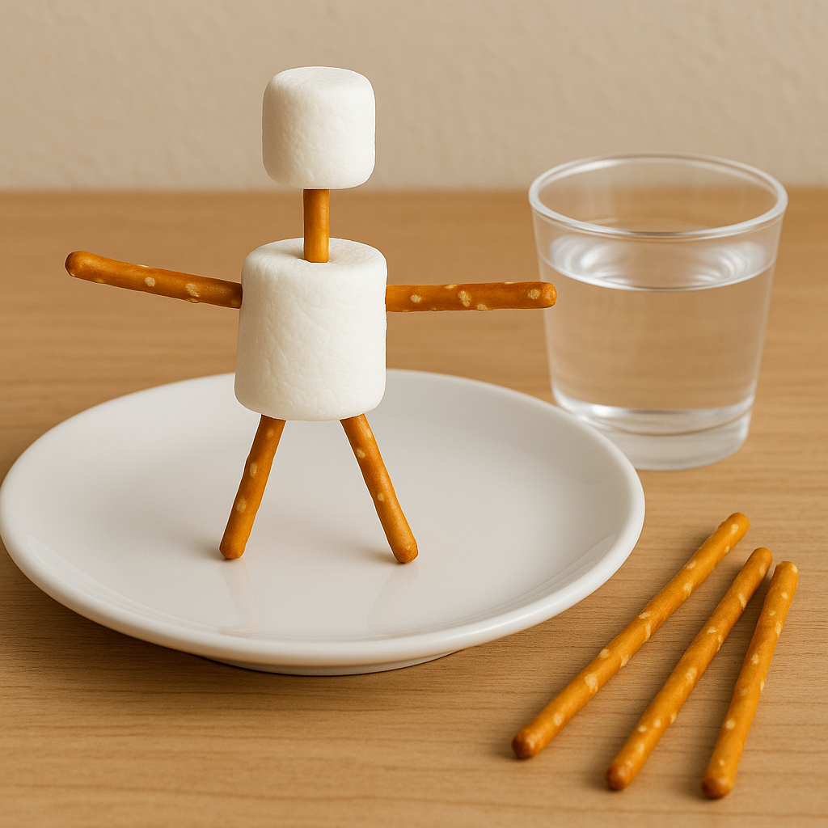
Once children have finished getting ready, encourage them to greet other kids as they arrive, help them get settled, and then play friendly games of rock, paper, scissors. Encourage them to play with as many kids as possible to help everyone feel included and welcomed.

Snack: Build a Standing Jesus Figure
Materials (per child): 1 plate, 1 large marshmallow (for Jesus’ body), 1 small marshmallow (for the head), 5 pretzel sticks (for arms, legs, and neck), a small cup of water to drink
Instructions:
Provide each child with a small cup of water and the snack materials to build a standing Jesus figure. While creating, help the children reflect on the idea that Jesus is alive and with us today!
- Body and Head
Place one large marshmallow on a plate or napkin — this will be Jesus’ body.
Push half of a pretzel stick into the top of the large marshmallow on the plate. Push a small marshmallow on the other end of that pretzel stick to create the head.
- Arms and Legs
Push two pretzel sticks into the sides of the large marshmallow to make arms.
Push two pretzel sticks into the bottom of the large marshmallow to form legs so the figure can stand upright. (Tip: You may need to gently balance or adjust the pretzels so it stands.)

Welcome
Good morning, everyone!
I want to start by asking you a question: Have you ever had a really bad day? A day when things didn’t go the way you planned?
(Listen to a few quick responses—broken toy, lost something, made a mistake, etc.)
Now imagine if someone came into that bad day and turned it into the best day ever. That’s what Jesus does—He brings new life to people when they feel lost or sad or feel like they’re not good enough.
Today we will hear a story from the Bible—and a story from Sierra Leone, Africa—about how Jesus brings hope and joy when everything seems hopeless.

Breath Prayer
Inhale: I have
Exhale: seen the Lord
Introduce a breathing exercise – Tell everyone you’re going to take three deep breaths together to help focus and prepare for worship.
Leader models the pattern – Repeat the previous step, but for each breath, the leader will say “I have” just before everyone inhales, and “seen the Lord” as they exhale. Do this three times.
Group joins in – Invite everyone to say the words along with the leader: “I have” before each inhale, and “seen the Lord” during each exhale. Repeat this rhythm for all three deep breaths.
These 9 breaths create a calm, unified moment of prayer as everyone prepares their hearts and minds.


Bible Memory
John 20:21 (NIV):
"Again Jesus said, 'Peace be with you! As the Father has sent me, I am sending you.'"
Here are simple, meaningful hand motions to help kids remember and engage with the verse. Feel free to create your own or have the kids come up with motions. Practice together a few times when you meet together each week!
"Again Jesus said,"
Cup hands around your mouth like you're speaking.
"Peace be with you!"
Make a peace sign with both hands.
"As the Father has sent me,"
Point both hands upward.
"I am sending you."
Extend both hands to point forward as if you're sending someone out.
“John”
Draw a letter “J” in the air with your pinky finger.
“20:21”
Make puppet hands talk to each other as if one is saying “twenty” and the other says back “twenty-one”.
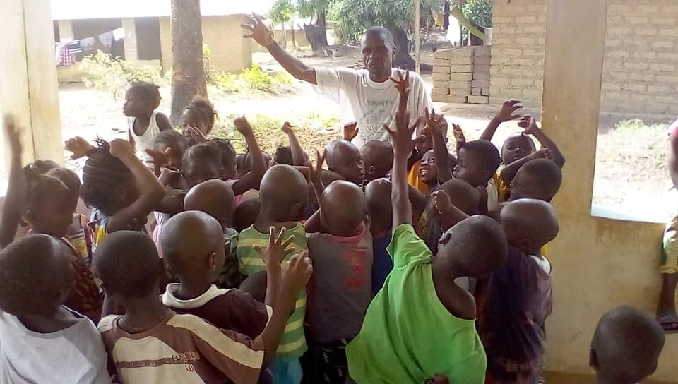

Tithes and Offerings
God has given us everything we have, and we have the joy of giving back to Him as a way to say thank you. When we give our treasures to God, He uses them in powerful ways—helping share the good news of Jesus here in (insert the name of your town here), in Sierra Leone, Africa, and all around the world! Now, let’s take time to collect our tithes and offerings.

Worship Through Song
Consider playing the songs “Walk with Jesus” by Consumed by Fire and “I See Grace” by Micah Tyler during worship time. These songs are a great way to help kids connect with God through music and meaningful lyrics.
To make worship more fun and interactive, consider creating simple hand motions or movements for the songs. You can even search YouTube for motion videos to get ideas!
Encourage all kids to stand during worship—even if they don’t know the words or aren’t ready to sing. Standing is one way we show honor and respect to our King—God!

Prayer
Dear Jesus,
Thank You for loving us so much, just like you loved your disciples and all who believe in you as their savior, king, and friend.
Thank You for being with us when we’re sad, and for giving us joy and purpose.
Help us to remember that our lives matter to You.
Give us courage to tell others about Your love.
We love You, Jesus! Amen.

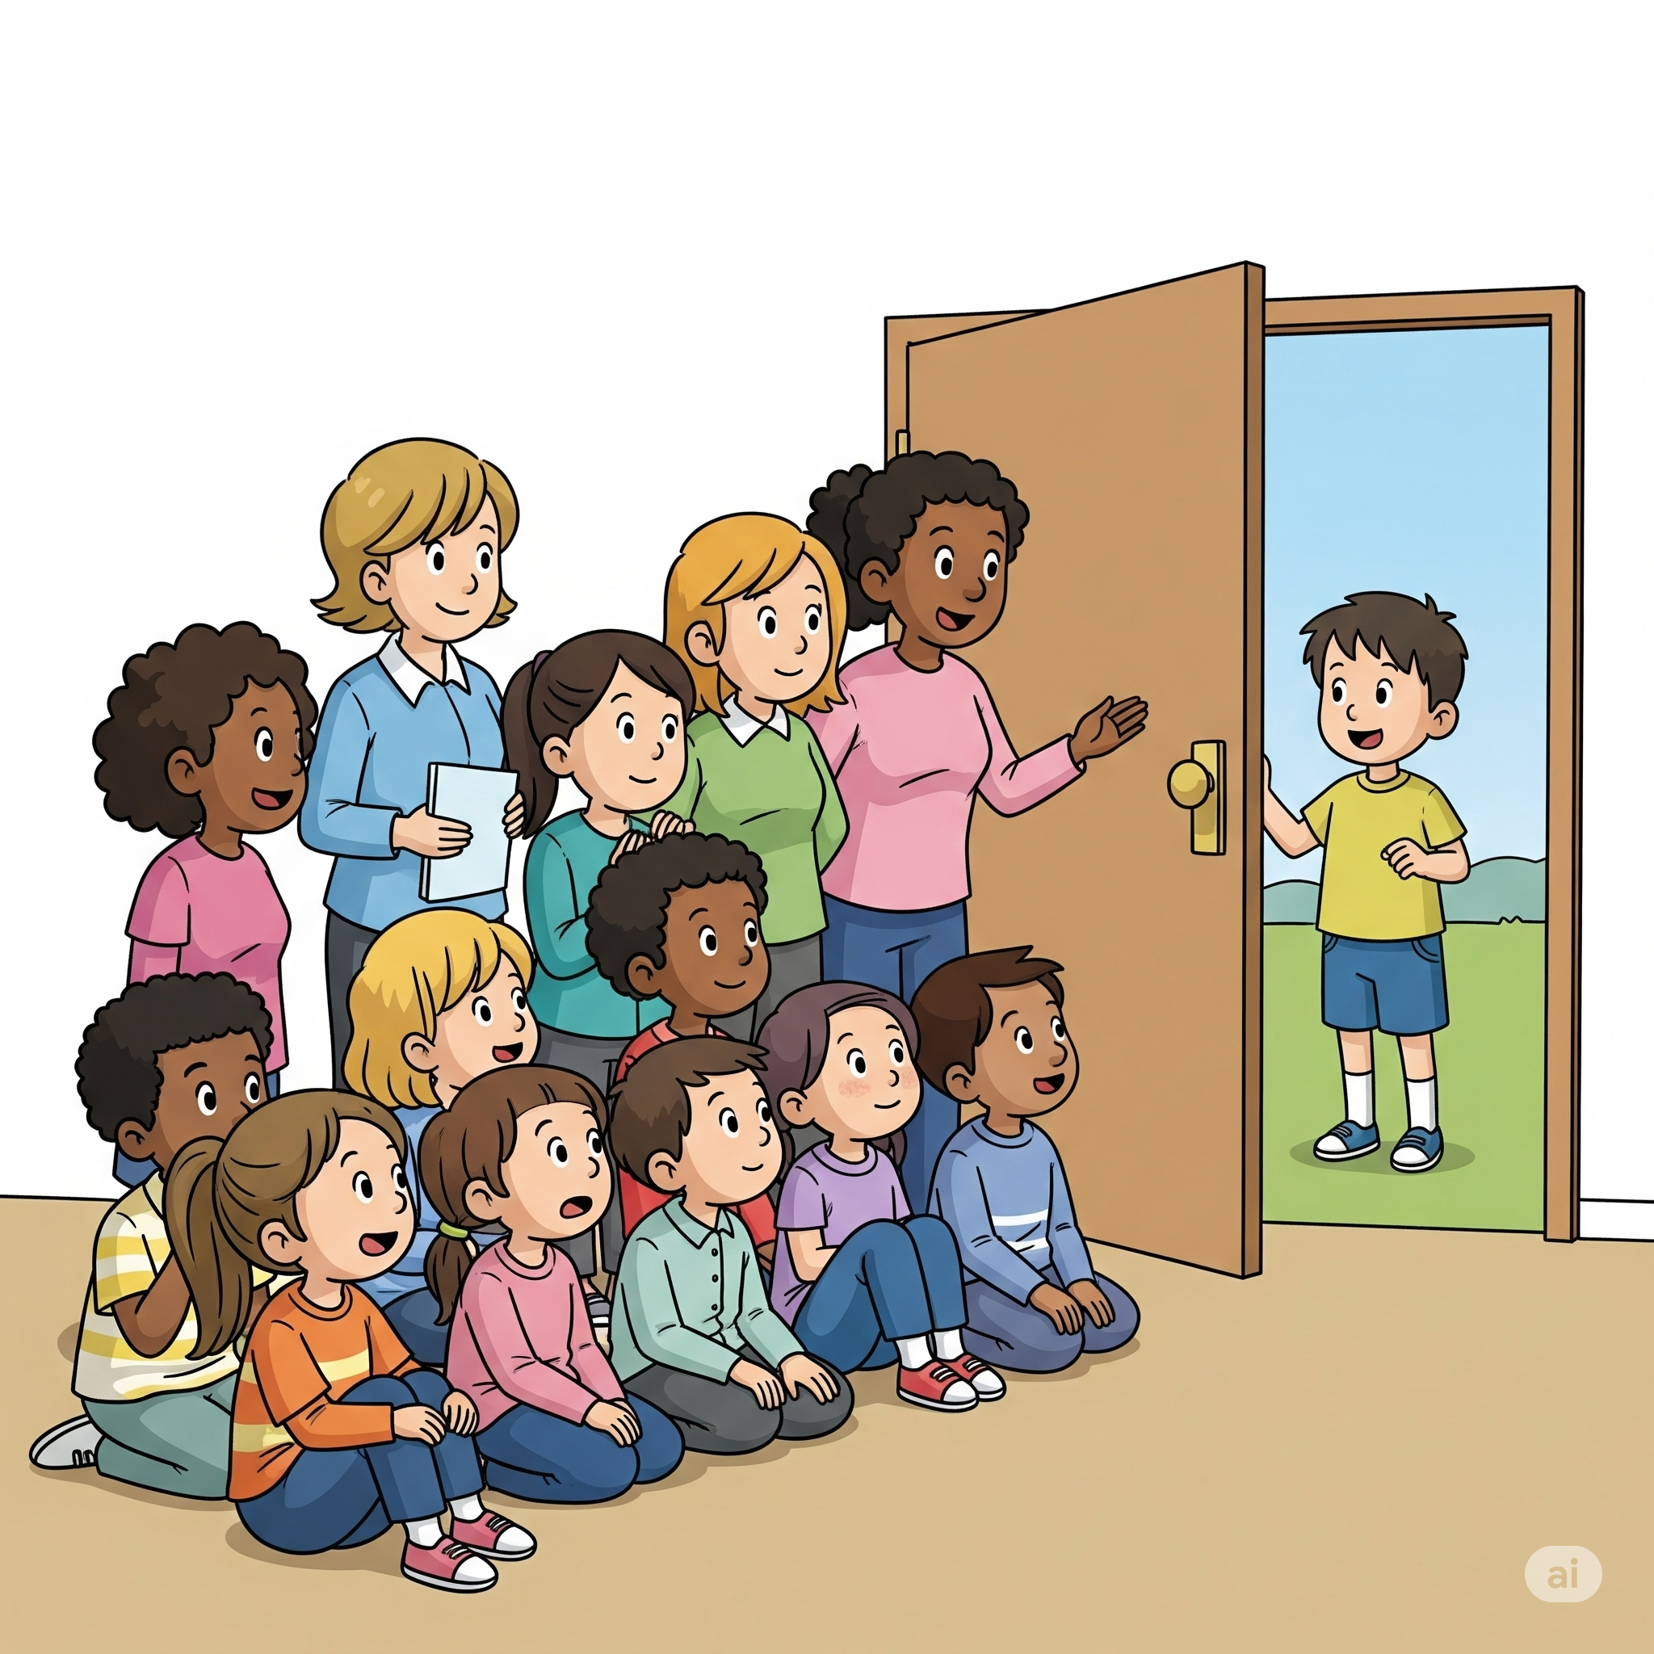
Activity
For Elementary Students – “Guess That Voice!”
Let’s have fun learning how to recognize voices—just like Mary Magdalene recognized Jesus’ voice in the garden!
Option 1: Behind the Door
One student stands behind a door and says the Bible memory verse or simple phrase like “Jesus is alive!”. Option: The person behind the door could be an adult or teen.
The rest of the group listens carefully and tries to guess who it is based only on their voice.
Option 2: Seated Guessing Game
- A teacher or student sits in a chair facing forward.
- One by one, classmates stand behind them and say, “Hi, [name of person seated]!”
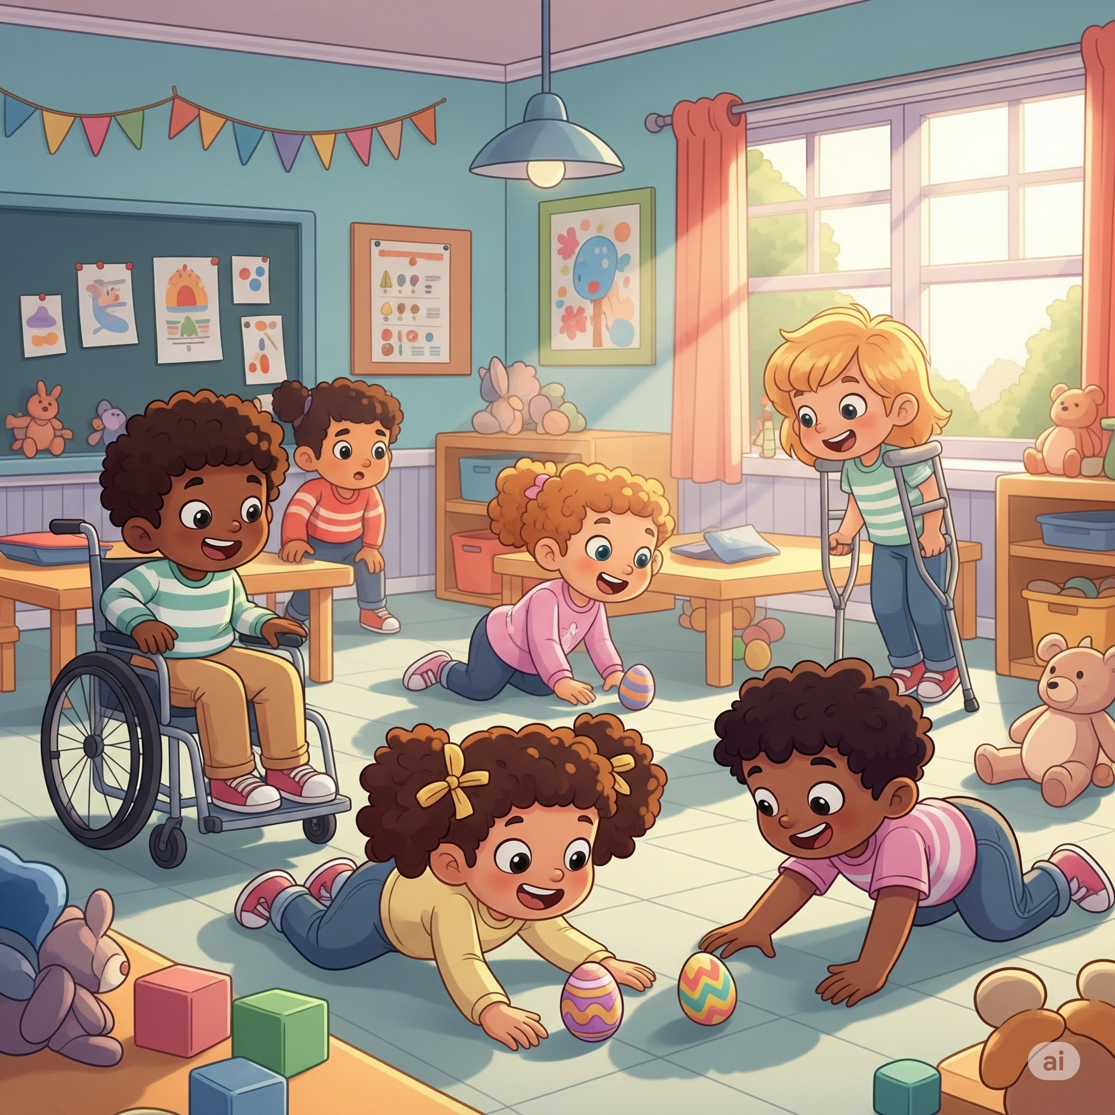
- The seated person tries to guess who is speaking without looking.
For Preschool Students – “Find Jesus!” Egg Hunt
Help little ones learn the resurrection story through a fun and meaningful egg hunt!
- Before class, hide several empty plastic Easter eggs around the room.
- In one egg, place a picture of Jesus or a small Jesus figurine. You could also hide a large picture of Jesus or a large Jesus toy or doll that does not fit in an egg as a symbol that Jesus was no longer in the tomb!
- Invite the children to search for the eggs and celebrate when someone finds “Jesus.”
Talk with them about how Mary Magdalene was searching too—and how happy she was when she found Jesus!

Sermon
Invite elementary-age students to look up John 20:11-18 in their own Bibles or use the classroom Bibles to follow along as you read the passage together.
Leader: Please stand for the reading of God’s Word.
Leader: Read John 20:11-18 out loud
Leader: This is the Word of the Lord
Congregation: Thanks be to God
Leader: Please be seated.
This story is about a woman named Mary Magdalene. She loved Jesus so much. He had helped her a long time ago when she was hurting, and now she followed Him everywhere.
But then... Jesus died on the cross, and Mary was so sad. On Sunday morning, she went to visit His tomb—and guess what?
The stone was rolled away! The tomb was empty!
Mary cried because she thought someone had taken Jesus. But then, someone spoke to her in the garden nearby…
It was Jesus! ALIVE! Mary was the first person to see Jesus after He came back to life!
Jesus didn’t wait for Mary to be happy or perfect—He came to her when she was crying.
He gave her new joy and a new job: “Go and tell the others!” And she did!
Jesus tells all of his disciples to “Go and tell the others!”
Let’s hear about what happened when some modern day disciples showed the JESUS film in Sierra Leone, Africa.
A lady named Aminata lived in Sierra Leone. She moved to a big city, hoping to start a business—but things went wrong. Aminata felt like her life didn’t matter. Then she watched a movie about Jesus.
Aminata saw how Jesus loved everyone—even someone like her.
She cried and said, “Now I know my life is valuable!”
Jesus gave Aminata a new life. Now, she tells her friends about Jesus too.


Journal
Leader: Mary Magdalene and Aminata were so full of joy that they just had to share it with others! Let’s take a few quiet moments to think about a time when you felt really happy or excited—so much that you wanted to tell someone right away!
Open your journal to the next blank page. If you’d like, write today’s date at the top.
Now, write or draw a picture of a time you felt that kind of joy-where you just had to share it with someone right away!
Maybe you got really great news, received a special gift, or something amazing happened in your life or your family.
Take your time—this is your moment to talk with God. Remember, your journal is just between you and Him, and you can share anything with Him.
Afterward, if anyone would like to share what they wrote or drew, you’re welcome to do so.
We’ll keep these journals in our worship space each week. When we are done using them—you can take it home to keep!

Response Activity: Sharing God’s Love
Materials: Writing utensils (colored pencils or markers), stickers, cardstock, a list of shut-ins or church members in the hospital
Now that you’ve heard today’s message, take a moment to think about someone who might be feeling sad, lonely, or going through a tough time.
Use this time to write or decorate a card to encourage them.
You can include a kind message, a Bible verse, or a simple reminder that they’re loved and not alone.
Let your words be a way to share the hope and joy that Jesus gives—just like Mary Magdalene and Aminata shared with others.

Extra Time Game
Telephone
If you have a few extra minutes at the end of your session, play a fun round of the classic game Telephone using one of the phrases below.
How to Play:
- Have everyone sit in a circle or line.
- The leader whispers a phrase into the first child’s ear only once.
- That child then whispers what they heard to the next person—and so on down the line.
- The last person says the message out loud to the whole group. Compare it to the original phrase for lots of laughs and a great lesson on listening!
Suggested Phrases to Use:
“Jesus is alive!”
“Mary saw Jesus in the garden.”
“Go and tell the others!”
“Peace be with you.”
“I have seen the Lord!”
John 20:21 "Again Jesus said, 'Peace be with you! As the Father has sent me, I am sending you.'"
Finish with: This game is a fun reminder of how important it is to listen closely—just like Mary listened and recognized Jesus’ voice. It also shows how messages can change when passed from person to person, and why it’s important to share God’s truth clearly!

