
Week 2

The Disciples and Ibrahim

Author: Rev. Alyssa Fulling

Jumpstart
As children enter the worship space, direct them to prepare for worship by putting away coats and personal items, as well as visiting the restroom before the service begins.
Direct them to take out their Bibles, bookmarks, journals, pencils, and any other necessary materials.
Once children have finished getting ready, encourage them to greet other kids as they arrive, help them get settled, and then play “Would You Rather”. Write some questions on a whiteboard or use the ones provided on the Google Slideshow.

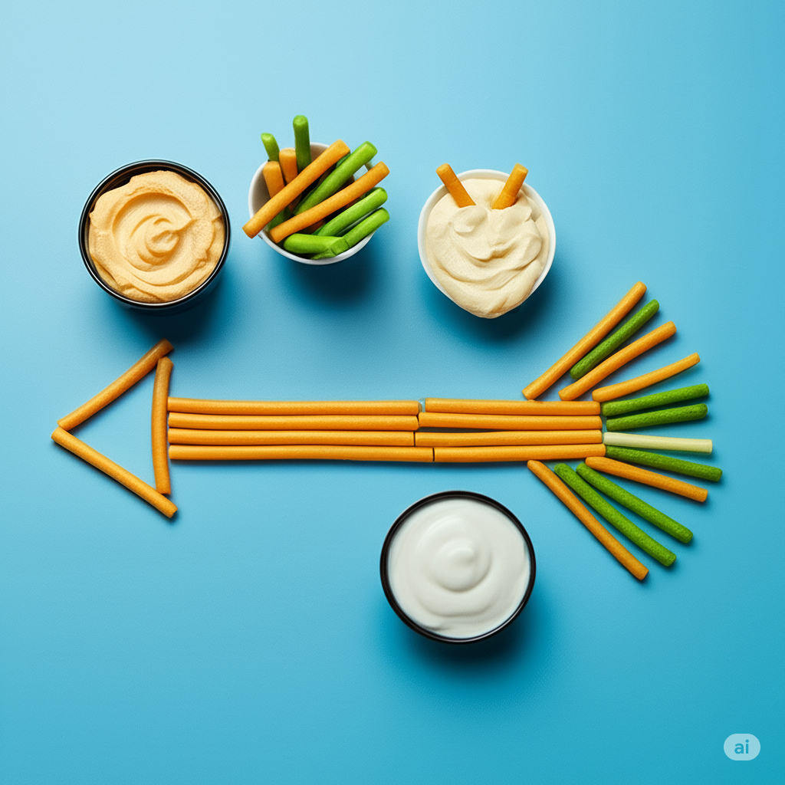
Snack: Building a Veggie Straw Arrow
Materials (per child): A handful of veggie straws (variety of colors like green, orange, yellow), a plate or flat surface, a small cup of water to drink, optional: hummus, ranch dip, or cheese dip for pairing
- Form the Arrow Shaft
Line up veggie straws in a straight row horizontally across the plate. These will be the “shaft” of the arrow.
- Make the Arrowhead
Use veggie straws to form a triangle at one end of the shaft. Arrange two straws diagonally from the end of the shaft to meet at a point, forming a “V.” Fill in the center with one more straw if needed.
- Create the Tail Feathers
At the opposite end of the shaft, place straws in a fan or "Y" shape to resemble feathers. You can angle them slightly up and down. Add a small bowl of dip next to the arrow if desired. Kids can pull off the straws and dip as they eat.

Welcome
Good morning, everyone!
I want to start by asking you a question: Have you ever gone on a long trip? Maybe a car ride to visit family or a fun vacation?
(Listen to a few quick responses—see grandparents, ski trip, etc.)
Today I want to tell you about a team of people who woke up really early—at 2 in the morning! They rode motorcycles, boats, and even little canoes to get to a tiny island. Can you imagine? Why do you think they did that? They went because they wanted to tell people about Jesus!"
They showed a movie called The JESUS film and told people that Jesus is alive and loves them. Some of the people used to believe in Jesus but had given up. When they watched the movie, they were filled with joy again and chose to follow Jesus. Wow, isn’t that amazing?

Breath Prayer
Inhale: Peace
Exhale: be with you.
Introduce a breathing exercise – Tell everyone you’re going to take three deep breaths together to help focus and prepare for worship.
Leader models the pattern – Repeat the previous step, but for each breath, the leader will say “Peace” just before everyone inhales, and “be with you” as they exhale. Do this three times.
Group joins in – Invite everyone to say the words along with the leader: “Peace” before each inhale, and “be with you” during each exhale. Repeat this rhythm for all three deep breaths.
These 9 breaths create a calm, unified moment of prayer as everyone prepares their hearts and minds.
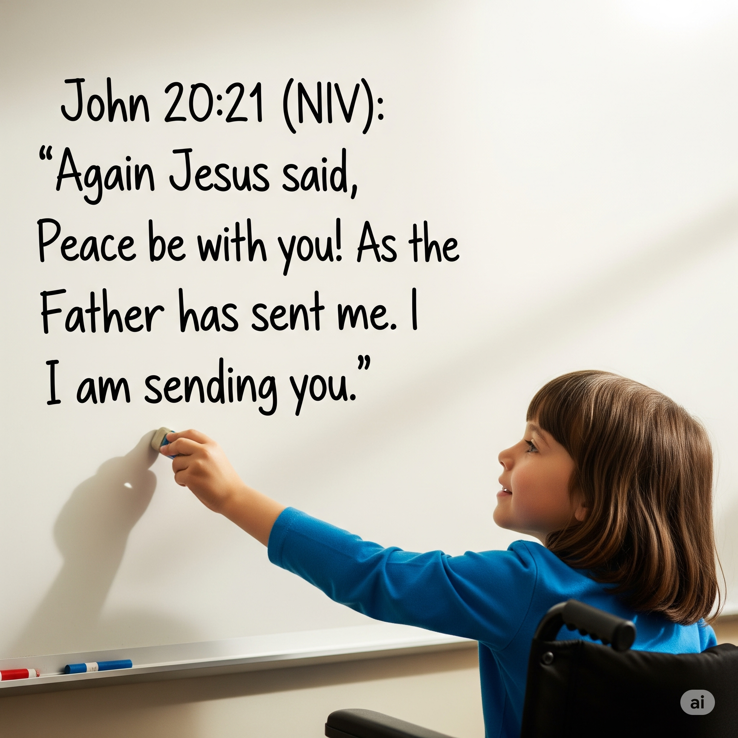

Bible Memory
John 20:21 (NIV):
"Again Jesus said, 'Peace be with you! As the Father has sent me, I am sending you.'"
Try this game to help kids remember and engage with the verse. Game Instructions:
- Write the verse on a large whiteboard that everyone can see.
- Read the verse out loud together as a group. (Feel free to demonstrate the motions from last week as well!)
- Choose a volunteer to erase 1–3 key words from the verse.
- Say the whole verse again from memory, including the missing words.
- Repeat steps 3 & 4 until the board is blank!
Alternative: Write out the verse with a word or two on each sticky note or notecard. Display the sticky notes or note cards and remove a few each round.
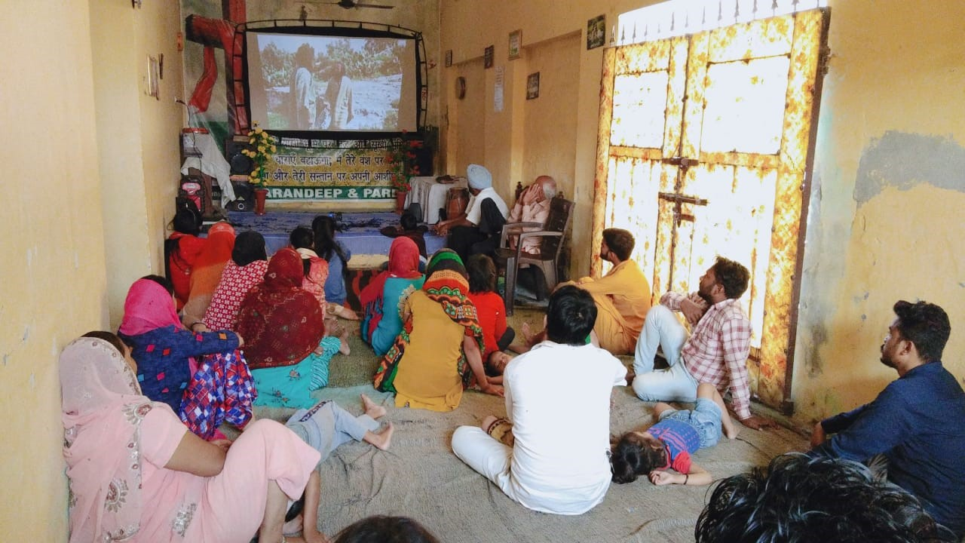

Tithes and Offerings
God has given us everything we have, and we have the joy of giving back to Him as a way to say thank you. When we give our treasures to God, He uses them in powerful ways—helping share the good news of Jesus here in (insert the name of your town here), in India, and all around the world! Now, let’s take time to collect our tithes and offerings.

Worship Through Song
Consider playing the songs “Firm Foundation” by Cody Carnes and “Do It Again” by Elevation Worship during worship time. These songs are a great way to help kids connect with God through music and meaningful lyrics.
To make worship more fun and interactive, consider creating simple hand motions or movements for the songs. You can even search YouTube for motion videos to get ideas!
Encourage all kids to stand during worship—even if they don’t know the words or aren’t ready to sing. Standing is one way we show honor and respect to our King—God!

Prayer
Dear Jesus,
Thank You for loving us and for giving us peace.
We want to be your disciples too.
Help us to not live with fear.
Help us to be brave and kind to others.
Please fill us with Your Holy Spirit so we can tell others that You are alive.
We love you, Jesus!
Amen.

Activity
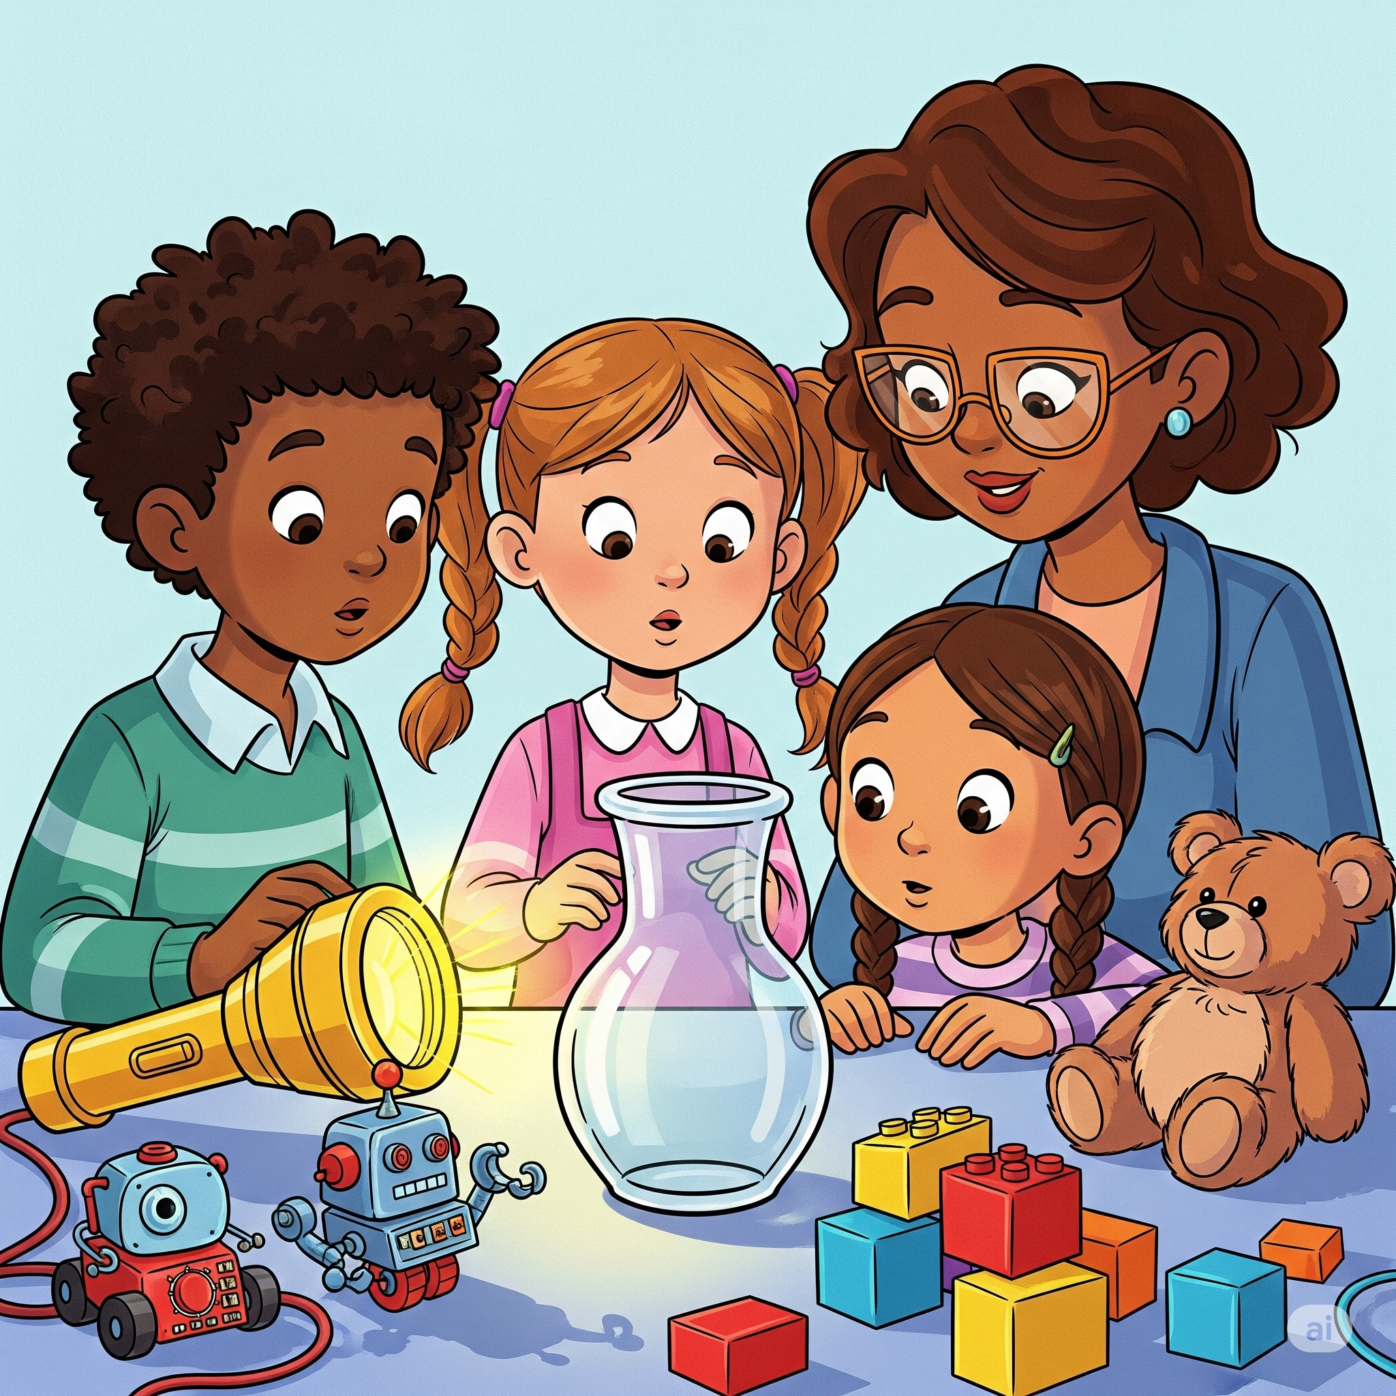
For Elementary Students – Science Challenge for Kids: "Through the Vase!"
Objective:
Can you figure out which object can go through the clear vase — without touching, breaking, or going inside it?
Materials Needed (per group of kids):
1 clear vase or cup(tall and narrow works best), 5 small objects (such as a pen, chapstick, toy car, spoon, etc), 1 flashlight
- Explore & Test:
Let the kids pick up each object and try to solve the challenge. Encourage observation, touching the objects (but not shoving anything into the vase!), asking questions, and working together.
- Give Hints if Needed:
“Some things go through... even though they aren’t solid.”
“Can something reach the other side without moving through the bottom or top?”
“What can go through but stay outside?”
- Reveal the Solution:

The Flashlight! When turned on, the light beam passes through the vase to the other side. It’s the only object that truly goes through without ever physically entering it. Jesus is the light of the world and nothing can separate us from his love!
For Preschool Students – Jesus Loves My Hands
Materials: Large construction paper (8.5x11 or larger), writing utensils, red dot stickers (or red crayons/markers to draw dots), optional: scissors for teacher use.
Instructions
- Say: “Today we’re going to do a special craft to remind us that Jesus loves us so much! We’re going to trace our hands and put a red dot in the middle to help us remember His love.”
- Give each child a sheet of paper. Help each child place one hand flat on the paper. Gently trace around their hands with a crayon or marker. Repeat for the other hand.
- In the center of each hand (in the palm), place a red sticker or use a red crayon or marker to draw a dot. Explain: “This red dot reminds us of Jesus’ hands when He died on the cross to show how much He loves us.”
- You can write a simple phrase on the paper like: “Jesus loves me!” or “These hands belong to Jesus!”
Closing Thought: Every time we see our hands, we can remember that Jesus loves us and He wants us to use our hands to help and love others!

Sermon
Invite elementary-age students to look up John 20:19-23 in their own Bibles or use the classroom Bibles to follow along as you read the passage together.
Leader: Please stand for the reading of God’s Word.
Leader: Read John 20:19-23 out loud
Leader: This is the Word of the Lord
Congregation: Thanks be to God
Leader: Please be seated.
Right after Jesus rose from the dead, His friends—the disciples—were scared. They were hiding in a room with the door locked! But guess what? Jesus showed up right in the middle of the room and said, 'Peace be with you!' He showed them His hands and His side to prove it was really Him. Then Jesus said something very special:
'As God sent me, I am sending you!'
Jesus was saying, "Now it’s your turn to go tell others about me!"
He gave them the Holy Spirit—God’s helper—to give them courage and love.
Do you remember the people who woke up at 2 in the morning and traveled to the little island? They were like modern-day apostles. That means they were sent by God to share His love. And guess what? You and I are also sent by Jesus—to our schools, our neighborhoods, even our families!
A boy named Ibrahim lived In the country of India. A team showing the JESUS film came to Ibrahim’s house. Ibrahim listened and made a decision to accept Jesus as his savior. His mom, dad, and sister did as well. Ibrahim knew his village might not like his decision, but still he said: 'I have decided to follow Jesus.' Wow, that takes a lot of courage!"

Journal

Leader: The disciples and Ibrahim both made a decision to follow Jesus. It was clear to them that this decision would not be easy, but it was the right choice. Let’s take a few quiet moments to think about a time when you made a hard decision, a choice that was not easy.
Open your journal to the next blank page. If you’d like, write today’s date at the top.
Now, write or draw a picture of a time you made a hard choice. Maybe you chose to share a toy even when you did not want to or were afraid the other person might break it. Maybe you chose to leave your friend group and sit with someone who was all by themself. Maybe you were tempted to steal or lie and had to choose to do the right thing.
Take your time—this is your moment to talk with God. Remember, your journal is just between you and Him, and you can share anything with Him.
Afterward, if anyone would like to share what they wrote or drew, you’re welcome to do so.
We’ll keep these journals in our worship space each week. When we are done using them—you can take it home to keep!

Response Activity
Whisper Party Game
- Have all the kids sit together on the floor or in chairs where they can clearly see the screen.
- Explain the Rules: Say “We’re going to play a picture game! You’ll see one picture at a time. When you see the picture, whisper to your neighbor what you think it is.But… when you see a picture of Jesus—don’t whisper! Instead, JUMP UP and DANCE WITH JOY to celebrate seeing Jesus!”
- Practice Round: Show a test slide (e.g. a cat). Let the kids whisper “cat” to each other. Then show a picture of Jesus and model for the kids, jumping up and dancing with joy!
- Play the Game: Start the slide show. Pause a few seconds on each slide to give kids time to whisper. Watch for the joyful chaos when Jesus appears!
- After the last slide, say: “Great job, everyone! It’s fun to see all kinds of things, but there’s no one like Jesus. We can always jump for joy when we see Him in our lives!”
Optional Add-On: Play happy music during the Jesus slides, such as “Your Way’s Better” by Forrest Frank

Extra Time Game
Simon Says (or Jesus Says!)
If you have a few extra minutes at the end of your session, play a fun round of the classic game Simon Says.
- Stand Up and Spread Out: Have all the kids stand up in an open space where they can move safely.
- Explain the Rules: Say “We’re going to play a game called ‘Jesus Says!’ When I say, ‘Jesus says do something,’ you do it! But if I don’t say ‘Jesus says,’ don’t do it! If you do it anyway, you sit down and cheer for your friends!”
- Start Giving Commands: Use a mix of silly and active actions.
  - “Jesus says raise your hands!”
  - “Jesus says spin in a circle!”
  - “Touch your toes!” (Don’t say “Jesus says” here—anyone who moves is out!)
  - “Jesus says hop like a bunny!”
  - “Clap your hands!” (Tricky one!)
- Keep it Fun and Encouraging: Celebrate the kids who stay in, but also cheer on those who sit out. Keep it lighthearted!
- End on a High Note: Finish with: “Jesus says give someone a high five and say, ‘Jesus loves you!’”

