
Week 3

Thomas & Raúl

Author: Rev. Alyssa Fulling

Jumpstart
As children enter the worship space, direct them to prepare for worship by putting away coats and personal items, as well as visiting the restroom before the service begins.
Direct them to take out their Bibles, bookmarks, journals, pencils, and any other necessary materials. Once children have finished getting ready, encourage them to greet other kids as they arrive, help them get settled, and then play “I Spy”.
- Choose a Spy: One player is the Spy and secretly chooses an object in sight — something everyone can see (e.g., a red book, a clock, a shoe).
- Give the Clue: The Spy says, “I spy with my little eye something that is the color ___.” (Example: "I spy with my little eye something that is the color red" – the object is a book.)
- Others Guess: The rest of the group takes turns guessing what the object might be. (Optional) If no one guesses after a few tries, the Spy can give more clues such as the letter it starts with “It starts with a B”, the size “It is smaller than a chair”, or the location “it is near the window”.
- Reveal & Switch: Once someone guesses correctly, it’s their turn to be the Spy!

Snack: Hole-y Snacks

Materials: You will need an assortment of hole-y foods such as donuts, bagels, and Cheerios. Also needed are plates, cups, and water to drink.
- Show the snacks to the kids and ask what all of these foods have in common. If they do not make the connection on their own say, “Today we’re having a hole-y snack! All of these yummy treats have something in common — they have holes. And did you know? After Jesus rose from the dead, He still had holes in His hands — from the nails when He died on the cross. The holes were there to show His love and that He really came back to life!”
- Give guidelines for kids to choose which hole-y snacks they would like to add to their plate, buffet style. Example: Only 1 donut and 2 donut holes per person.
- As all are enjoying the snack say, “Every time we see something with a hole in it, we can remember Jesus’ love and that He’s alive! Right now, today (maybe even say today;s date) Jesus still has holes in his hands. This is not a reminder for us to be sad, but to remember how much Jesus loves us!”

Welcome
Hi everyone! Today we will hear a really amazing part of the Bible where Jesus shows His hands to a man named Thomas. Thomas had a really big question: "Is Jesus really alive again?" What do you think? (Listen to a few quick responses).
At first, Thomas didn’t believe what the other disciples were saying. He said, “I won’t believe it until I see it with my own eyes!” Have you ever had questions or doubts? Like:
- "Is Jesus really with me?"
- "Why did something sad happen?"
- "Can Jesus help me when I feel scared or alone?"
Guess what? Jesus is not mad at us when we have questions. He came right to Thomas and showed him His hands and side—the places where Jesus had holes from the cross.
Jesus didn’t yell at Thomas or say, “You’re too late!” He said: “Stop doubting and believe.”

Breath Prayer
Inhale: We have
Exhale: seen the Lord.
Introduce a breathing exercise – Tell everyone you’re going to take three deep breaths together to help focus and prepare for worship.
Leader models the pattern – Repeat the previous step, but for each breath, the leader will say “We have” just before everyone inhales, and “seen the Lord” as they exhale. Do this three times.
Group joins in – Invite everyone to say the words along with the leader: “Peace” before each inhale, and “be with you” during each exhale. Repeat this rhythm for all three deep breaths.
These 9 breaths create a calm, unified moment of prayer as everyone prepares for worship.


Bible Memory
John 20:21 (NIV):
"Again Jesus said, 'Peace be with you! As the Father has sent me, I am sending you.'"
Try this game to help kids remember and engage with the verse.
- Prepare the Verse: Break John 20:21 into small sections—one phrase or a few words per section. Write or type each of these sections on their own paper in large font.
- Tape the Papers: Give one paper to each child to tape to their own chest.(Optional Challenge) Ensure the kids cannot see what is taped on them by putting it on their back.
- Explain the Task: Tell the children they will work together to put the verse in the correct order. Have the kids stand in a scattered group and let them talk with each other, sharing and reading the parts on each other’s papers to figure out the correct order of the verse. (Optional Challenge) Try it without speaking!
- Line Up: When they think they have the correct order, have them line up in a row according to the verse. Read the verse aloud together to see if the order is correct. If it’s not quite right, encourage them to adjust and try again until they get it right.

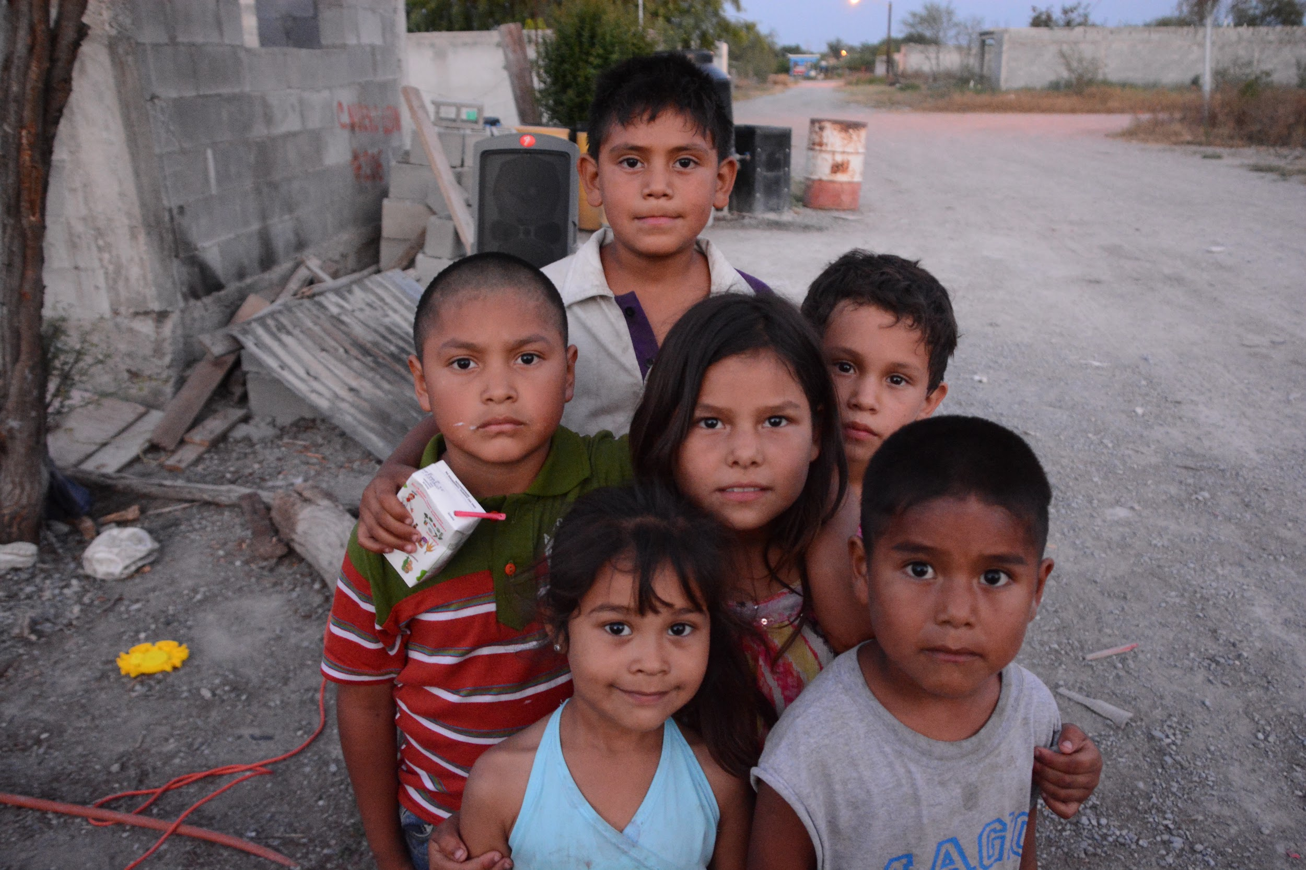
Tithes and Offerings
God has given us everything we have, and we have the joy of giving back to Him as a way to say thank you. When we give our treasures to God, He uses them in powerful ways—helping share the good news of Jesus here in (insert the name of your town here), in Mexico, and all around the world! Now, let’s take time to collect our tithes and offerings.

Worship Through Song
Consider playing the songs “Evidence” by Josh Baldwin and “I Believe” by Phil Wickham during worship time. These songs are a great way to help kids connect with God through music and meaningful lyrics.
To make worship more fun and interactive, consider creating simple hand motions or movements for the songs. You can even search YouTube for motion videos to get ideas!
Encourage all kids to stand during worship—even if they don’t know the words or aren’t ready to sing. Standing is one way we show honor and respect to our King—God!

Prayer
Dear Jesus,
Thank You for loving us, even when we have questions or doubts.
Help us believe You are always with us.
Show us Your love in ways we can feel and see.
We want to say like Thomas: “My Lord and my God!”
In Jesus’ name we pray, Amen.

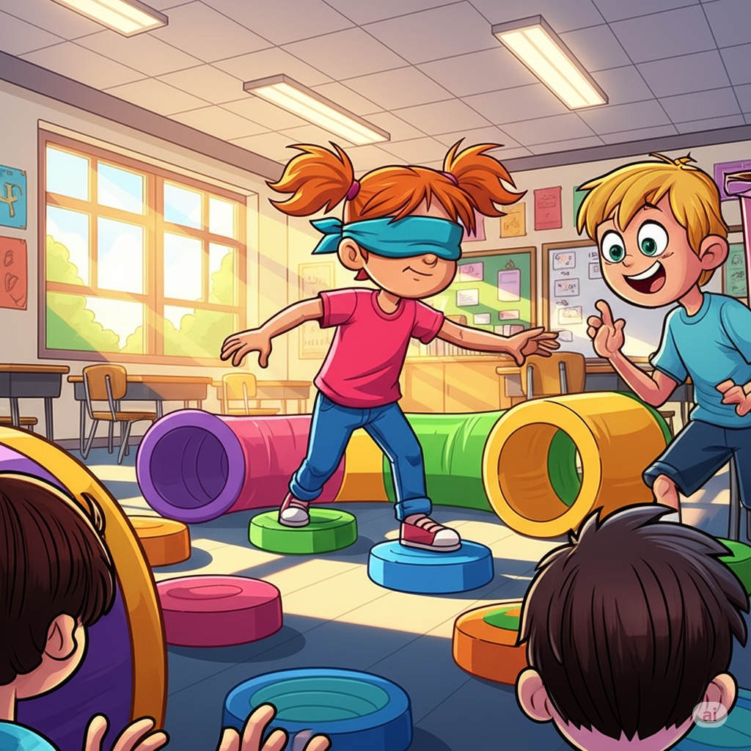
Activity
For Elementary Students – Blindfold Obstacle Course
Materials Needed (per group of kids): Blindfolds, an obstacle course set up in a safe area using items like cones, chairs, pillows, or tape lines (anything safe and easy to navigate around)
- Create a simple obstacle course with safe objects spaced out so kids can walk around or step over them.
- Divide kids into pairs or groups. One child in each group will be blindfolded; one other child or an adult will be the guide.
- The blindfolded child stands at the start of the obstacle course. The guide stands beside or behind their partner.
- The guide uses only words (no touching) to tell their partner how to move. Examples: “Take two steps forward,” “Turn slightly left,” “Step over the pillow,” “Stop,” “Turn right,” etc. The blindfolded child carefully follows the instructions to navigate the course.
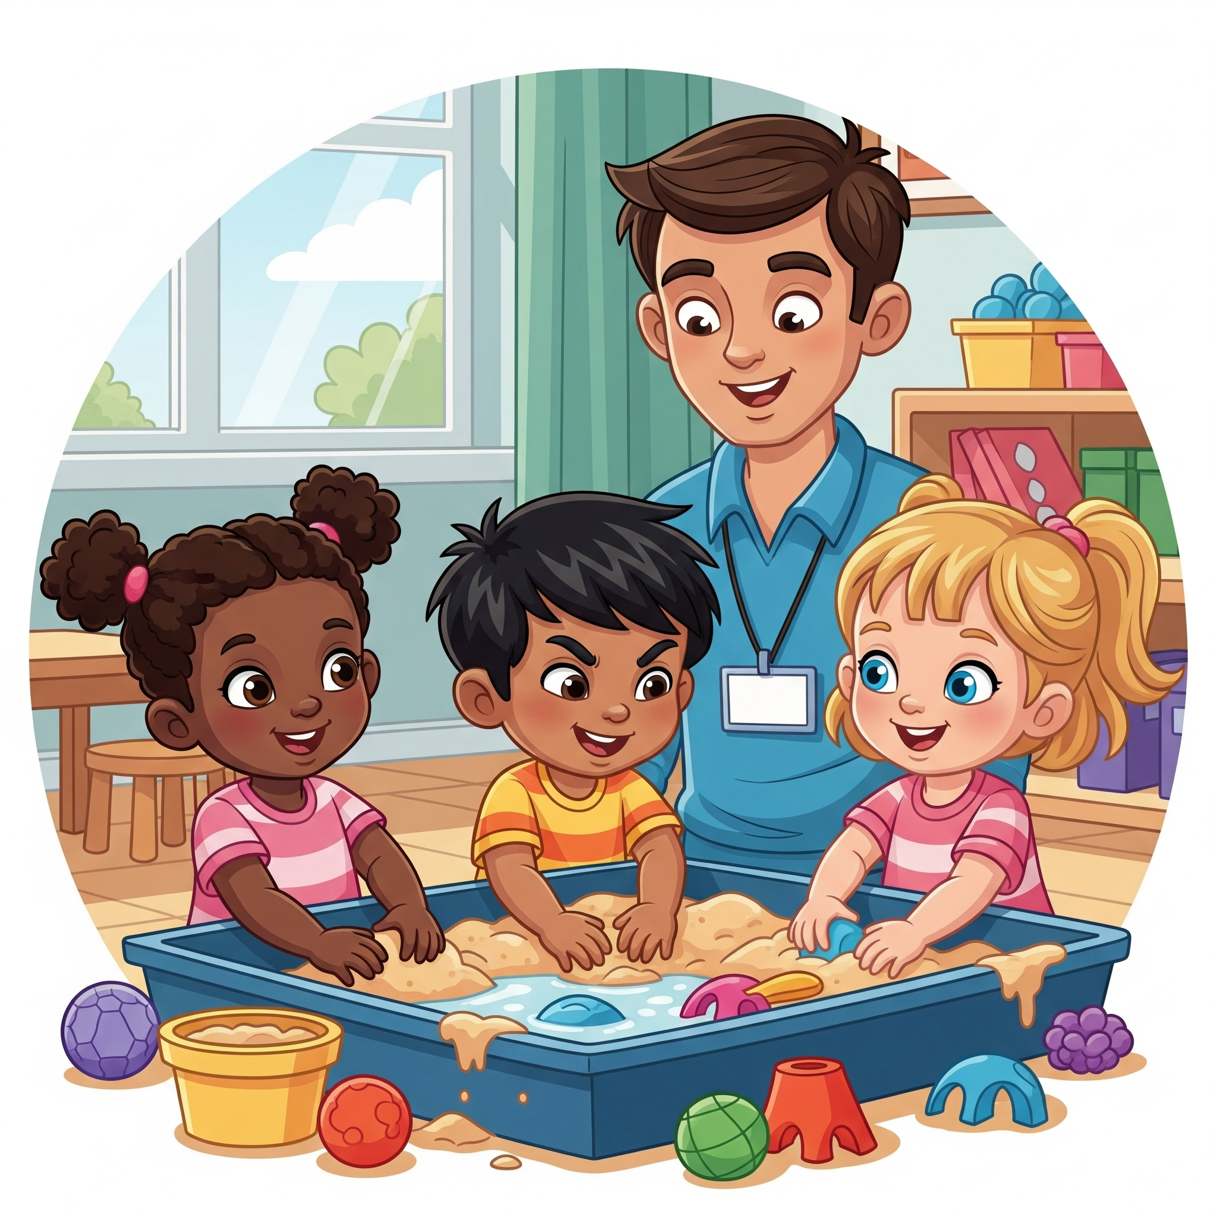
- When they reach the end, the children switch roles and try again. Encourage kids to speak clearly and listen carefully!
For Preschool Students – Sensory Bin Exploration
Materials: Nails (plastic or wooden, safe for kids), keys (old or toy keys, no sharp edges), Mr. Potato Head hands, heart-shaped toys (soft or plastic), Thomas the Train toys (small enough to handle), base material such as rice, dried beans, or shredded paper
Setup:
Fill a large bin or container with a base material like rice, dried beans, or shredded paper (optional for more sensory fun).
Mix in the above mentioned items. Place the bin where all of the children can easily reach it.
Instructions:
Invite the children to explore the bin using their hands. Encourage them to find and pick up different objects. Ask questions like:
“Can you find the keys?”
“How does the nail feel? Is it smooth or rough?”
“What color is the heart toy?”
“Where is Thomas the Train?”
Let them play and explore freely, talking about what they find. For added fun, invite them to sort objects by shape, size, or color.
Safety Tips: Always supervise children during the activity. Use only child-safe items (no real sharp nails or keys). Remind children not to put objects in their mouths.

Sermon
Invite elementary-age students to look up John 20:24-31 in their own Bibles or use the classroom Bibles to follow along as you read the passage together.
Leader: Please stand for the reading of God’s Word.
Leader: Read John 20:24-31 out loud
Leader: This is the Word of the Lord
Congregation: Thanks be to God
Leader: Please be seated.
In the Bible story today, there was a disciple named Thomas. His friends said, “We saw Jesus! He’s alive!” But Thomas didn’t believe them. He said, “I won’t believe unless I see Jesus myself.”
Have you ever had trouble believing something until you saw it with your own eyes? (Wait for a few answers: maybe a magic trick, or a surprise gift.) That’s how Thomas felt. He wasn’t trying to be bad—he was just really confused and really sad that Jesus had died.
But guess what Jesus did? Did Jesus get mad at Thomas for doubting? No! Jesus showed up and said, “Thomas, here I am. Look at my hands. You can believe in me.” And do you know what Thomas said? He said, “My Lord and my God!” That means he finally believed—and he trusted Jesus with his whole heart.
Sometimes, like Thomas, we might have doubts. We might wonder:
"Does Jesus really love me?"
"Will He really help me when I’m scared or sad?"
A man named Raúl was not sure about this. Raúl’s home was in Mexico and he had many problems. Raúl tried to solve these problems by paying lots of people to help him. But one day, Raúl was invited to watch the JESUS film and he experienced peace. Raúl started to believe that Jesus loved him and wanted to help him. Raúl saw with his own eyes the importance of choosing Jesus as Lord, God, and helping friend everyday.
But here’s the good news: Jesus is always patient with us. He understands our questions. And He shows us love in real ways—through our parents, our teachers, our friends, and His Word. He wants us to keep coming back to Him, even when we’re unsure.

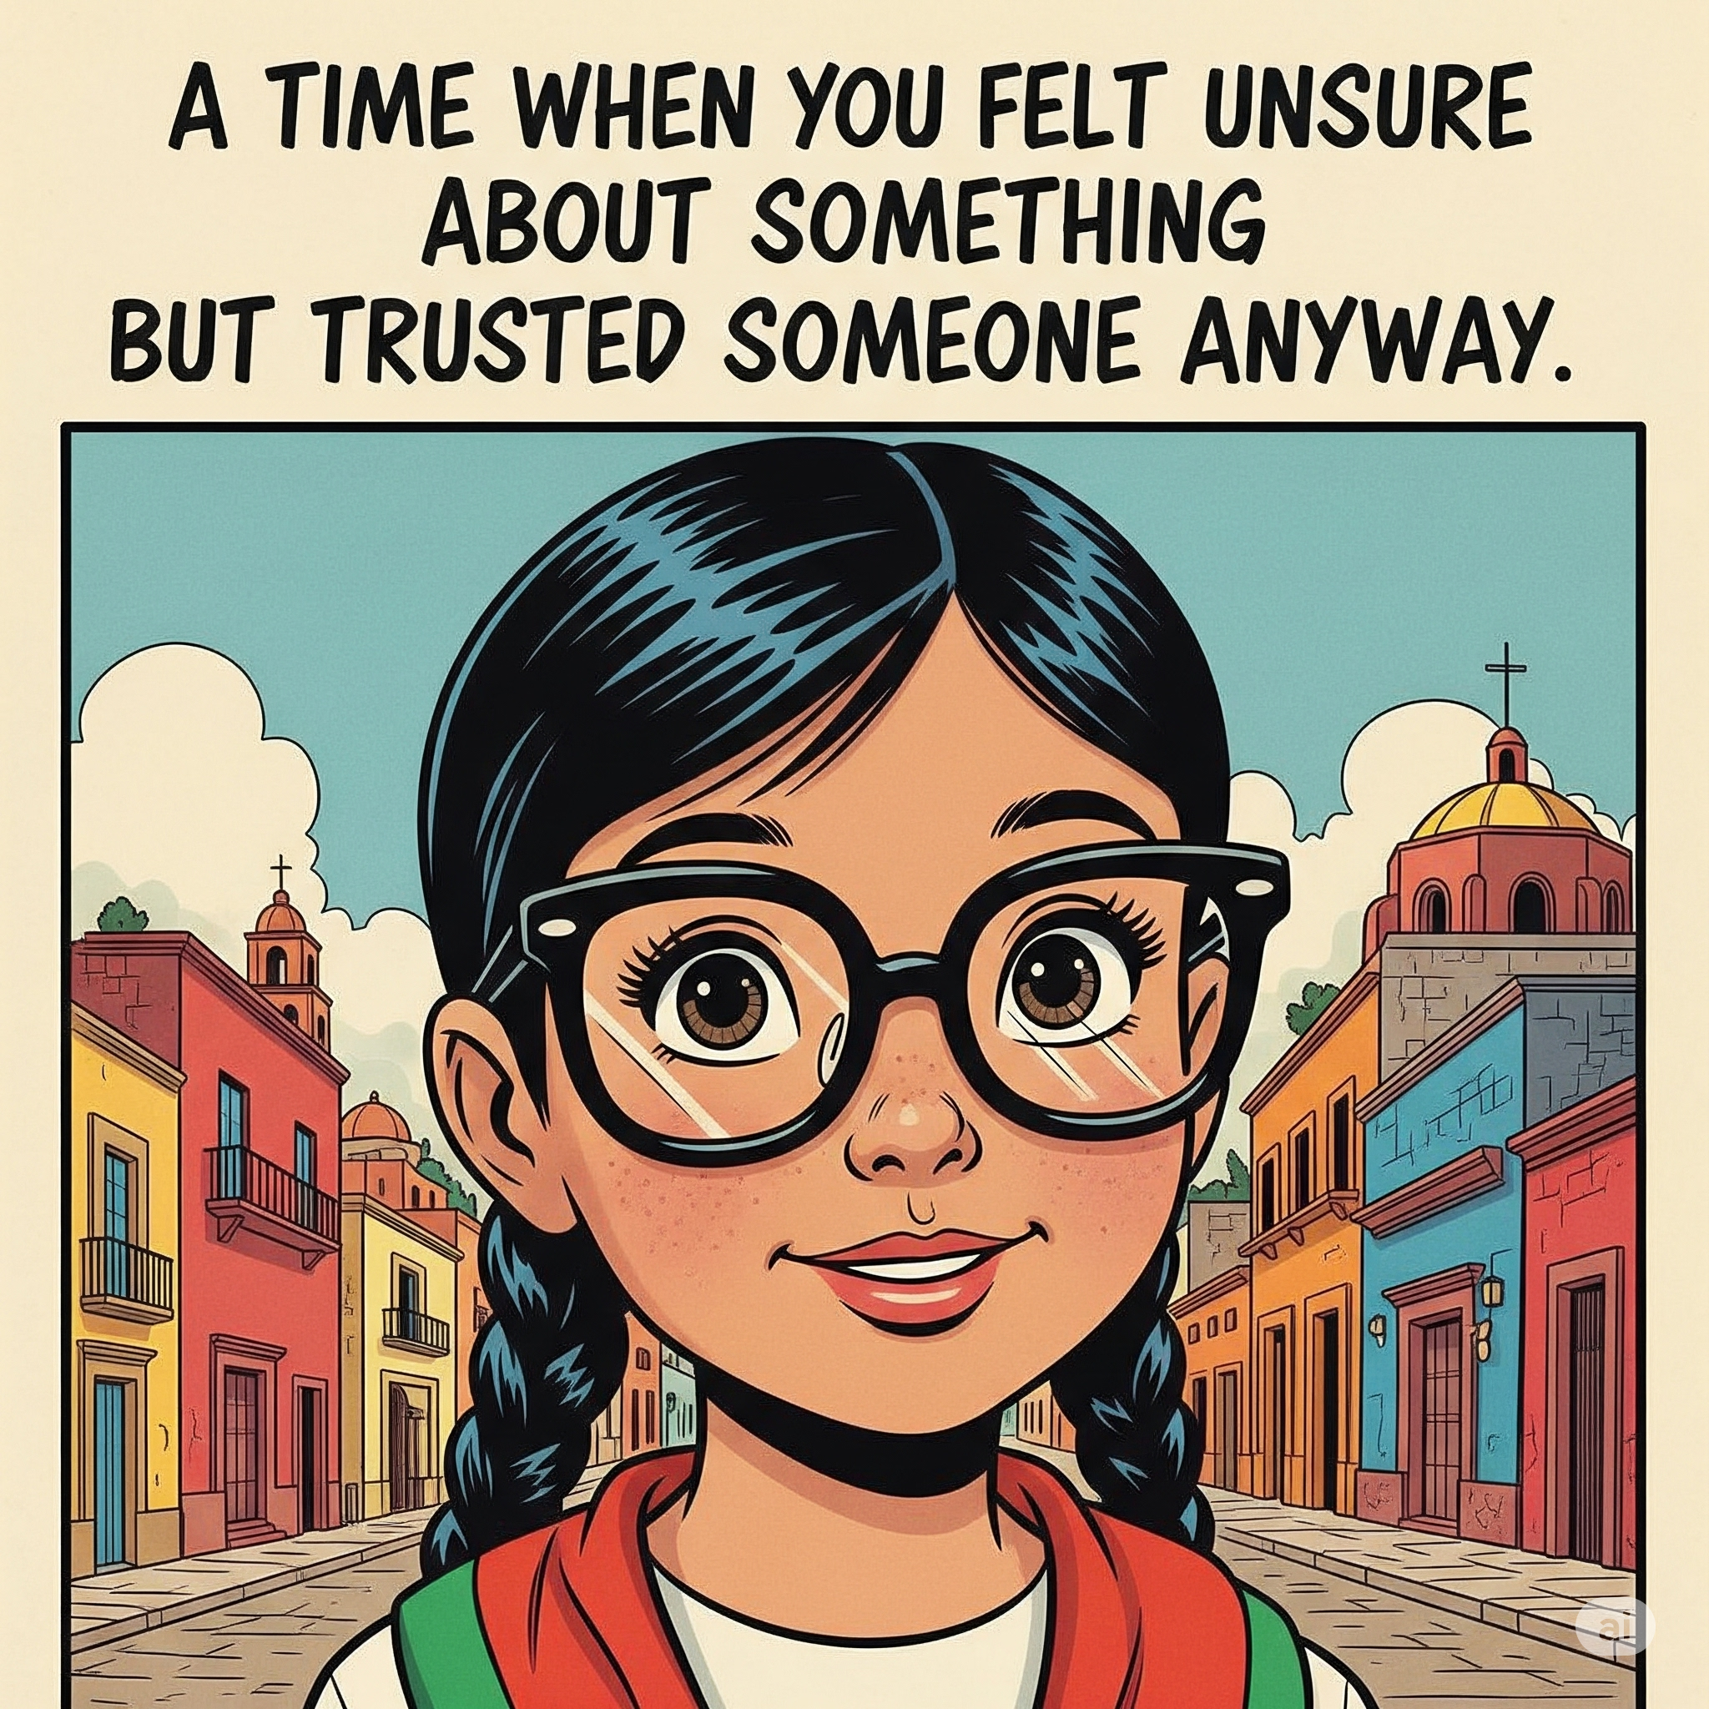
Journal
Leader: Thomas and Raúl both made a decision to believe in Jesus. They had doubts, but that did not scare Jesus away. Jesus showed that his love is greater than any doubt. Let’s take a few quiet moments to think about a time when you were unsure, but trusted someone to help you.
Open your journal to the next blank page. If you’d like, write today’s date at the top.
Now, write or draw a picture of a time when you felt unsure about something but trusted someone anyway. How did it turn out?
Then write: “Jesus, help me trust You even when I don’t understand everything.”
Maybe you were not sure about taking off the training wheels of your bike, but you trusted a parent to help you learn to balance.
Maybe you were not sure about a thunderstorm, but you trusted the people with you and God to keep you safe.
Maybe you were not sure about going to a new class or school, but you trusted that God would help you make new friends, and he did.
Take your time—this is your moment to talk with God. Remember, your journal is just between you and Him, and you can share anything with Him.
Afterward, if anyone would like to share what they wrote or drew, you’re welcome to do so.
We’ll keep these journals in our worship space each week. When we are done using them—you can take it home to keep!

Response Activity
What’s In My Hands?
Supplies Needed: a blindfold (scarf, bandana, or soft cloth), a selection of small objects (safe and familiar), such as:a toy car, spoon, stuffed animal, a plastic fruit or vegetable, a block, a new toothbrush, comb, ball, etc.
Set up: Place all the objects on a table or in a box out of sight of the blindfolded child.
- Have the children sit in a circle.
- Choose one child to be the first “guesser.” Blindfold the guesser.
- Choose a small object from the set and quietly place it in their hands. The blindfolded child feels the object using both hands. No peeking!
- After 10–15 seconds of touching and thinking, they try to guess what it is.
- If they guess correctly, the group can cheer! If not, you can give a clue and let them guess again.
- Once their turn is over, remove the blindfold and pick the next child to go. Repeat until everyone has had a turn.
At the end of the game, say, “Was it hard to figure out what you were holding without seeing it? That’s how it can feel sometimes when we can’t ‘see’ God, but we can still feel His love through the things around us—like family, friends, and the church. Just like Thomas, we learn to believe not just by seeing, but by experiencing. And the more we trust Jesus, the more we recognize His love—no matter what.”

Extra Time Game
4 Corners
If you have a few extra minutes at the end of your session, play a fun round of the classic game 4 Corners.
Setup: Choose one child (or adult) to be the Caller. Assign a number or name to each corner of the room: 1, 2, 3, 4 (or fun names like “Apple,” “Banana,” “Cat,” “Dog”). All other players stand in the middle of the room.
How to Play:
- The Caller closes their eyes or turns around and counts slowly to 10.
- While the Caller counts, players quietly choose a corner and move to stand in it.
- When the Caller finishes counting, they shout out a corner number or name (for example, “Corner 3!”) with their eyes still closed.
- Everyone standing in that called corner is out and must sit down in the middle of the room or designated “out” area. The remaining players stay standing and go back to the center.
- Repeat with the Caller counting and players choosing corners again. The game continues until only one player remains — that player is the winner!

