
Week 4

Peter and Sarah
Author: Rev. Alyssa Fulling

Jumpstart
As children enter the worship space, direct them to prepare for worship by putting away coats and personal items, as well as visiting the restroom before the service begins.
Direct them to take out their Bibles, bookmarks, journals, pencils, and any other necessary materials.
Once children have finished getting ready, encourage them to greet other kids as they arrive, help them get settled, and then play “Animal Charades” together.
- Choose a player to go first.The player silently thinks of an animal (like a cat, elephant, frog, etc.). Optional: For younger children, whisper an animal suggestion or provide a card/picture with an animal on it.
- The player stands up and begins acting like the animal using only movements and gestures, no sounds. Examples:
  - Elephant – swing arms like a trunk
  - Kangaroo – hop with hands curled in front
- The group guesses what animal it is! Encourage kids to raise hands if the group is large or shout out answers if it’s small and informal. If players are having a difficult time guessing, encourage the actor to make the sound of that animal.
- Once the correct animal is guessed, choose a new player and repeat.


Snack: Sheepy Snacks
Materials: Mini marshmallows, Goldfish crackers, blue frosting or blue paper plates (optional for "water" background), small cup of water for each child
Prepare each plate or napkin with:
- A small handful of mini marshmallows in one area (these are the “sheep”).
- A small pile of Goldfish crackers in another area (representing the fish).
- Optional: add a dollop of blue frosting or use a blue paper plate to represent the sea.
After a breakfast of fish, Jesus asked Peter to show his love by feeding His sheep—His people. This snack reminds us that Jesus wants us to love others and care for them too!

Welcome
Hello everyone! I’m so glad you’re here today! We’re going to talk about something really important — how Jesus loves us no matter what, and how He wants us to love others too.
Let me ask you a question: Have you ever said something you wished you hadn’t? Maybe you were upset or angry and your words hurt someone’s feelings? (Listen to a few quick responses with compassion.)
That happens to all of us sometimes, even Peter, one of Jesus’ closest friends! But the amazing thing is, Jesus still loves us and wants to help us do better. Today, we’ll hear how Jesus helped Peter after Peter said some things he shouldn’t have — and how Jesus asked Peter to love and care for others.
And guess what? Jesus wants each one of us to help others learn about Him too! So, get ready to hear a story about forgiveness, love, and how we can grow closer to Jesus every day — and help others do the same. Let’s open our hearts and listen!

Breath Prayer
Inhale: Yes, Jesus
Exhale: I love you.
Introduce a breathing exercise – Tell everyone you’re going to take three deep breaths together to help focus and prepare for worship.
Leader models the pattern – Repeat the previous step, but for each breath, the leader will say “Yes, Jesus” just before everyone inhales, and “I love you” as they exhale. Do this three times.
Group joins in – Invite everyone to say the words along with the leader: “Peace” before each inhale, and “be with you” during each exhale. Repeat this rhythm for all three deep breaths.
These 9 breaths create a calm, unified moment of prayer as everyone prepares their hearts and minds.


Bible Memory
John 20:21 (NIV):
"Again Jesus said, 'Peace be with you! As the Father has sent me, I am sending you.'"
Activity Option 1: As a group, recite the Bible Memory verse for parents or other classes around the church. Consider adding in the motions you learned on Week 1!
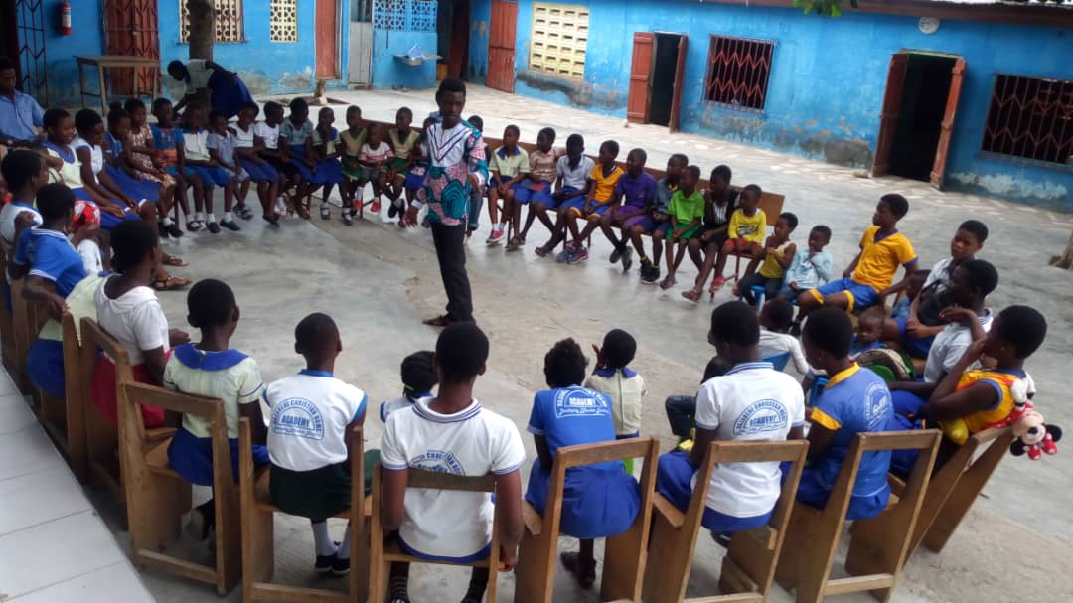
Activity Option 2: Print the included image of the Bible Memory verse in color and cut into several pieces. Or write out the Bible Memory verse on a piece of paper and cut into several pieces. Have the kids assemble the puzzle and then read the verse out loud upon completion.

Tithes and Offerings
God has given us everything we have, and we have the joy of giving back to Him as a way to say thank you. When we give our treasures to God, He uses them in powerful ways—helping share the good news of Jesus here in (insert the name of your town here), in Liberia, and all around the world! Now, let’s take time to collect our tithes and offerings.

Worship Through Song
Consider playing the songs “God Did It” by Micah Tyler and “Three” by Jackson Michelson during worship time. These songs are a great way to help kids connect with God through music and meaningful lyrics.
To make worship more fun and interactive, consider creating simple hand motions or movements for the songs. You can even search YouTube for motion videos to get ideas and inspiration!
Encourage all kids to stand during worship—even if they don’t know the words or aren’t ready to sing. Standing is one way we show honor and respect to our King—God!

Prayer
Let’s pray together. (Option) You can repeat after me:
Dear Jesus,
Thank you for loving us even when we mess up.
Help us say kind words.
Help us love You and take care of Your people.
Thank You for giving us second chances.
We love you, Jesus!
In your name we pray, Amen.

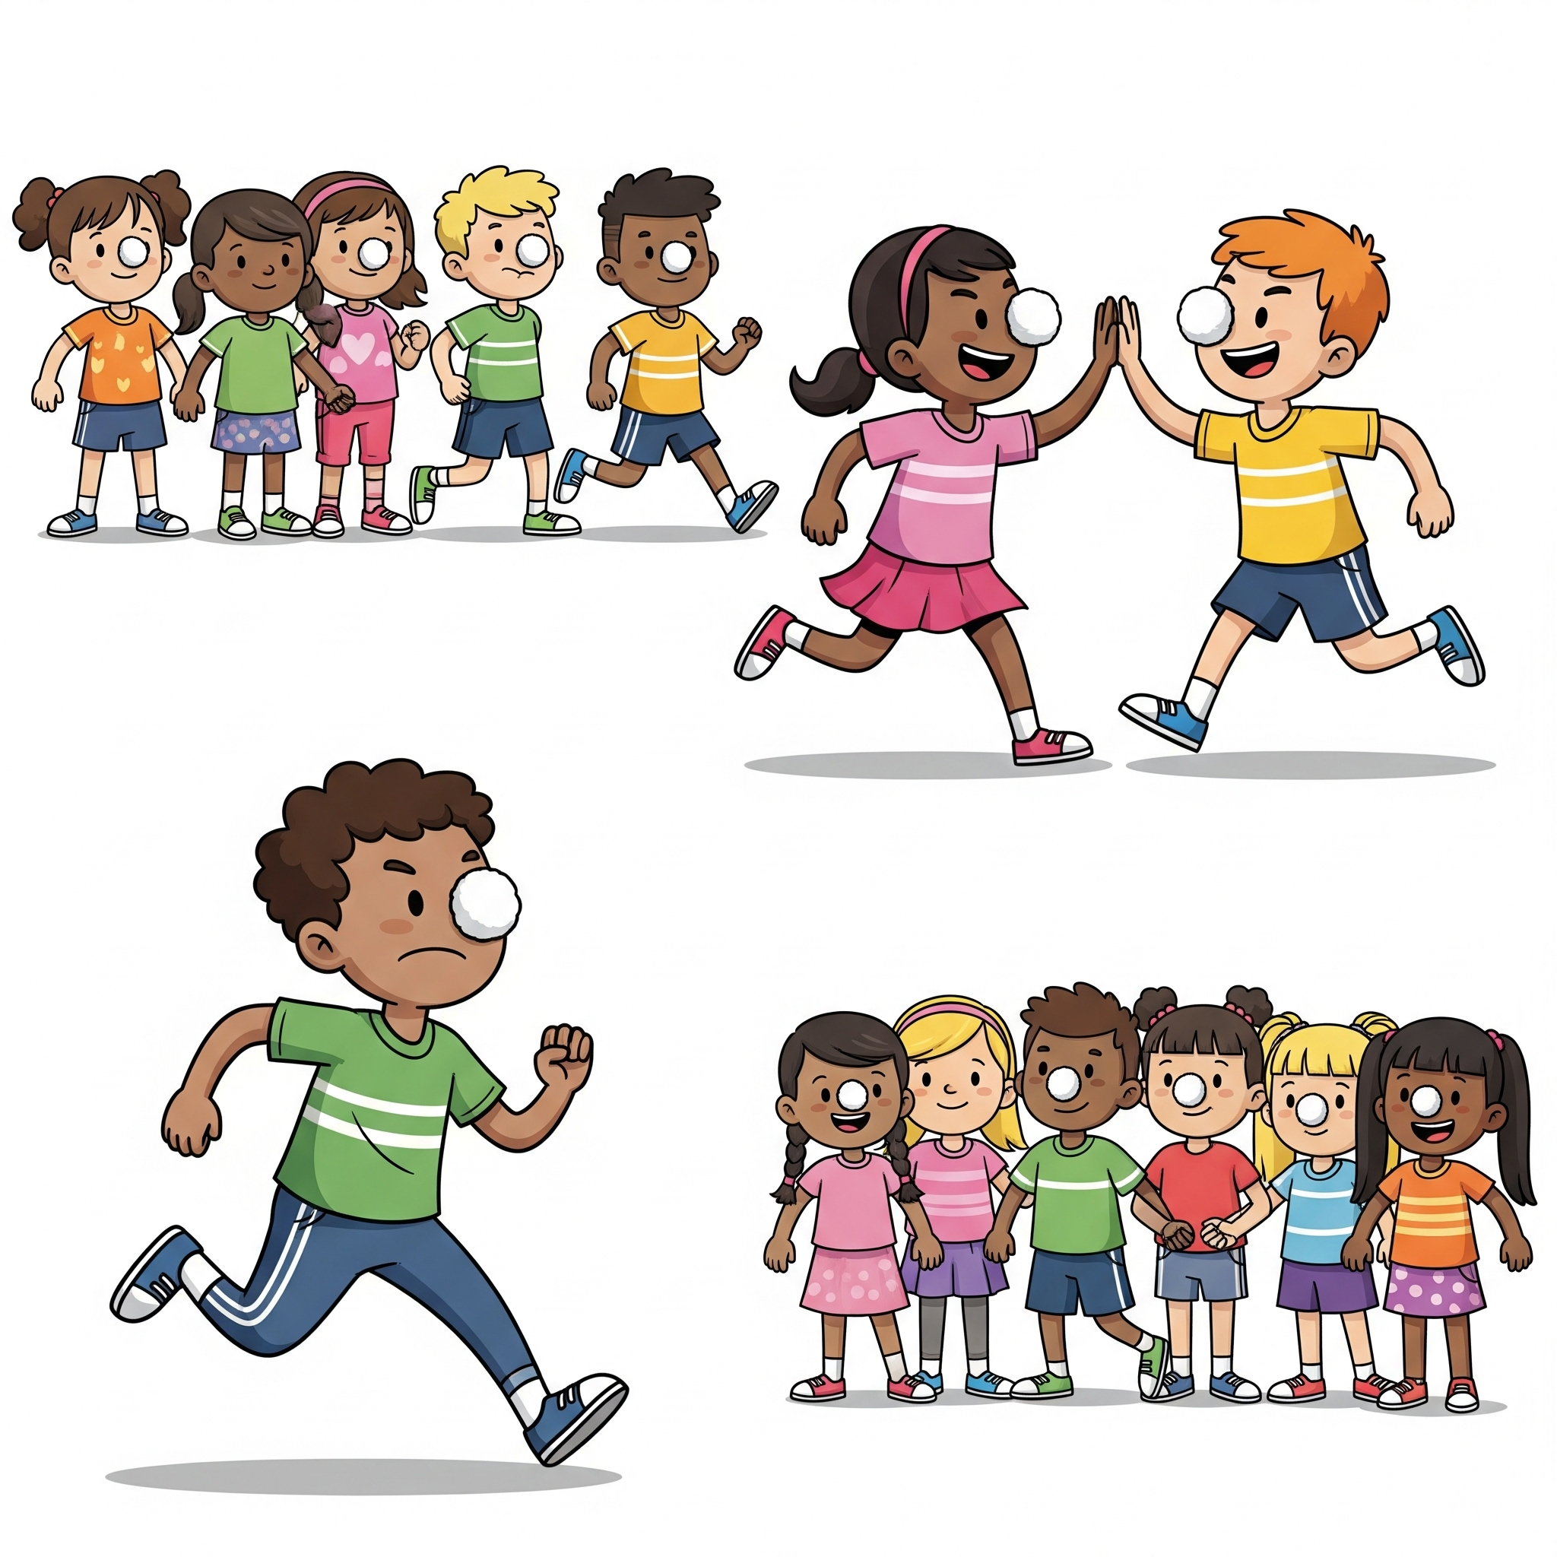
Activity
For Elementary Students – Sheep Relay Activity Instructions
Materials: Vaseline (petroleum jelly), cotton balls, a clear space or hallway for running or crawling
Instructions:
- Divide the kids into two or more teams and have each team line up on one side of the room.
- Give each player a small amount of Vaseline to put on their nose. Give each player a cotton ball — this is their “sheep.”
- When you say “Go!”, the first player must stick the cotton ball to their Vaseline-covered nose and carefully walk or run to the other side of the room without dropping it. Once they reach the other side, they gently remove the cotton ball from their nose and run back to high-five the next player on their team.
- The next player then sticks on the cotton ball on their nose and carries their “sheep” to the other side of the room. Keep going until every player has carried the cotton ball on their nose. The first team to finish the relay with all their players wins!
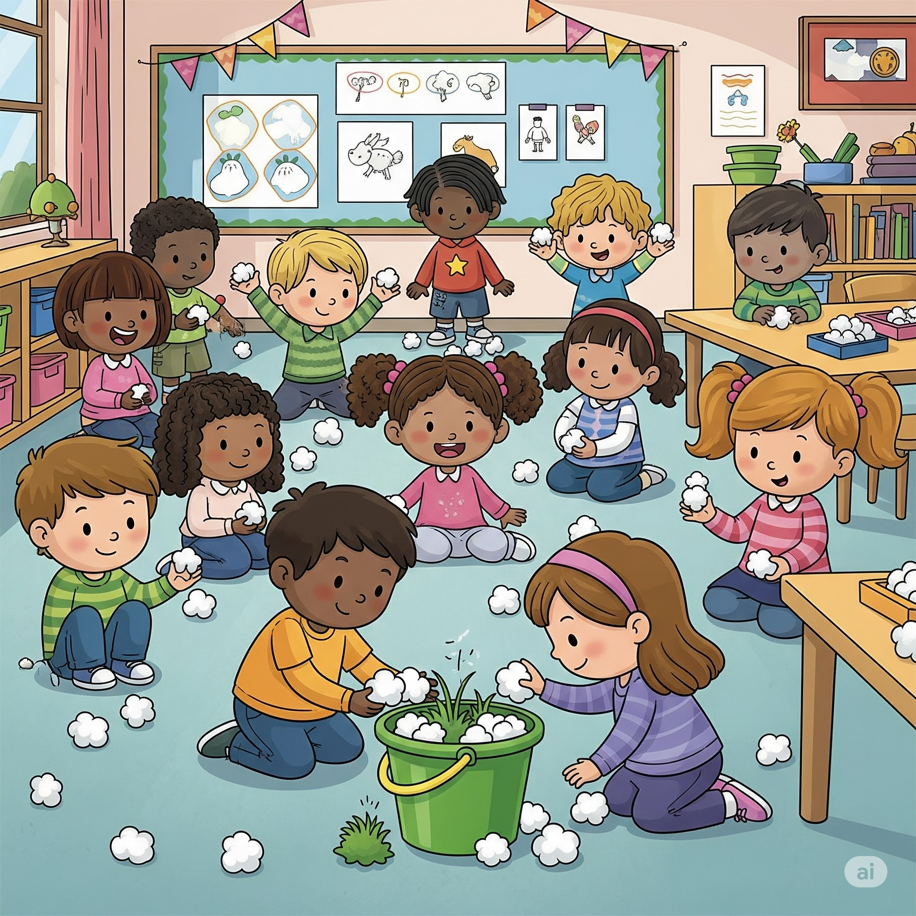
Tips: Remind kids to move carefully so the “sheep” doesn’t fall off! You can make it sillier by having them “baa” like a sheep during their turn!
For Preschool Students – Hide and Sheep
Materials: Cotton balls (these are the “sheep”), green Easter grass, green shredded paper, or a green bucket (to be the “pasture”)
Instructions:
- Before the activity begins, hide the cotton balls (“sheep”) around the room. Make sure some are easy to find and some a little trickier, but all safe for kids to reach.
- Show the children the green pasture (Green Easter grass, shredded paper, or bucket) — explain this is the “pasture” where all the sheep need to go.
- Tell the kids it’s time to find the sheep! Their job is to find as many sheep (cotton balls) as they can and bring them back to the pasture.
- Encourage the kids to keep searching until all the sheep are found and safely returned. Celebrate together once all the sheep are back in the pasture!
Tip: Count how many sheep you hide so you can be sure all are found!

Sermon
Invite elementary-aged students to look up John 21:13-17 in their own Bibles or use the classroom Bibles to follow along as you read the passage together.
Leader: Please stand for the reading of God’s Word.
Leader: Read John 21:13-17 out loud
Leader: This is the Word of the Lord
Congregation: Thanks be to God
Leader: Please be seated.
Today’s story is about Peter. Peter was one of Jesus’ closest friends. But something really sad happened. When Jesus was being taken to the cross, Peter said three times that he didn’t even know Him. Peter was afraid.
Have you ever said something you wish you hadn’t said? (Pause for a few responses.) Me too.
But here’s the amazing thing. After Jesus rose from the dead, He talked to Peter and gave Peter another chance. Jesus didn’t say, “You’re in trouble!” He asked Peter, “Do you love me?” three times. And Peter said yes each time. Then Jesus gave him a job—He told Peter to take care of His sheep. That means: take care of His people!
You know what? Jesus gives us second chances too. And He gives us a job, just like Peter. He wants us to help others know Him and feel His love.
In Africa, there is a country called Liberia. Sarah lives in Liberia. Sarah used to say mean things to people. She often teased others just to irritate and bother them. Sarah was very rude to others.
She even made fun of the people who were setting up for the JESUS film to be shown in her community.
But she still showed up for the JESUS film showing that night. As she watched the story of Jesus, she felt her heart soften when Jesus told his disciples that they had to become like children in order to enter the Kingdom of God. Hearing this, Sarah wanted to change.
Now Sarah uses her words to tell people about God's Kingdom! Just like Peter, she got a second chance. And just like Peter, Sarah is feeding Jesus’ sheep.

Journal

Leader: Peter messed up—but Jesus still loved him and gave him a big job. Sarah messed up–she was rude and mean and unkind. But Jesus still loved Sarah and trusted Sarah to tell others about God’s love. That’s how Jesus loves us too! When we love Jesus, we also take care of His people.
“Jesus asked Peter, ‘Do you love me?’ If Jesus asked you that today, what would you say?
Open your journal to the next blank page. If you’d like, write today’s date at the top.
Now, write or draw a picture of how you can show love to Jesus this week?”
You might draw a picture of feeding sheep, helping a friend, or saying kind words. Or you can write a few sentences if you want.
Take your time—this is your moment to talk with God. Remember, your journal is just between you and Him, and you can share anything with Him.
Afterward, if anyone would like to share what they wrote or drew, you’re welcome to do so.
We’ll keep these journals in our worship space each week. When we are done using them—you can take it home to keep!

Response Activity
Giving Our Sins to Jesus — Tongue Activity
Materials: pink or red construction paper, scissors (adult use or pre-cut tongue shapes), markers, crayons, or pencils, an altar or a cross display area
Instructions:
- Before the activity, cut large tongue shapes out of pink or red construction paper—one for each child.
- Explain that sometimes when we talk, we might say things that aren’t kind or true—like lying, saying mean things, or talking back to parents. These are called sins.
- Give each child a tongue shape and some markers or crayons. Invite each child to write or draw some sins they want to give to Jesus—especially things they’ve done with their words that they want to say sorry for.
- After they finish, the kids come up and place their tongues on the altar or at the foot of the cross. Explain that putting their tongues there means they are giving those sins to Jesus and that He forgives each person because He loves them.
- Close with a short prayer thanking Jesus for forgiveness. (Option: this could be a prayer where the kids repeat after the leader.)
Dear Jesus,
Thank You for loving me,
Even when I say things I shouldn’t.
Please forgive me for the lies,
The mean words, and the times I talk back.
Help me to use my words to be kind and loving.
Thank You for always forgiving me.
I love You.
Amen.

Extra Time Game
Sheep and Wolves Game
Materials: Open space to run safely
How to Play:
- Choose 1 or 2 kids to be the wolves. The rest of the kids are sheep.
- The wolves start in the middle of the play area. The sheep line up on one side of the room or field.
- When you say “Go!”, the sheep try to run across to the other side without being tagged by a wolf. If a wolf tags a sheep, that sheep becomes a wolf too and helps tag other sheep.
- The game continues until all the sheep have been tagged and turned into wolves.
- The last sheep tagged at the end is the winner, or you can start a new round and pick new wolves.

