# **Week 1: Adult Bible Study**

# **Bearing Witness to People Like You**

# **Acts 2:1-41 and Joel 2:12-32**

**Author: *Rev. Bill Kirkemo***

* **Lesson Goals:**
  + **Head:** Celebrate the Holy Spirit’s infilling of Peter. This fulfillment of Jesus’ promise enables Peter to preach a powerful sermon on Pentecost that leads to thousands of people giving their lives to Jesus and being baptized.
  + **Heart:** Recognize whether you have been filled with the Holy Spirit. Is the Spirit of Jesus filling your heart, soul, and strength?
  + **Hands:** Find specific ways to bear witness to God’s great salvation this week. How can you demonstrate the Good News, that everyone who calls on the name of the Lord will be saved, with those who are close to you?
* **Lesson Summary:**
  + The Biblical witness often presents Peter as brash (Matthew 26:31-35), impulsive (Mark 6:45-51), and unable to understand Jesus’ mission on earth (Matthew 16:13-28). This passage, however, shows a much different Peter. After being filled by the Holy Spirit, Peter preaches to the gathered crowd a powerful message about the mission of God to this world, and how that mission was manifest in the life, death, and resurrection of Jesus Christ. Thousands of God-fearing Jews from all over the Roman world, who were in Jerusalem for Pentecost, accepted Peter’s message and were baptized.
* **Text Background:**
  + The Gospels bear witness to many defining events in the life of Peter as he followed Jesus. Probably the most defining event of Peter’s life, prior to Pentecost, was denying he knew Jesus, following Jesus’ arrest. This event, coming after having followed Jesus for three years demonstrates a complete failure of putting into practice all the promises Peter had made to Jesus, and all the teachings Jesus had given while his Rabbi. As Peter denies three times being one of Jesus’ disciples, **Peter is clearly a Failed Disciple**.
  + **Verses 14-15** However, we see a very different Peter from Pentecost onwards. This Holy Spirit-filled Peter is still brash, impulsive, and does not always fully understand Jesus’ mission on earth (we’ll see an example of this in two weeks in relation to Cornelius). However, change has happened in Peter’s heart, soul, mind, and strength. He is no longer a Peter-dominated person trying to understand Jesus. He is now a Holy Spirit-dominated person living out God’s will in his life. **Peter can now be defined as a Faithful Witness**.
  + **Verses 16-36** In the sermon Peter preaches, he refers to several Old Testament texts to explain to the crowd that Jesus’ death and resurrection were not contrary to what the Old Testament taught about the promised Messiah but were in fact fulfillments of the Old Testament prophecies. In particular, he quotes the prophet Joel, who prophecies about this very day on which Peter is preaching, the Day of the Lord on which the Holy Spirit would be poured out on all people. This “Day of the Lord,” of course was not just this one Pentecost, but began on this Pentecost, as the Holy Spirit will now go out through these new believers back to their homes, towns, and countries to continue his ministry there.
  + **Verses 37-41** The results of Peter’s filling with the Holy Spirit and his preaching are amazing. Three thousand in the crowd give their lives to Jesus and are baptized. The Church, the fellowship of followers of Jesus Christ, is born this Pentecost day from these three thousand, and the others who had already been filled with the Holy Spirit. We today, as the current-day Church, are called to continue Jesus’ ministry, to continue Peter’s preaching, to continue the work of the Holy Spirit in and through our lives, ministries, worship services, and outreach to those around the world who do not yet know Jesus Christ as their Lord and Savior.
* **Bible Study Outline**

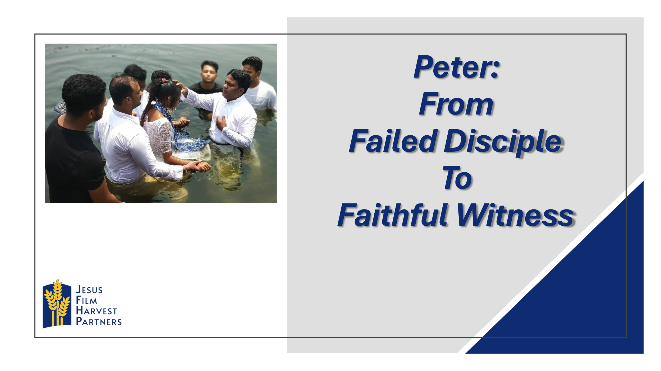

* + **Pray**
    - Ask for prayer requests and praises.
    - Thank God for the praises shared.
    - Pray for the prayer requests.
    - Ask the Holy Spirit to open your hearts and minds to receive with joy what God has to share with you today.
  + **Hear**
    - Read both Bible Lesson texts.
    - Summarize the “Text Context” from above for the class.
    - Read both Bible lesson texts again.
    - Have someone retell the main Bible text.
  + **Testimony of a Life Transformation**

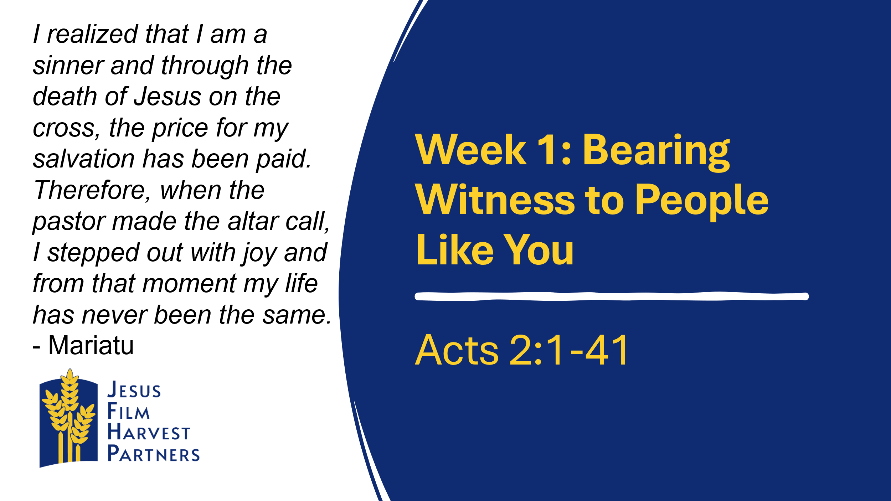

* + - **Country: Sierra Leone** My name is Mariatu, and I am twenty years of age. I am from an animist family background. My father is an herbalist, and he uses charms and amulets to heal sick people and provide spiritual help. I heard about the *JESUS* film through the announcement in my community. It was my first time watching it and it touched me deeply. It caught my attention because it was in my local language, and I’ve never watched a film in my local language before. I was amazed by the many miracles that Jesus performed. I’ve never seen anything like that before. I saw Him raise the dead, heal the sick, make the blind to see and it made me want to know more of him. My thirst to know about Jesus led me to attend the rest of the other two days with an expectant heart. The film helped me to understand that Jesus died on the cross for my salvation. I realized that I am a sinner and through the death of Jesus on the cross, the price for my salvation has been paid. Therefore, when the pastor made the altar call, I stepped out with joy and from that moment my life has never been the same. Please keep me in your prayers because this is a very important decision in my life. I know my father will not be happy and he will want to discourage me. I keep trusting the Lord to see me through my new journey of faith and for me to stand firm and continue to serve the Lord.
      * Mariatu said the *JESUS* film caught his attention because it was the first film he had ever seen with the dialogue in his native tongue. Why do you think it is significant to hear the Gospel in your own native language, instead of through a translator?
      * Do you think it is harder to share the Gospel with someone you know well, or with a stranger? Why?
  + **Share**



* + - **Head:** **What Does the Text Mean?** Peter can only be transformed from a Failed Disciple to a Faithful Witness through the infilling of the Holy Spirit. God’s plans for us are never to leave us as repenting sinners, but to empower us to be Jesus’ faithful witnesses in our communities and around the world.
      * Who are some people you know who need a life-change they can only receive from God? What do you think would have to happen for them to be open to God’s work in their lives?
      * Who are some spiritual mentors who have been instrumental in helping you know Jesus better, and helped you understand his plans for your life?



* + - **Heart****: Who Does the Text Say We Should Be?** Though Peter was a Failed Disciple, God restores his heart, soul, mind, and strength through the infilling of the Holy Spirit. Instead of living a life of struggle between trying to live for Christ and yet always bound to sin, Peter was able to begin to live wholly for Jesus.
      * In what ways, like Peter, has Jesus transformed your life from human brokenness to spiritual strength?
      * What damage results when a Christian will not surrender their life fully to Jesus Christ? How does this affect their ability to be a faithful witness to God’s mighty power and salvation?



* + - **Hands****: How Can We Put the Word of God into Action?** The Holy Spirit’s filling of the Christian is not to be a one-time event, but a daily reality. When the Christian lives out of God’s power instead of their own power, they bear witness to the work of the Holy Spirit in their lives.
      * Name some specific people in your life – at school, work, home, etc. – who need a spiritual revival. Name some specific actions you can take this week to be a blessing to these people.
      * If you have never been filled with the Holy Spirit, reach out to a trusted Christian friend or pastor who can share with you the blessings that come from being filled.
  + **Testimony of a Life Transformation**

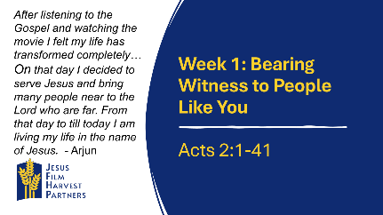

* + - **Region: South Asia** Greetings in the name of our Lord Jesus Christ on the behalf of our team members. My name is Arjun and I am 37 years old. I would like to share my testimony that before accepting Jesus in my life, I was far from Jesus and His identity. I was trapped by Satan. I was living my life just as a nominal Christian. I was not living according to the Bible. I was spending my life as I wanted. One day, a JFHP Team came into my village to preach the holy Gospel and present the *JESUS* film. After listening to the Gospel and watching the movie I felt my life has transformed completely. I felt changed spiritually. On that day I decided to serve Jesus and bring many people near to the Lord who are far. From that day to till today I am living my life in the name of Jesus. Many people are receiving the blessing of God by my sharing the Word of God. Now, I am very happy after receiving the love and joy of the Lord in my life. I truly want to spend my life in Jesus with my whole family. I am thankful to the JFHP team members who are doing this wonderful ministry, and I pray that God will help them to spread the Gospel.
      * What is the danger of living a “nominal Christian” life like Arjun had for so many years?
      * What kind of change do you think Arjun’s family members saw in him after his experience at the *Jesus* Film showing?
  + **Apply**

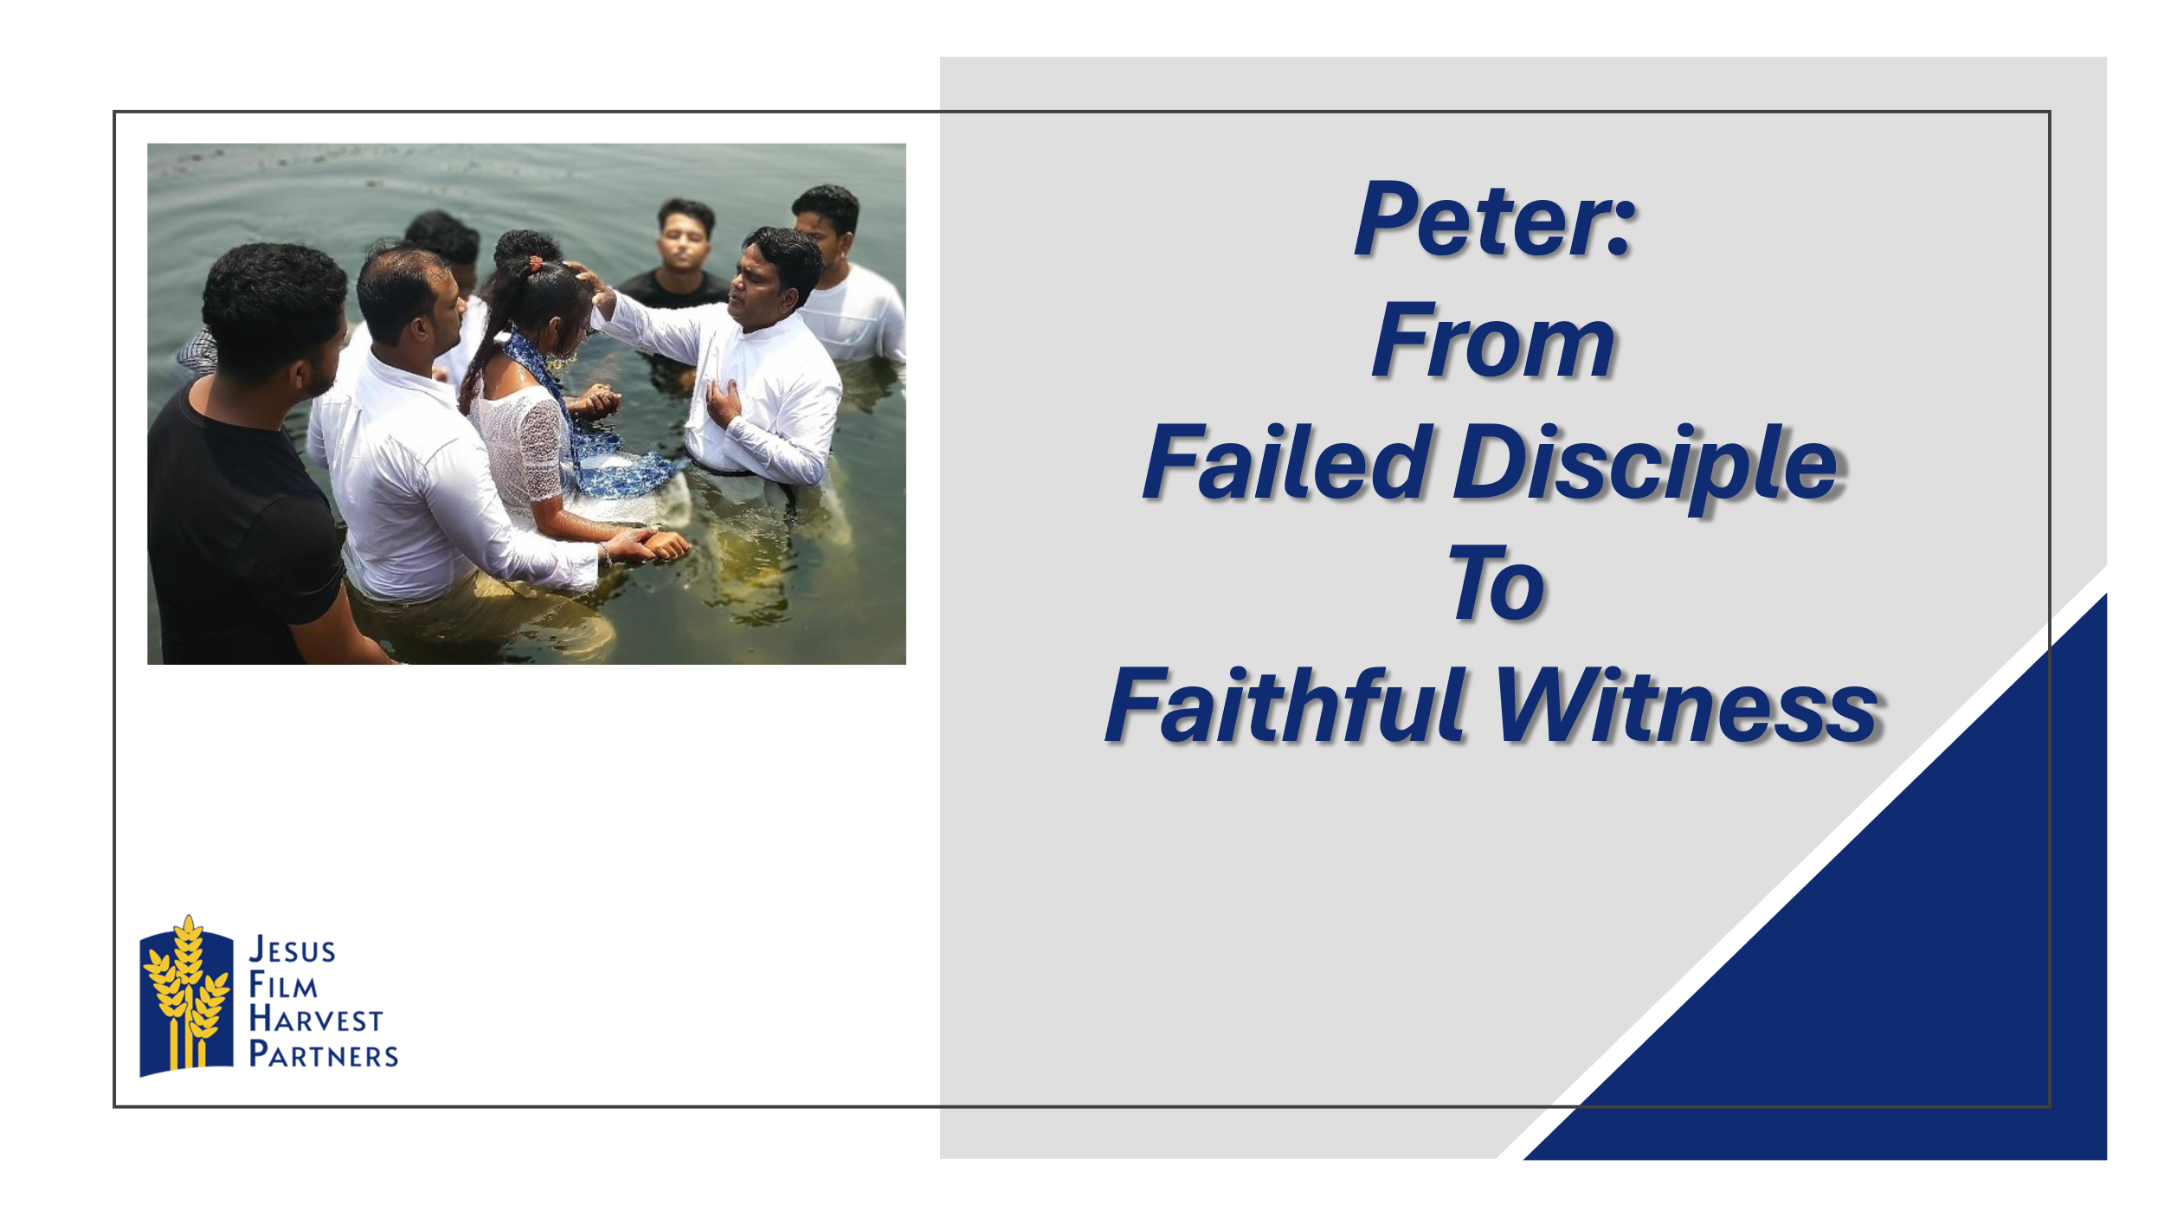

* + - Ask someone to retell the main Bible lesson text again.
    - Ask the group to share how they think God wants them to respond to today’s lesson.
    - Spend time in prayer for your community, one another, and for wisdom in living out today’s lesson.
    - Close by having the group pray together the Lord’s Prayer.