**2: Adult Bible Study**

# **Bearing Witness to People Who Are Against You**

# **Acts 5:12-32**

**Author: *Rev. Bill Kirkemo***

* **Lesson Goals:**
  + **Head:** Understand why some people are opposed to the Gospel of Jesus Christ.
  + **Heart:** Reflect on the truth that repentance is necessary to enjoy the peace and joy of the Gospel of Jesus Christ.
  + **Hands:** Strategize how you can effectively share the Gospel in word and action with others, especially those who are against the Gospel message.
* **Lesson Summary:**
  + Following Pentecost, Jesus’s followers enjoyed fellowship with each other, the favor of the people of Jerusalem (Acts 2:42-47), and continued to witness God’s miraculous healing power at work (Acts 5:12-16). However, they also began to face resistance from the Jewish religious leaders. In this lesson’s scripture passage the religious leaders arrest the Apostles hoping to intimidate them into abandoning their preaching of a resurrected Jesus and their miracle working. Once again, though, Peter speaks up and boldly proclaims that regardless of any threats the religious leaders may make, the followers of Jesus must follow God’s call upon their lives.
* **Text Background:**
  + **Verses 12-18** Prior to His death Jesus made clear that if the Disciples will trust Him and receive the Holy Spirit, they will continue His ministry on this earth (John 14:12-21) after He returns to Heaven. The book of Acts bears witness to the truth of Jesus’ words, as it reports the ministry of the Apostles continues Jesus’ ministry of teaching, compassion, and healing. And just as these acts of Jesus caused opposition with the religious leaders during His earthly ministry, so also the Apostles face opposition from the same religious leaders.
  + **Verses 19-20** God will not allow the Gospel to be held captive and sends an angel to open the doors of the jail. The angel then gives the freed Apostles the mandate to return to the temple courts (where they had just been arrested) and proclaim the Gospel of Jesus Christ (“this new life”).
  + **Verses 21-28** As the religious leaders gather the next day to use their power and position to threaten the Apostles into silence, they are told the Apostles are no longer in the jail cells. Not only have they escaped, but a witness reports they are back in the temple courts once again teaching the people. The religious leaders send for the Apostles to stand before them. Here is an almost comical contrast – the religious leaders of the people are too afraid of the people to now force the Apostles to stand before them. However, the Apostles are boldly teaching the people.
  + **Verses 29-32** While the religious leaders threaten the Apostles, trying to force their silence about Jesus, Peter speaks up and defiantly declares their ultimate responsibility to obey God rather than human leaders. This is a much different Peter now confronting the High Priest than the Peter who cowered in the courtyard of the High Priest, denying he was a friend of Jesus (Mark 14:66-72). In his message to the religious authorities, Peter boldly proclaims the authorities’ guilt for having Jesus killed. He also declared God’s raising Jesus from the dead, the need for repentance for the forgiveness of sins, and the presence of the Holy Spirit in the lives of God’s people. This outline of the Gospel of Jesus Christ was boldly proclaimed in the face of persecution.
* **Bible Study Outline:**

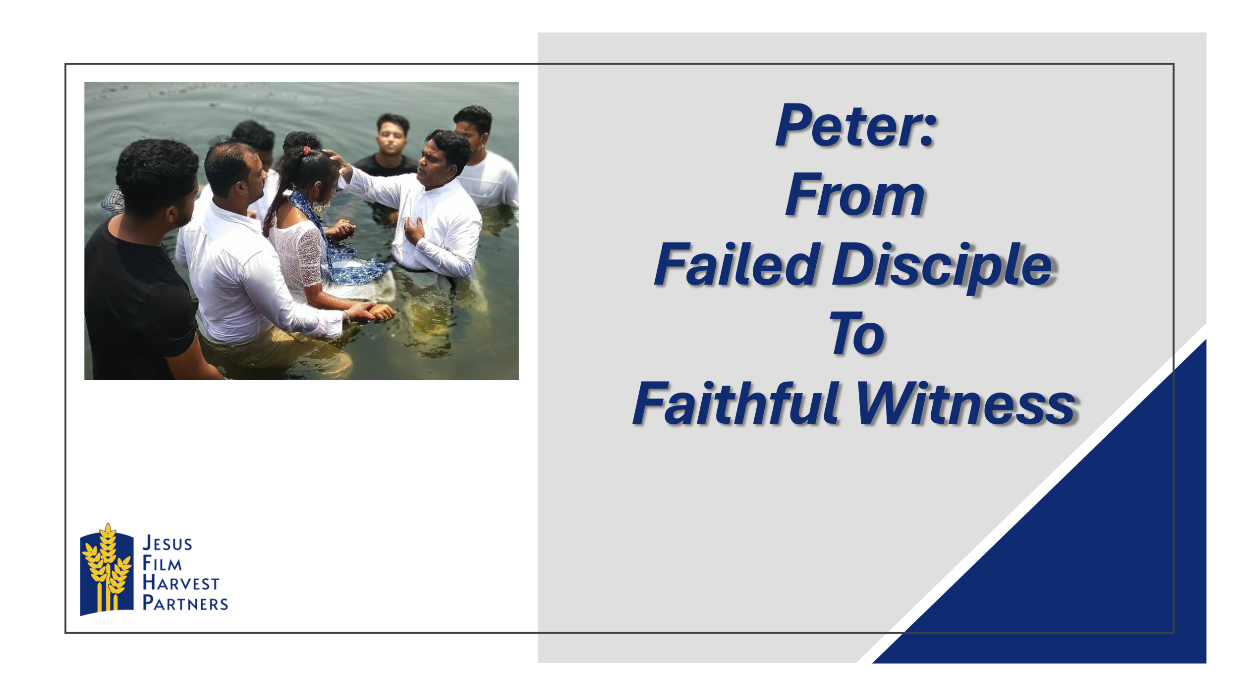

* + **Pray**
    - Ask for prayer requests and praises.
    - Thank God for the praises shared.
    - Pray for the prayer requests.
    - Ask the Holy Spirit to open your hearts and minds to receive with joy what God has to share with you today.
  + **Hear**
    - Read both Bible Lesson texts.
    - Summarize the “Text Context” from above for the class.
    - Read both Bible lesson texts again.
    - Have someone retell the main Bible text.
  + **Testimony of a Life Transformation**

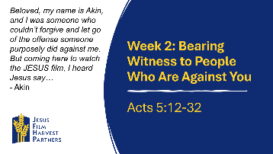

* + - **Country: Nigeria** Beloved, my name is Akin, and I was someone who couldn’t forgive and let go of the offense someone purposely did against me. For example, there's a case now in a court in which I purposely wanted to pay him back for what his father did to my father which eventually caused my father's death. But coming here to watch the *JESUS* film, I heard Jesus say, "But I tell you who hear me: Love your enemies, do good to those who hate you, bless those who curse you, pray for those who mistreat you". My brethren, when I heard that I cried uncontrollably and decided to have a change of mind and live for Christ forever. That's why I am praying for forgiveness because the person is no longer my enemy but rather my good friend and I promise to withdraw the case from court and settle the matter between me and him and pay him back for all what he spent because of the matter because he is my brother. Thank you, Jesus, for opening my eyes to see you, Hallelujah.
      * There is often a cost to bearing witness to your faith, whether you are bearing witness with your work or actions. Why do you think Akin did not consider dropping the court case against his former enemy too high a price to pay?
      * How can treating people who are against you with kindness and respect help further Jesus’ work in your life, and in their lives as well?
  + **Share**

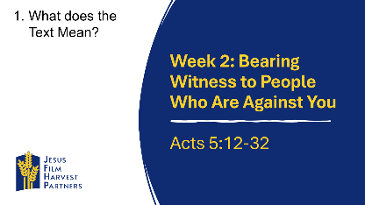

* + - **Head: What Does the Text Mean?** One of the characteristics of the transformed Peter after Pentecost is his bold proclamation of the Gospel of Jesus Christ amid persecution. While the Gospel is Good News, it is not always received that way. The religious authorities were threatened by the popularity of the Apostles.
      * What are some reasons why people today are hostile to the Good News of the Gospel?
      * How can you determine how to bear witness to Jesus Christ in a relationship marked by tension and disrespect?

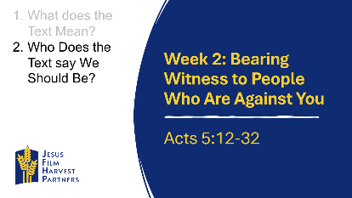

* + - **Heart: Who Does the Text Say We Should Be?** Being a Christian is not simply believing Jesus died, but that Jesus died for our sins. As Peter says, Jesus came to call people to repentance and forgiveness.
      * What differences would you expect to see between a Christian who has repented of their sins and a non-Christian who rejects Jesus when both are faced with a hostile person?
      * How does repenting of sins bring joy, peace, and boldness into the life of Christians?

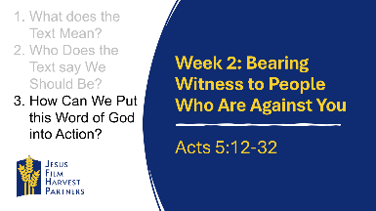

* + - **Hands: How Can We Put the Word of God into Action?** Peter was confrontational in his response to the religious authorities, but he was not disrespectful or hostile. There is sometimes a tough balance between boldly bearing witness to the Gospel of Jesus Christ and humbly bearing witness amid opposition.
      * Many people reject Jesus Christ because they have been hurt by Christians. How can you live this week to offer a more authentic Christian witness than others may have previously experienced or witnessed?
      * Like Peter’s brief Gospel presentation in our passage, spend time this week developing your own 4-5 sentence summary of the Good News that you can share with others.
  + **Testimony of a Life Transformation**

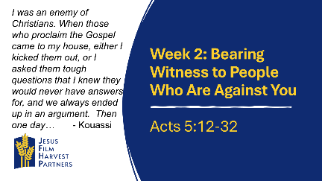

* + - **Country: Cote d'Ivoire** My name is Kouassi and I am a high school Math teacher. I was an enemy of Christians. When those who proclaim the Gospel came to my house, either I kicked them out, or I asked them tough questions that I knew they would never have answers for, and we always ended up in an argument. Then one day God caught hold of me, and scales fell from my eyes. I understood that when Jesus visits you, it is the light that shines on you, and you understand the things of God. I will now be a defender of the Gospel. I know that I will be attacked a lot, but I am with Jesus Christ and His servants will pray for me. Thank you, Lord, for your grace
      * From your experience, what could have been some reasons why Kouassi was so hostile to Christians who came to his house to witness to him?
      * What are the benefits and dangers of trying to debate with a non-Christians, trying to prove Christianity is true and that the non-Christian is wrong?
  + **Apply**



* + - Ask someone to retell the main Bible lesson text again.
    - Ask the group to share how they think God wants them to respond to today’s lesson.
    - Spend time in prayer for your community, one another, and for wisdom in living out today’s lesson.
    - Close by having the group pray together the Lord’s Prayer.