**3: Adult Bible Study**

# **Bearing Witness to People Who Are NOT Like You**

# **Acts 10**

**Author: *Rev. Bill Kirkemo***

* **Lesson Goals:**
  + **Head:** While our hearts may be pure because of God’s forgiveness, we will not always know all there is to know about God and His love and compassion for others.
  + **Heart:** While our hearts may be pure because of God’s forgiveness, we will always have more grace and love to experience in our relationship with God and with others.
  + **Hands:** Being able to reach out and find commonalities amid our differences is an essential part of being an effective and authentic witness of the Gospel of Jesus Christ.
* **Lesson Summary:**
  + Does the Chrisitan Gospel extend beyond Jews? To what extent are Jewish Christians supposed to look at Gentiles differently because of Jesus? We assume quick and easy answers to these questions today, but the answers were not quick or easy in the first century. This passage records God’s revelation to Peter the fact that the Gospel was for all people, not just for the Jews. We may think it is odd Peter did not already understand this, but in Peter’s time and place, the Jews understood the promised Messiah would be a Jew to help save Jews from the Gentiles (a Gentile is simply anyone who is not a Jew). Although Jesus had healed, taught, and saved many non-Jews during his ministry, it appears Peter had understood those times to be exceptions to the rule of Jewish preference by God, not the rule. Now, as we hear in Acts 10, God has made clear to Peter there is no divine preference, all are invited to enjoy the salvation bought by the blood of Jesus Christ.
* **Text Background:**
  + **Verses 1-8** Cornelius was aRoman commander, overseeing 100 men. However, he was also a Gentile with great respect for the Jewish God and modeled his life after the Jewish expectations of piety: he was devout, a God fearer, generous, and prayed regularly. In a vision he saw an angel who told him he pleased God, and he was to send for Peter.
  + **Verses 9-16** Peter also had a vision. However, in Peter’s vision he was called to kill and eat animals lowered from heaven in a sheet. Peter had a problem, however. Some of the animals were forbidden by Jewish cultic law to be eaten by any Jews. They were seen as impure and unclean. And so, Peter refuses the command of God. In this sense, (at least in his dreams) Peter is still the brash, impulsive and stubborn person he has always been.
  + **Verses 15-23** God, however, reveals to Peter the truth that nothing God makes is impure or unclean. This revelation would have been shocking to Peter. These events then happen two more times, with both the same call and the same response by Peter, and the same revelation by God. The vision ends with God revealing to Peter messengers were coming for him, and he needed to travel with them.
  + **Verses 24-33** Peter was probably still confused and troubled by his vision; however, he obeys God’s command. He goes to this Gentile Roman’s home. It was one thing for Peter to obey God and go with these envoys. However, for Peter to enter the house of a Roman soldier is even more shocking. However, Peter has learned to obey God’s command, regardless. As he enters the house and asks why he was called, Cornelius reveals he was at prayer (at about the same time Peter had his vision) and was commanded by God to send for Peter.
  + **Verses 34-43** In response Peter gives an extended speech, the fourth one so far in the book of Acts. In this message Peter outlines his change of thinking about the relationship of Jesus’ Gospel with the Gentiles. He now recognizes Jesus’ death and resurrection does not just bring salvation to Jews who repent, but also Gentiles.
  + **Verses 44-48** And just as on the Day of Pentecost, The Holy Spirit came upon the listeners with great power. Peter calls upon them to be baptized.
* **Bible Study Outline:**

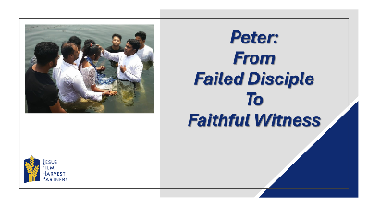

* + **Pray**
    - Ask for prayer requests and praises.
    - Thank God for the praises shared.
    - Pray for the prayer requests.
    - Ask the Holy Spirit to open your hearts and minds to receive with joy what God has to share with you today.
  + **Hear**
    - Read both Bible Lesson texts.
    - Summarize the “Text Context” from above for the class.
    - Read both Bible lesson texts again.
    - Have someone retell the main Bible text.
  + **Testimony of a Life Transformation**

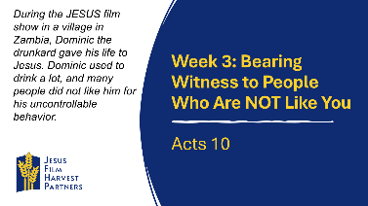

* + - **Country: Zambia** During the *JESUS* film show in a village in Zambia, Dominic the drunkard gave his life to Jesus. Dominic used to drink a lot, and many people did not like him for his uncontrollable behavior. When he heard about the *JESUS* film show in the area, he came with his friends to watch the show. After watching the film and hearing the message of how Jesus suffered for the salvation of all people, he couldn’t resist going forward during the altar call. The following day, he came to attend follow-up lessons, and he testified how his life before giving his heart to Jesus was total darkness. He was so grateful to the team for bringing the *JESUS* film to his village. Pray for the Lord to give us more harvest of souls as we match and plunder the enemy’s territory.
      * How uncomfortable would it be for you to witness to someone like Dominic before he became a Christians – someone who was a drunkard and whose life was out of control?
      * What are ways we can both protect ourselves from getting caught up in sin, and yet still reach out to those who are enveloped in sin?
  + **Share**

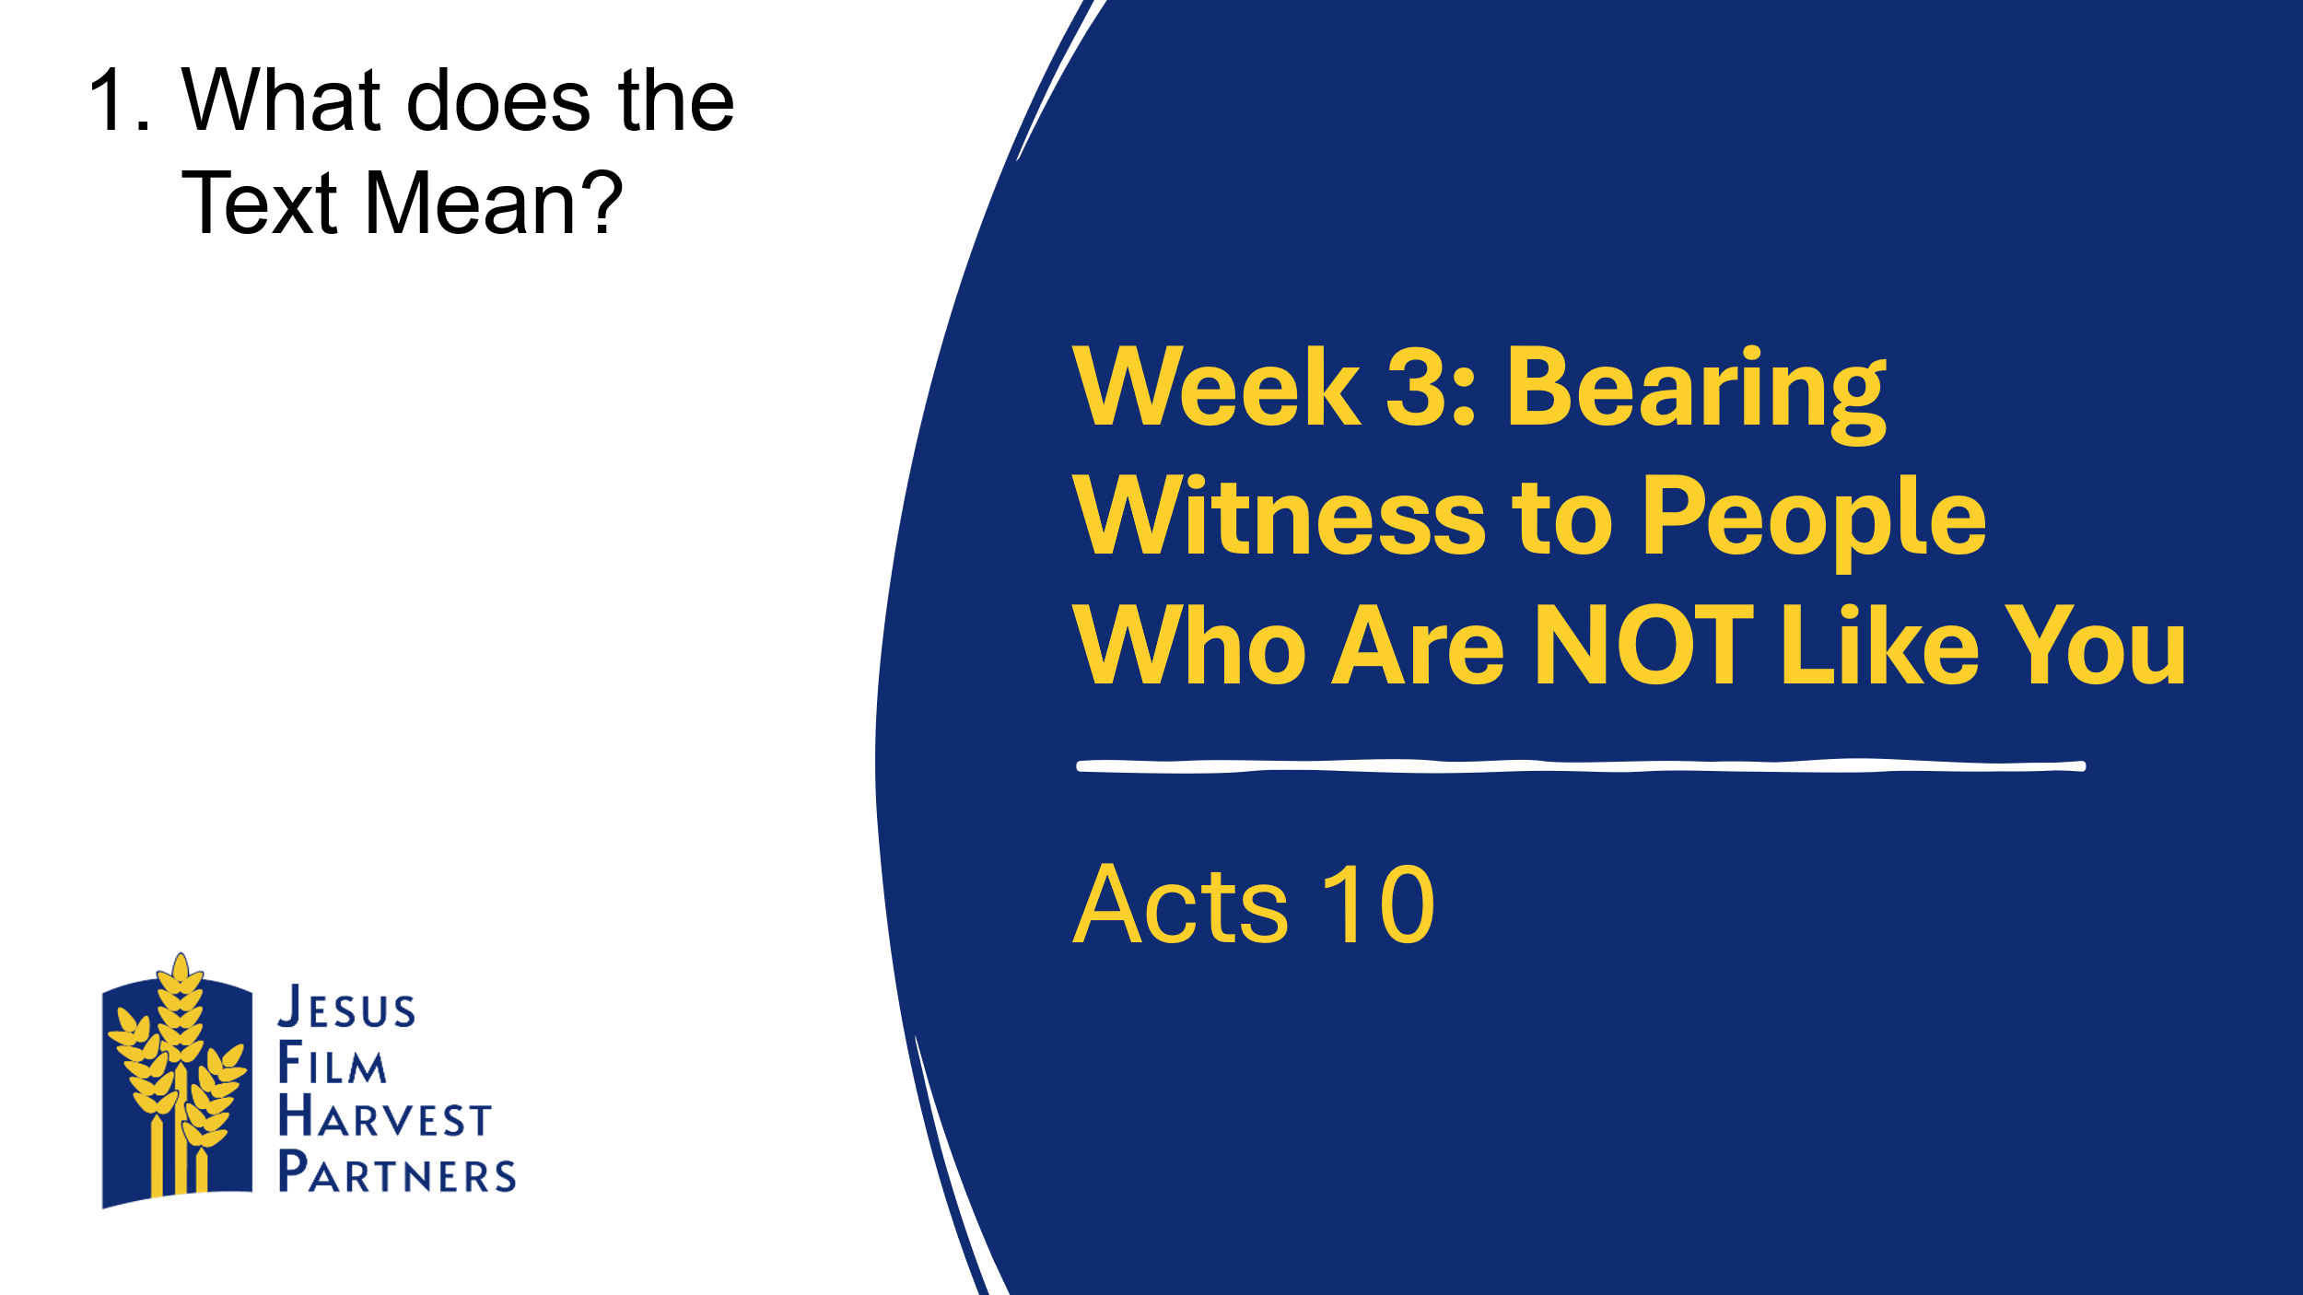

* + - **Head:** **What Does the Text Mean?** Though Peter and the crowd on Pentecost were filled with the Holy Spirit, they did not understand everything there was to understand about the Gospel. Growth in grace, as well as the knowledge of the extent of God’s salvation, was ongoing for Peter and the others.
      * Are there any people whom you assume are not interested in God’s grace or forgiveness? Any co-workers or neighbors who you just assume have no interest in finding peace with God?
      * Besides visions, like Peter and Cornelius had, what are other ways in which God usually communicates significant spiritual truths to His children today?



* + - **Heart:** **Who Does the Text Say We Should Be?** There is a difference between purity of heart and Christian maturity. Purity of heart comes in an instant at the infilling of the Holy Spirit, but maturity comes over a lifetime of learning how to live out the Christian life.
      * What mistakes might we expect from someone who is pure of heart but still immature in their Christian faith?
      * How does Acts 10 show us a Peter who is pure in heart but not yet a fully mature Christian?



* + - **Hands:** **How Can We Put the Word of God into Action?** In 1 Samuel 15:22, we hear “to obey is better than sacrifice.” In other words, obedience to God is better than simply going through the motions with our religious faith.
      * What are some ways we can overcome social and racial differences with others that can hinder our ability to witness to them about Jesus Christ?
      * How can you reach out to someone who is different from you this week and share your testimony?
  + **Testimony of a Life Transformation**

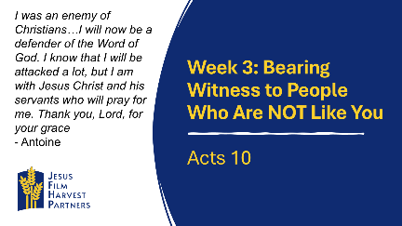

**Country: Cote d’Ivoire** My name is Antoine, and I teach high school Math. I was an enemy of Christians. When those who proclaim the Gospel would come knocking at my house, either I would outright reject them, or I would pepper them with really difficult and obscure questions they could not answer. This usually resulted in arguing, and we would both be very upset when we parted. However, one day God caught hold of me, and scales fell from my eyes. I understood that when Jesus visits you, it is the light that shines on you, and you understand the things of God. I will now be a defender of the Word of God. I know that I will be attacked a lot, but I am with Jesus Christ and his servants who will pray for me. Thank you, Lord, for your grace

* + - * Antoine was an abrasive person, and both knew it and embraced it. How would you have felt knocking at his door in order to witness to him about Jesus?
      * What are some commonalities we all share with each other, regardless of our race, nationality, or personality? How can those help us bridge our differences?
  + **Apply**

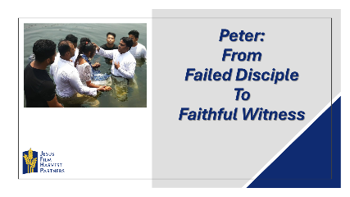

* + - Ask someone to retell the main Bible lesson text again.
    - Ask the group to share how they think God wants them to respond to today’s lesson.
    - Spend time in prayer for your community, one another, and for wisdom in living out today’s lesson.
    - Close by having the group pray together the Lord’s Prayer.