**4: Adult Bible Study**

# **Bearing Witness to People Who Are Suffering**

# **1 Peter 4:7-19**

**Author: *Rev. Bill Kirkemo***

* **Lesson Goals:**
  + **Head:** Understand while suffering is part of living in this world, Jesus calls us to keep our suffering in perspective with His suffering as well as our mission to this world.
  + **Heart:** Make us aware of the different types of suffering people are enduring around us and help us know how to take steps to help alleviate that suffering.
  + **Hands:** Prayerfully ask God to put us in times and places where we can help people who are suffering.
* **Lesson Summary:**
  + On the night in which He was betrayed, Jesus told His disciple, “In this world you will have trouble.” (John 16:33) The disciples would soon come to know deep trouble as Jesus was arrested, tortured, and crucified. However, Jesus did not just say they would have trouble, He also told them immediately after this, “But take heart! I have overcome this world.” Yes, the disciples would face suffering, but suffering is not the end of the story. The reality is, what a person believes about the future determines how they will live in the present.As Christians, we will face suffering, and we will interact with those who face suffering, both deserved and undeserved. How should we respond? In this lesson we will read Peter’s writing to Christians who are suffering for their faith, and we will find guidance on how we view the future and how we might help others who are suffering find hope and healing in Jesus.
* **Text Background:**
  + When talking about suffering, it is essential to outline there are at least three different types of suffering.
    - First, there is suffering that is the consequence of our poor decisions and/or actions (for example, getting caught cheating on your spouse). That is not the type of suffering this passage explores.
    - There is a second type of suffering, the suffering that may come to a person simply because they are living in this fallen world (for example, having your house burn down because it was struck by lightning). Again, this is not the type of suffering this passage explores.
    - This passage explores directly a third type of suffering, suffering Christians face because of their faith and trust in Jesus Christ (for example, losing your job because your faith would not allow you to break the law that your boss was demanding you to do). This suffering can come in the form of persecution, of being taken advantage of, etc. Peter encourages these persecuted Christians to remain steadfast in their faith, and to keep eternity in perspective when enduring suffering, in whatever form it takes.
  + **Verses 7-11** Peter likely writes this letter of 1 Peter near his death. In it, we do not hear the brash, impulsive young man we have in the Acts passages we have studied. In this letter we hear a Peter who is more reflective on the Christian life and the way Christians are to live in anticipation of Christ’s return.
  + **Verses 12-15** The ultimate danger for Christians facing persecution for their faith is that they will turn away from Christ and embrace an easier life of compromise. We must admit, when you are in the throes of suffering, this can be a very attractive option. It is likely many Christians in Peter’s day have embraced this option, to the detriment of their souls. Also, to encourage these suffering Christians to remain true to Christ, Peter reminds them that when they suffer because of their faith, they are not just suffering fruitlessly. They are actually participating in the sufferings of Christ (4:13).
  + **Verses 16-19** To encourage these Christians to remain true to Christ, Peter reminds them that this life is not all that there is to their existence. Eternity is on the horizon, and they should live their lives in light of that reality (4:7). If they keep the reality of eternity before them, then they will live their lives with the priorities of prayer, love, hospitality, and putting into practice the spiritual gifts Christ has given to them.
* **Bible Study Outline:**

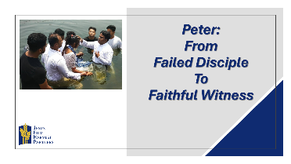

* + **Pray**
    - Ask for prayer requests and praises.
    - Thank God for the praises shared.
    - Pray for the prayer requests.
    - Ask the Holy Spirit to open your hearts and minds to receive with joy what God has to share with you today.
  + **Hear**
    - Read both Bible Lesson texts.
    - Summarize the “Text Context” from above for the class.
    - Read both Bible lesson texts again.
    - Have someone retell the main Bible text.
  + **Testimony of a Life Transformation**

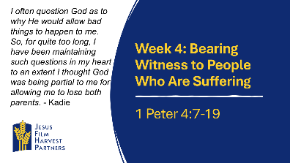

* + - **Country: Sierra Leone** I am Kadie, and I am 28 years of age. I was invited to the *JESUS* film by one of the team members. I was partially raised by a single parent. I lost my mother just after giving birth to me, and some years after that I lost my father too owing to some severe health condition. So, ever since then I have sadly been living without them. I often question God as to why He would allow bad things to happen to me. So, for quite too long, I have been maintaining such questions in my heart to an extent I thought God was being partial to me for allowing me to lose both parents. However, as I watched the film, I learnt that God is a good God, and He wants all the best for us. I also learned He wants us to be saved from sin and from all the works of the enemy in our lives. I realized that I need to turn from my ungodly lifestyle and serve the one and true God who has sent His son Jesus to die for me and the rest of humanity. Discovering God’s love for me through the film gave me a different perspective of life. When the pastor made the altar call, I stepped out and surrendered my life to Christ. Since that moment, I have a strong assurance of God’s love for me, and it has changed my life and thoughts drastically. Please keep me in your prayers so I will continue to grow in God’s love and my understanding of Him. Also pray that my life and testimony will minister to my friends and family, and they will also surrender their lives to Christ.
      * How do you think God will use Kadie’s suffering to help others who are struggling with suffering?
      * It is important to remember that often there is no easy answer to why suffering happens in our lives. With this understood, how can you minister, in practical ways, to people who are suffering?
  + **Share**

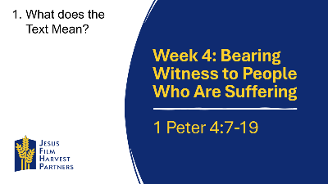

* + - **Head: What Does the Text Mean?** Suffering comes in many shapes and sizes. It also comes for many reasons (see the three different types of suffering outlined above). After identifying why we are suffering, regardless of the reason, we must always keep our eyes on Jesus and let His strength and wisdom be our guide through the suffering.
      * Give examples of ways in which you have faced suffering, either because you were a Christian, or because you simply live in this fallen world.
      * Should the reason why someone is suffering affect the way we reach out to them with compassion and love?



* + - **Heart: Who Does the Text Say We Should Be?** Because “the end of all things is near,” we must live our lives on earth in light of our eternal home in glory. This can be easy to say, but tough to live out amid the pain suffering brings. However, if we can keep before us, not just eternity, but our suffering Savior, we can find help and hope to endure anything (4:19).
      * How can you keep from becoming bitter and angry as you endure suffering? What are some practical steps you can take to protect yourself from bitterness and anger?
      * How can you offer comfort to others who are suffering? What do you think you need to have done first, before engaging with a suffering person, to bring healing instead of more pain?

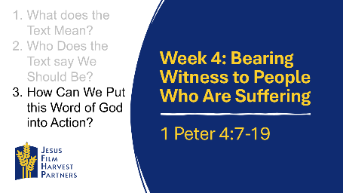

* + - **Hands: How Can We Put the Word of God into Action?** One of the dangers of reaching out to hurting people is causing more hurt by simply giving pat and easy answers to their deep pain (see the book of Job and Job’s three “friends”). Oftentimes, the greatest act of love a Christian can give is simply to be willing to sit and listen to the one suffering.
      * Commit to spending time this week learning about Christians who are suffering for their faith around the world. Then spend time in prayer each day for the persecuted Christians you learned about.
      * Prayerfully ask God to make you aware and sympathetic to people who are suffering around you. Also make it part of your prayer time to ask God to show you how you can take action to help alleviate the suffering of those around you.
  + **Testimony of a Life Transformation**

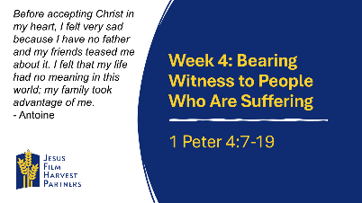

* + - **Country: Peru** My name is Jaime; I am 13 years old. Before accepting Christ in my heart, I felt very sad because I have no father and my friends teased me about it. I felt that my life had no meaning in this world; my family took advantage of me. When I went to work helping wash motorcycle taxis near the river, everything I earned was stolen from me. Now I've accepted Christ into my heart, and I feel much better and happier because I know that from now on, He will be my Father, and He will help me become a better person. When I feel like nobody loves me and nobody cares about me, I remember that I have my God who loves me and is very interested in my welfare. I promise to serve God from now on and fulfill what He asks me, even if I must suffer the scorn of those who call themselves my friends.
      * How can suffering make someone more open to hearing about the Gospel of Jesus Christ?
      * What are ways you can enter into the suffering and pain of others to gain the right to speak words of grace and healing into their lives?
  + **Apply**

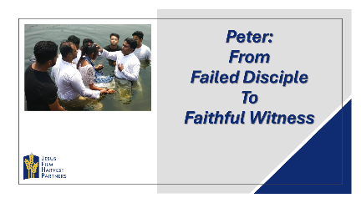

* + - Ask someone to retell the main Bible lesson text again.
    - Ask the group to share how they think God wants them to respond to today’s lesson.
    - Spend time in prayer for your community, one another, and for wisdom in living out today’s lesson.
    - Close by having the group pray together the Lord’s Prayer.