**1: Sermon**

# **From Mourner to Preacher**

# **John 20:1-18**

**Author: *Rev. Bill Kirkemo***

**Introduction**

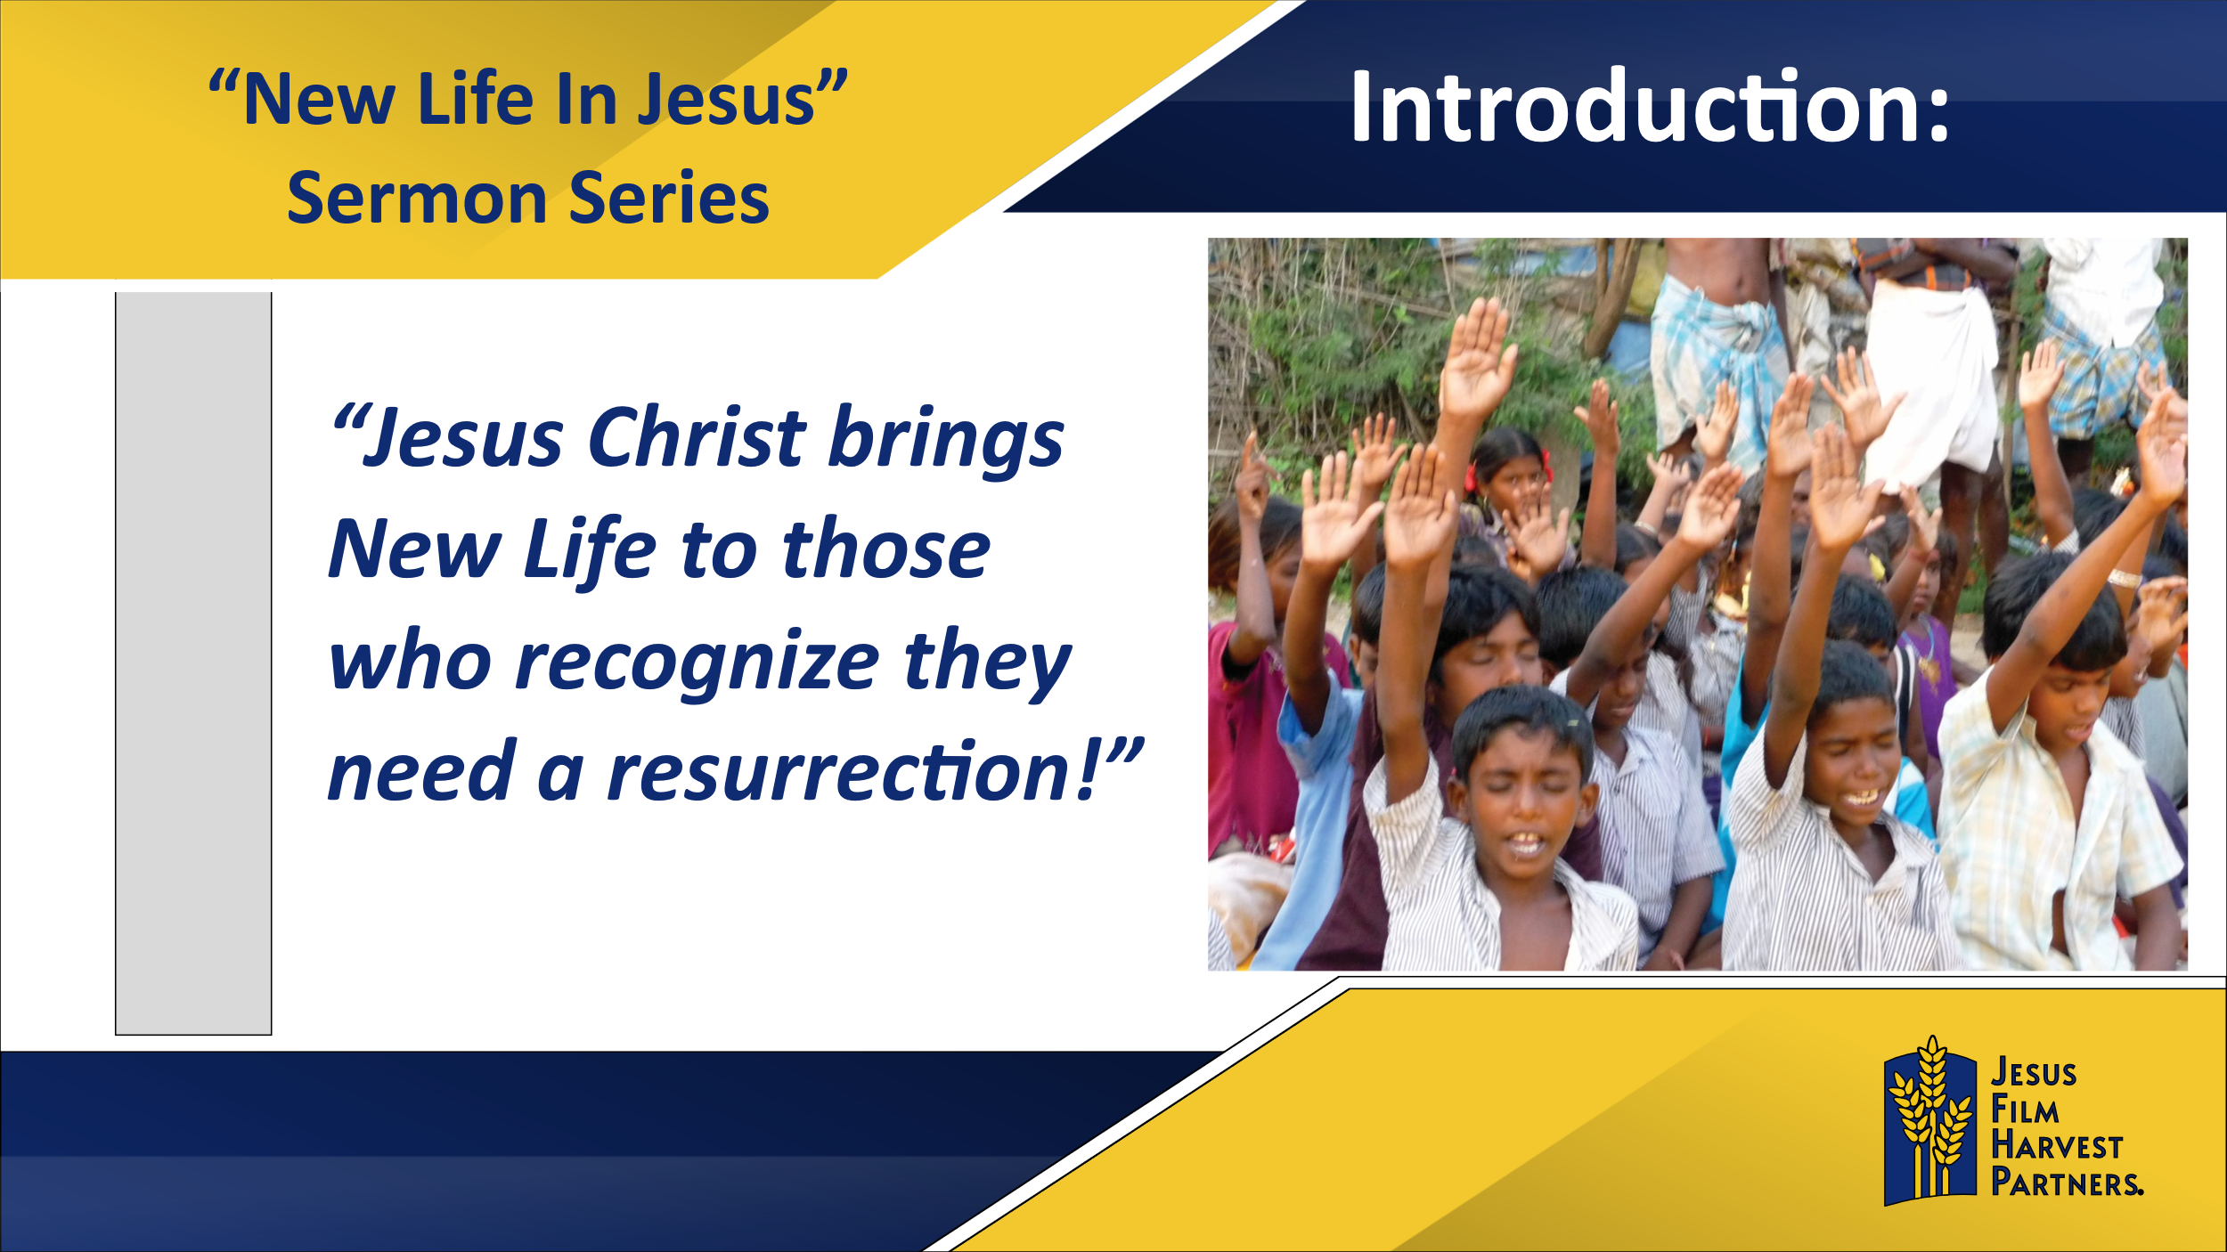

**Jesus Christ brings New Life to those who recognize they need a resurrection!**

Aminata is one whose life has been resurrected by the love of Jesus. Growing up in a rural area of Sierra Leone, she left her family behind to move to a city in hopes of starting her own business. Life did not go as planned and after setbacks and disappointments, she ended up as a sex worker. One day though, she heard about a film showing nearby. Not really caring what the film was about, but just wanting to be entertained, she watched the *JESUS* film for the first time. She tells about that event:

*“The film touched me deeply and my spiritual eyes were opened. I learned that Jesus was not selective of the social stature of people He interacted with. For instance, He ministered to a prostitute, and her life changed. That aspect of the film inspired me a lot and made me realize that God was willing to forgive me, no matter my state or condition. This made me fall in love with Jesus Christ, and because of that I wept, because of the first time, I realized my life is valuable.”*

**Jesus Christ brings New Life to those who recognize they need a resurrection!** Aminata needed and received New Life!

I invite you to open your Bibles with me to John’s Gospel, chapter 20, where we will read of another woman in need of New Life, Mary Magdalene. Mary had already experienced a bit of New Life years ago when Jesus cast seven demons out of her (Luke 8:2). But that New Life came crashing down around her on Good Friday as she watched Jesus’ crucifixion. Our text takes place on Easter Sunday morning, and we will hear Jesus bring abundant and lasting New Life into Mary’s heart.

**Read John 20:1-18**

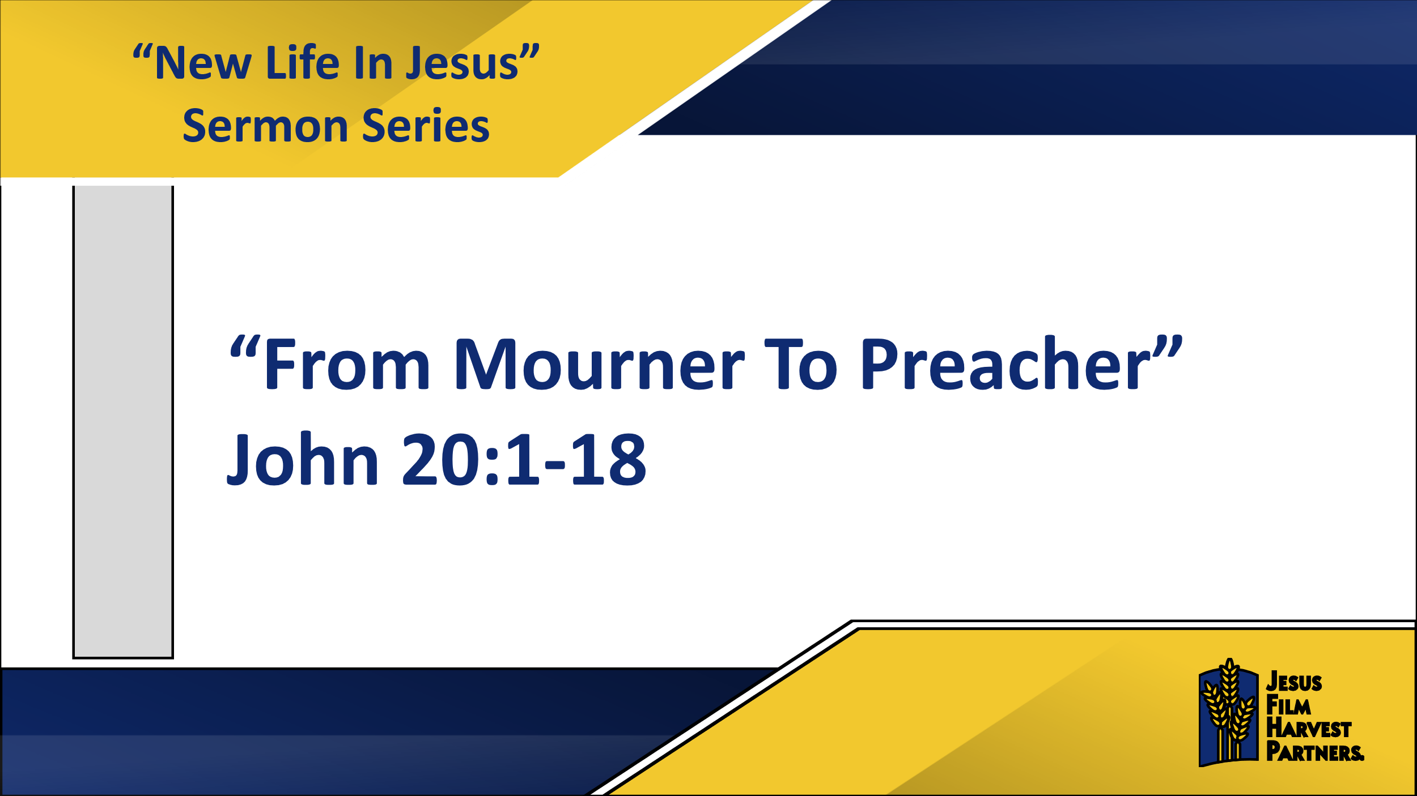

**1. Jesus Meets Us Where We Are…**



**Jesus Christ brings New Life to those who recognize they need a resurrection!**

Over the next four weeks we will explore four passages in the book of John in which Jesus brings New Life to those in need of a resurrection. Each of these passages happen after Jesus’ death and resurrection, as Jesus meets people in their sorrow, doubts, misunderstandings. Instead of giving them what they deserved – rejection and chastisement for their lack of faith, Jesus instead offers them forgiveness and commissioning. Jesus offers them New Life.

The promise of the Gospel of Jesus Christ that Jesus can forgive our sins. But it is also so much more! The promise of the Gospel is also Jesus wanting to bring New Life into our dead heart, soul, mind, and strength. As Aminata discovered, as Mary Magdalene experienced, Jesus wants to do more than just forgive us our sins, Jesus wants to give us New Life. Jesus wants to restore our relationships, to bring deep and abiding peace and joy to our hearts, to give us a glorious purpose for our lives!

And one of the most powerful and beautiful aspects of the Gospel of Jesus Christ is, Jesus does not wait for us to recognize we need a resurrection. Jesus does not give us a road map for how to get our life back on course so that we can find forgiveness. Instead, Jesus comes down to us, amid our brokenness, our confusion, our sin, our doubts, and offers us New Life where we are.

Mr. H is another example of a person meeting Jesus amid his brokenness. Mr. H was a farmer in a Southeast Asian country, planning on how to commit suicide because his crops had failed. With failed crops, he now was not going to have any money to pay back the loan he took out for a new tractor. Mr. H had lost all hope. However, amid his depression, as he was walking down the road a member of a Jesus Film Harvest Partners (JFHP) Team met him. This team member approached Mr. H, concerned because he looked so frustrated and sad, and asked what was going on. Mr. H shared his agony and suicide plan. This team member shared with Mr. H the hope of the Gospel of Jesus Christ and took him to receive help and hope and counseling from other JFHP Team members. Mr. H gave his life to Christ, received forgiveness of his sins, and now the spirit of God is active in his life as he grows in Christ. Jesus meets us where we are.

**Jesus Christ brings New Life to those who recognize they need a resurrection!**

**2. Jesus Sends Us to Tell Others…**



**Jesus Sends us to Tell Others…**

The Gospel of Jesus Christ does not just come and meet us where we are, it also sends us to tell others the Good News of Jesus’ love and forgiveness. Jesus met Mary Magdalene amid her sorrow and doubts. She had watched Jesus die on the cross. And even though Jesus had told Mary and His other followers He must die, they did not understand He was sharing literal truth. However, Jesus did not just meet Mary amid her sorrow and doubts and bring her New Life, Jesus also commissioned her to tell others this Good News.

Aminata did not just receive forgiveness of her sins, she also currently ministers to her friends who are still working as sex workers, sharing with them the love of God and sharing with them the truth of a better way of life.

These JFHP Team members who ministered to Mr. H also did not just receive forgiveness of their sins at some point in their lives. They also felt the call of Jesus upon their lives to share with others the Good News that Jesus offers them New Life.

In the following weeks, as we continue studying these appearances of Jesus to His followers after His resurrection, we will see over and over again this simple but powerful truth: Jesus does not just bring them New Life, He also commissions them to share the Good News of that New Life they have received with others. Jesus commissioned Mary to go to the disciples, gathered in fear of their lives, and tell them that Jesus was alive. In fact, Mary is known as the first preacher of the Gospel, for she is the first to declare, “I have seen the Lord!” Mary Magdalene, from Mourner to Preacher!

So, it is in our lives as well. Jesus comes to each of us where we are, amid our brokenness and sin and offers us New Life. Jesus also commissions us to share this Good News with others. Like Mary, this call often looks like sharing the Good News with those we are close to - our friends, our family, our neighbors. Through our words, through our compassionate actions, through our demonstrating forgiveness and love we can daily bear witness to the truth of the Good News.

But like this JFHP Team that encountered Mr. H, sometimes we are also called to step out of our comfort zones, and go beyond our immediate relationships, and share Jesus with others we see in need of New Life. For this JFHP Team, it meant leaving their homes behind for a time, going to a new community, and sharing with them the *JESUS* film and their very lives. Sometimes Jesus calls us to do the same. Jesus still calls full-time missionaries. Jesus still calls short-term missionaries. And Jesus still calls those of us with financial means who are not called to physically go, to support those who Jesus calls to physically go.

**Jesus Sends us to Tell Others…**

**Conclusion**

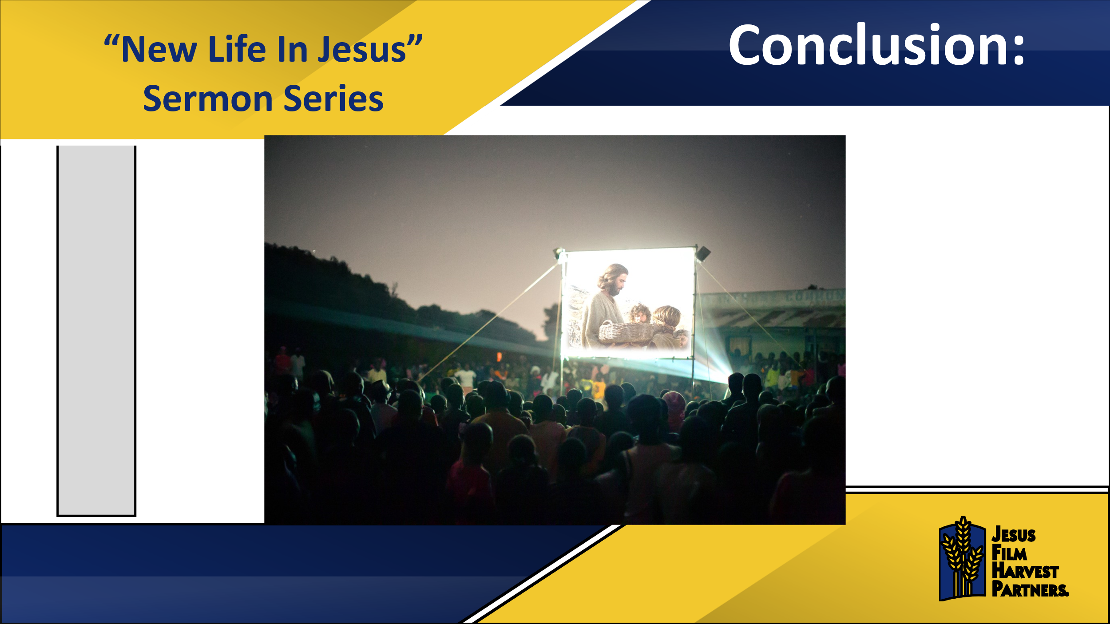

Forty-two-year-old Mr. Z grew up in a non-Chistian family in a Southeast Asian country. He had heard the Gospel from evangelists but had never accepted Jesus. He thought of Christianity as a foreign religion, and he wanted to stay true to his nationalistic religion. He freely admits hated Christians.

However, at one point he became extremely sick. Concerned, he did all he was supposed to do, according to his animistic religious leaders. He took their medicines, he called on the witch doctor, he sacrificed animals. But he only got worse. He and his family lost all hope.

Having heard of his condition, a JFHP Team member approached him and asked if he could show him and his family the *Jesus* film. Seeing the film, hearing Jesus’ words in his own native language, and witnessing the depiction of the miracles of Jesus, Mr. Z desperately wanted a miracle in his own life. And through a mighty move of the Holy Spirit Mr. Z received New Life. Not just spiritual New Life, though, he also received physical healing. In addition, as we have been seeing, he did not just receive blessings from Jesus, but Jesus commissioned him to go and tell others the Good News as well. Mr. Z reports he and his family have hope in Christ. His sorrow of heart turned into joy. Now he encourages others to come to saving faith of Jesus. Once his door was closed to Jesus, now his door is open for the fellowship.

Have you accepted this New Life of Jesus Christ into your life? I hope you have. But if you have not, you can receive this New Life today!

Have you accepted Jesus’ commission in your life to share the Good News of this New Life with others in your life, and around the world? I hope you have. But if not, you can start sharing this very day!

Like Mary Magdalene, like Aminata, like Mr. H, and like Mr. Z, you can experience the joy of not just accepting this great salvation Jesus brings, but also the joy of sharing that Good News with others!

**Call to Action: *Identify hurting people in your life.*** Make a list of people in your life who are in a time of mourning, confusion, pain and/or just far from God. Use the list to pray for those people every day this week, asking God not just to bring healing and hope to them, but asking God how He wants to use you to bring that healing and hope.