**2: Sermon**

# **From Disciples to Apostles**

# **John 20:19-23**

**Author: *Rev. Bill Kirkemo***

**Introduction**

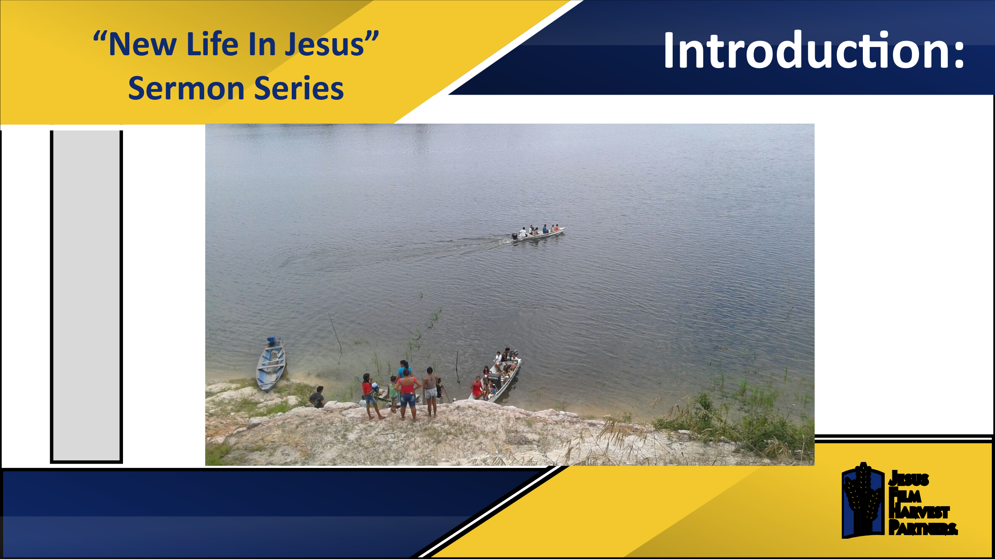

Their day began at 2 am, as they left their homes on an island in the Philippines. For the first three hours they traveled by motorcycle to the coast, thankful for the little traffic to slow them down. When they arrived at the port city, they shared breakfast and then boarded a boat for a 2-hour ride to a smaller island. After their boat docked at the next port, they jumped into a Jeep for a ride across the island. On the other side of the island, they got on a *pamboat*, which is a type of outrigger canoe, and made their journey to a yet smaller island. From that island’s port they boarded an even smaller boat and made their way to a yet smaller island. Ten hours after they left their homes, the Jesus Film Harvest Partners (JFHP) Team arrived at their final destination, a small village of people who at one time had been exposed to the Gospel, but over time, because of discouragement and lack of perseverance, had abandoned their faith. The children started gathering around their team as they started distributing food and told them about a movie showing happening in their village in the evening.

That evening, as they began showing the *JESUS* film, people started arriving, and the Holy Spirit invaded the village. As the people watched the film, many recommitted themselves to Jesus, and a revival broke out in that village. Over the next several days, the JFHP team continued to minister to the community through evangelism, preaching, teaching, and developing relationships. The team leader reported as they left the village, “our hearts are filled with joy leaving that place knowing that our labor is not in vain. All the glory and honor belong to God alone.”

Why would a group of people get up at two in the morning and travel ten hours in increasingly smaller boats to a tiny island to minister to people who had fallen away from their faith? Simple, God called them to go. They are modern day Apostles, people called by God to go and share the Good News, no matter how dangerous the journey, or how long it takes to get to their destination.

Last week we began our “New Life in Jesus” sermon series by studying Jesus’ commissioning of Mary Magdalene to be the first preacher of the Gospel. After meeting the resurrected Jesus, she went to the disciples, gathered for fear for their lives after Jesus’ crucifixion, and boldly declared to them “I have seen the Lord!” (John 20:18) This week we pick up the account as Jesus enters the room in which the disciples are gathered. As we will hear, Jesus, like He did with Mary Madelene, meets them in the midst of their sorrow, their confusion, and their doubts, then He encourages them and commissions them to go and tell others the Good News that He has risen from the dead.

**Read John 20:19-23**

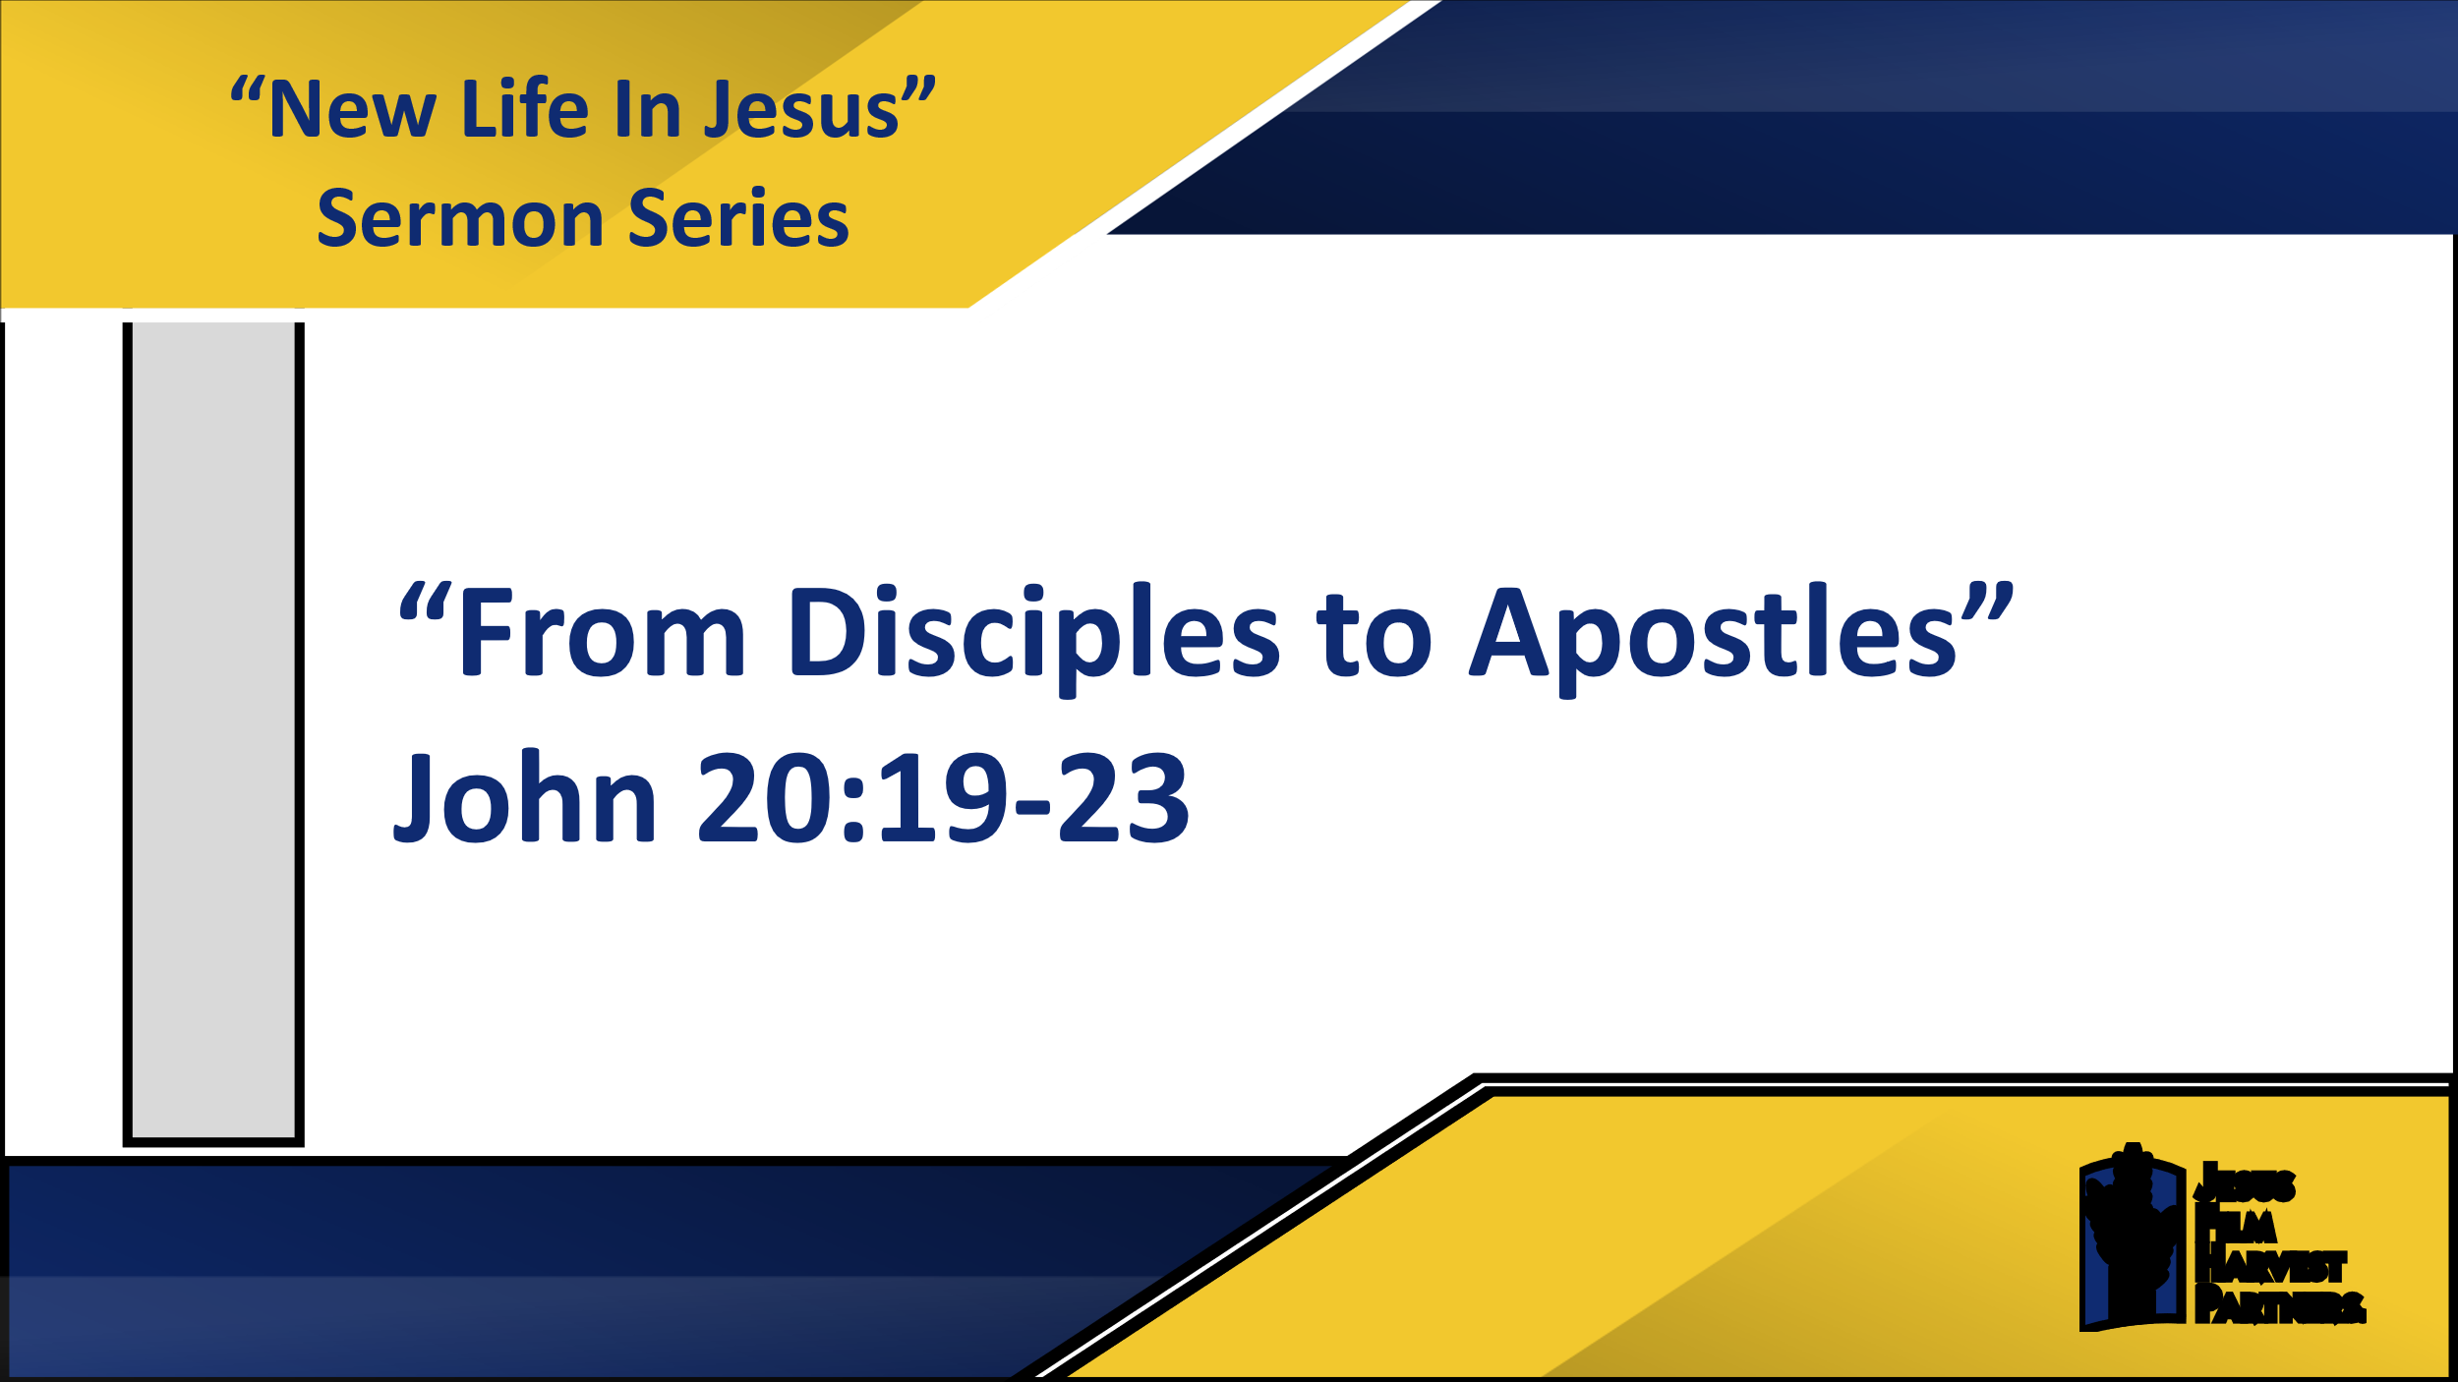

**1. Following is not the Goal**

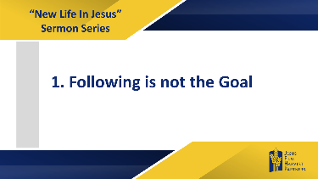

It is Easter Sunday evening, and the disciples are still in shock. They assumed they were following Jesus to Jerusalem for the Passover Feast and to continue enjoying all the favor of the people. They assumed Jesus would continue His powerful teaching, His mighty miracles, and His confounding of the religious authorities. But that is not how this Passover played out. Instead, just as Jesus had warned them, He was betrayed, He was turned over to the authorities, He was unjustly condemned to death, and He suffered an agonizing death.

Amazingly, some of the women of their group showed up that Easter morning declaring to the disciples the tomb was empty and that Jesus had risen from the dead. Peter and John rushed to the tomb and verified it was empty, but they did not see the Lord. And so, these disciples, amid all their doubts, confusion, and fear, are huddled together, waiting. I am not sure they knew what they were waiting for, but they were waiting for something to happen.

And something dramatic did happen. Suddenly Jesus appeared among them, and greeted them with the beautiful words, “Peace be with you!” Peace is definitely something they had not experienced for several days now, but peace is what Jesus offers them. Jesus showed them His wounds, confirming His bodily resurrection, and the disciples are filled with joy, no longer with fear and doubts, but with joy!

After proving His resurrection and filling them with joy, just as He did with Mary Magdalene, Jesus commissions these disciples to tell others of the New Life they can have through faith in Jesus Christ. Jesus declares to them, “as the Father has sent me, I am sending you.” These Disciples are now Apostles.

For the last three years these disciples have been following Jesus. These disciples have been learning as Jesus taught them. They have been growing in their faith as they have witnessed Jesus’ miracles. They have been becoming stronger as they have sought to model their lives after the compassionate and gracious life of Jesus. That is what disciples do, they follow, they learn, they prepare.

But now Jesus commissions them, “as the Father has sent me, I am sending you.” This Greek term Jesus uses here to describe the sending God has done in Jesus and is now doing for them is “*apostalkeo*,” from which we get our English term “Apostle.” They are no longer Disciples; they are now Apostles. They are no longer simply followers; they are now the sent-out ones. Jesus then imparts onto these once scared Disciples, now joyful Apostles, the Holy Spirit – and tells them Go.”

**2. Counting the Cost**



Why would a group of Christians leave their homes at two in the morning and get on increasingly smaller boats to go to increasingly smaller islands to meet with people who have abandoned the Christian faith? Simple, they are modern-day Apostles. They are modern-day “sent ones” whom God calls to not just be followers of Jesus Christ, but to be God’s messengers of love to the world.

If you read through the book of the Acts of the Apostles, which immediately follows the next chapter of this Gospel of John, what you will read on page after page are these once confused, fearful, full of doubts disciples being so filled with the Holy Spirit that they preach and teach and work miracles with the same power Jesus displayed. They have become Apostles, not just commissioned by Jesus to go, but so filled with the Holy Spirit that they literally continue the very ministry of Jesus Christ wherever they go.

Jesus calls us to continue this Apostolic ministry of Jesus in our world as well. Jesus also calls us to be more than disciples, but to be “sent out ones,” Apostles, sent into this world to be the hands, the feet, the voice, and the ears of Jesus.

Our world is full of brokenness and sin. Many of the people we work with, shop with, maybe even live with are full of regret, fear, and doubt. They need to know there is a living God who offers them hope and freedom from the power of sin and guilt.

It is not only the pastors of this world Jesus calls to go and spread this message. It is each of you, each of you who have given your lives to God and received Jesus’ forgiveness who Jesus calls to proclaim this message. Sometimes it comes very easily and naturally for you to share our hope with others. Sometimes it comes at a great cost.

Mr. R, who lives in India, made the joyful, but also tough, decision to follow Jesus Christ as his Savior. I say tough, because the village in which he lives strictly prohibits any outside religions in their community. Mr. R had some doubts about whether or not following Jesus was worth the cost it would mean to him and his family. But after prayer, Bible reading and discussion, Mr. R said,

*“I know what’s going to happen to me if I accept Jesus Christ and become Christian. I know I won’t get anything from the community but hatred and rejection and even possible persecution. Today will be my last day of living peacefully with this community. When tomorrow comes, I will be a stranger to them. I will be an enemy to them because I will be a Christian, a follower of Jesus Christ. But then, I cannot deny it, I already decided personally and with my family to be a faithful Christian till the end. I have decided to follow Jesus Christ, leaving all my old life behind.”*

Mr. R then asked for prayer, as he recognized he cannot just be a follower of Jesus Christ, but has been sent to his local community to be a Christian witness, even though the cost will be high. Sometimes God sends us to the other side of the world to be His witnesses. Sometimes He sends us next door to be His witnesses. Either way, God always sends us…because His love and forgiveness are so great that our lives cannot contain them.

**Conclusion**

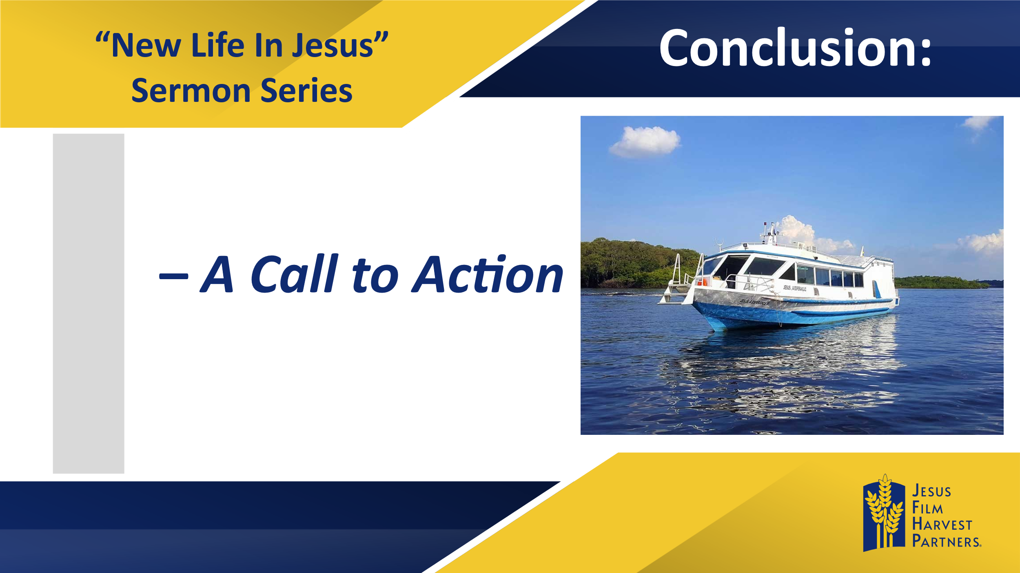

Where has God sent you?

Maybe you look back decades ago and recall a mission’s trip on which God sent you to share the Good News with strangers.

Maybe you look back to when you started at your current school, and recognize God sent you to that school to share the Good News with teachers and fellow students.

Maybe you look ahead, because you sense God is sending you somewhere, but you do not yet know when or where.

**Call to Action: *Be Willing to Step Out of Your Comfort Zone.*** Yes, we are Disciples of Jesus Christ, called to model our lives after His love, humility, and grace. But we are also Apostles, ones God sends to this world to share with it the hope that the love, humility, and grace of Jesus Christ can bring joy and peace into their lives. This week I challenge you to step out of your comfort zone and obey whatever call God is placing on your life.