**4: Sermon**

# **From Denier to Disciple-Maker**

# **John 21:15-25**

**Author: *Rev. Bill Kirkemo***

**Introduction**

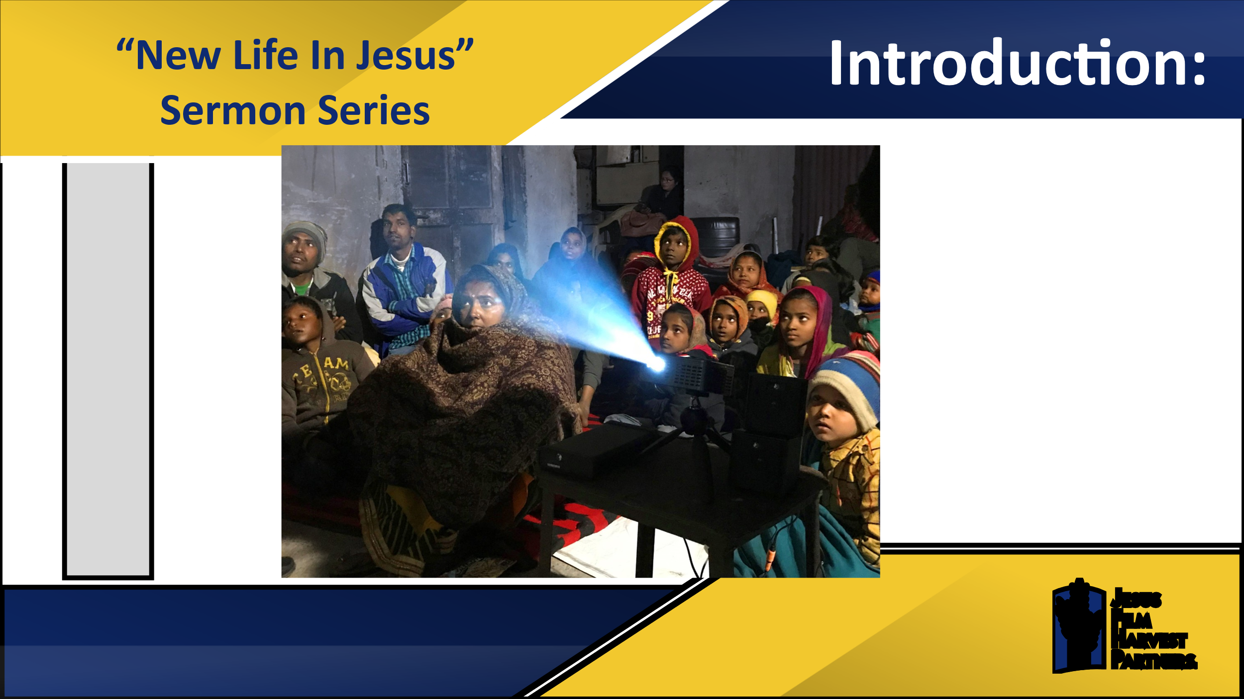

Cecelia lived in a town in Liberia visited by a Jesus Film Harvest Partners (JFHP) Team. Cecelia admits she was one of those people who took satisfaction in provoking other people. She freely admits she more than earned her reputation in town for being rude, insulting, and threatening. In fact, earlier that day, when the JFHP Team was setting up for the showing that night, she went out of her way to insult the team members, making fun of them.

But she still showed up for the *JESUS* film showing that night, and reports she was struck to the heart when Jesus told His disciples that they had to become like children in order to enter the Kingdom of God, and that you are actually blessed when other people throw insults as you and mock you for being Christians. She recognized that she was one of those people always doing the insulting and mocking.

As she watched the *JESUS* film, she started to feeling guilt and shame for how she was living her life. She no longer wanted to be that kind of person. She reports,

*“I want Jesus to take control of my heart and control of my mouth from insulting people and rather tell them more about the Kingdom of God.”*

Her pastor reports Cecelia is following through with that commitment and is one of the hardest working members of their church.

Keeping control of our tongues can be one of the hardest disciplines we can master. Whether it is out of anger, jealousy, or even fear, we often cause great harm with the words we use. On the night in which Judas betrayed Jesus, His disciple Peter was in a dangerous place. The authorities arrested Jesus, and Peter was observing His trial at a distance. However, people around him recognized him as one of Jesus’ followers and confronted him. Rather than stand up for Jesus and declare his dedication to Him, Peter denied even knowing Jesus. Not just once, but three times Peter used his words to distance himself from Jesus, to deny even knowing Him, and according to Matthew’s gospel, even called down curses. (Matthew 26:74)

In our sermon text this morning, as we continue to study the post-resurrection appearances of Jesus, we will hear Jesus restore Peter. Jesus will graciously remove the shame of Peter’s denials, and commission Peter to be a Disciple-Maker.

**Read John 21:15-25**

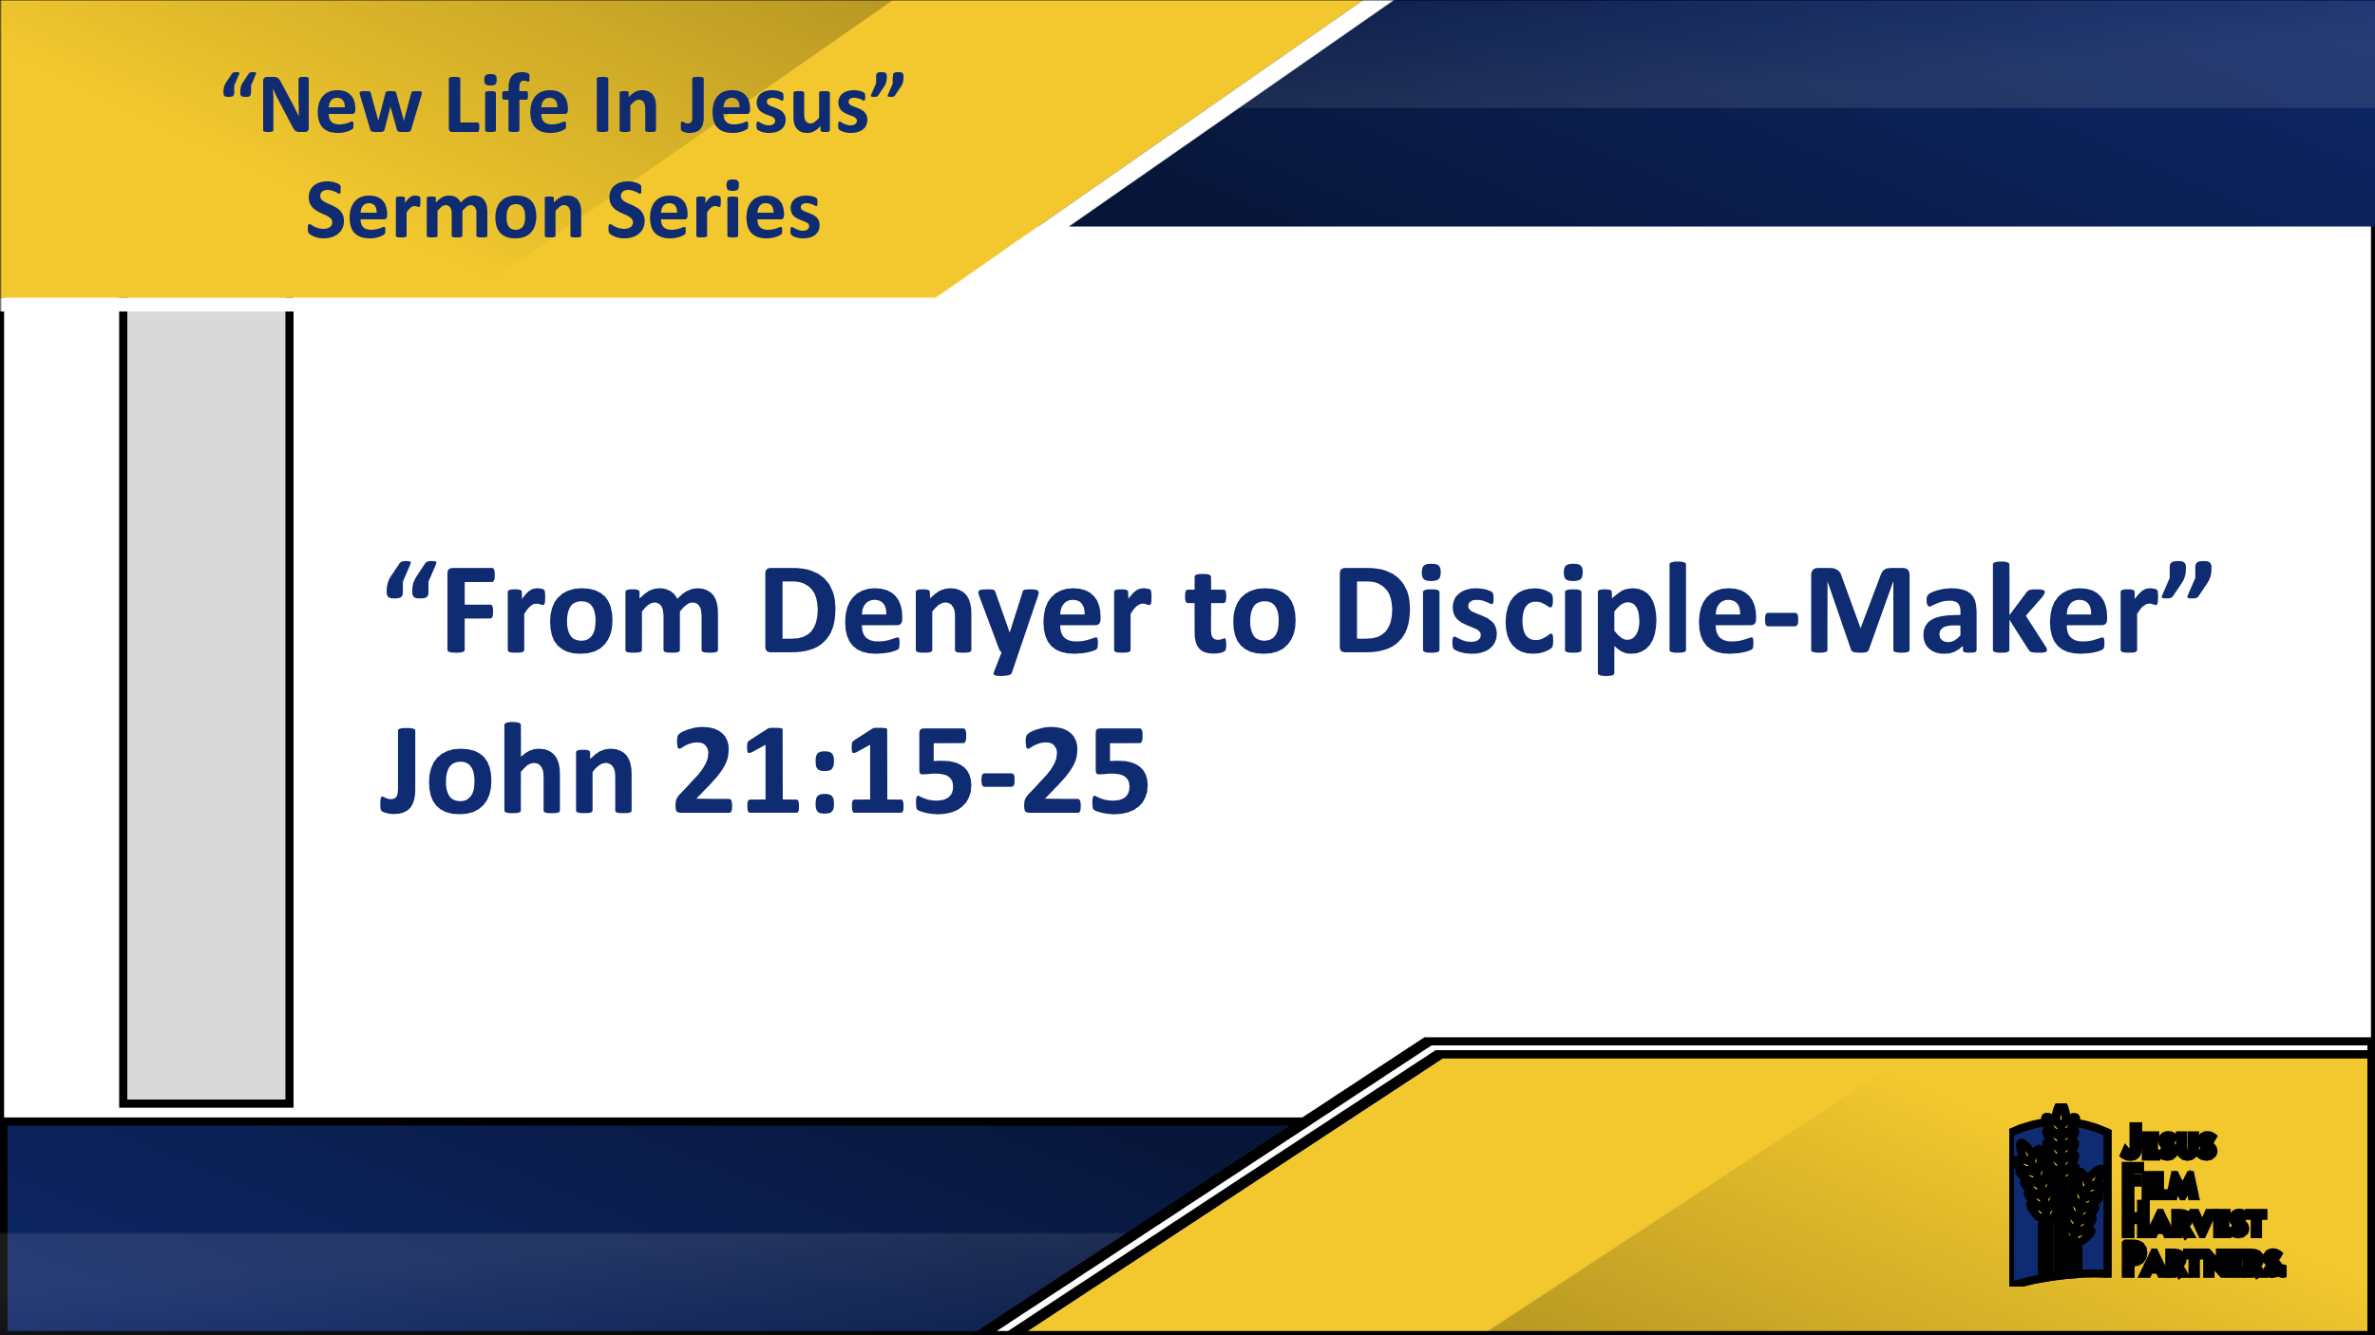

**1. Dying to Ourselves**

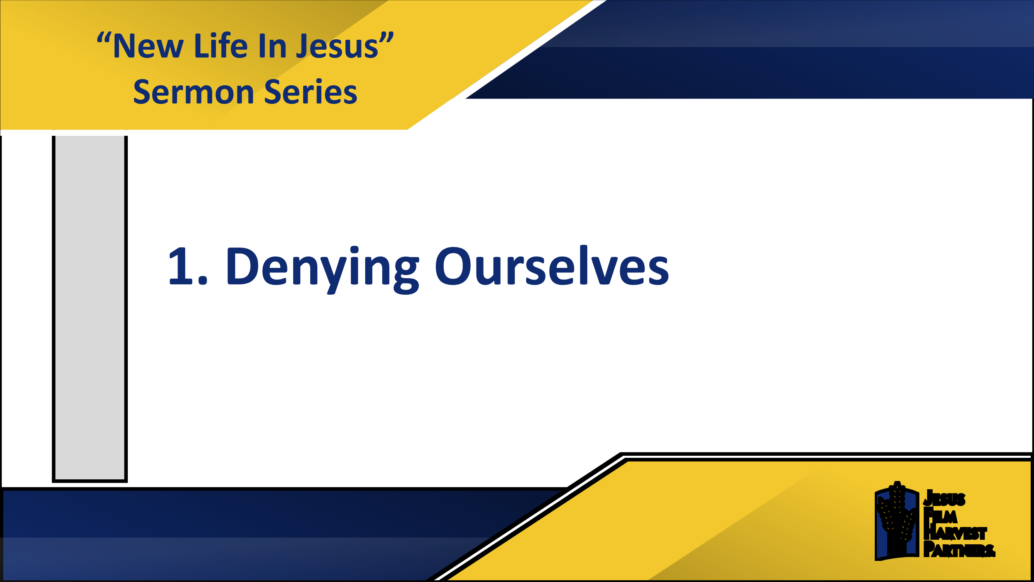

The Germon Pastor Deitrich Bonhoeffer wrote in his book the Cost of Discipleship, *“When Christ calls a man, He bids him come and die.”* Oftentimes we hear a statement like this assume Christ is simply calling people to die to their past sins. However, when Jesus calls us, Jesus calls us to die to more than just our past sins. Jesus calls us to die to our prejudices, to die to our hangups, to die to our greed, to die to our anger, and the list can go on and on. Jesus calls us to die to anything in our life that makes us less than the fully obedient and faithful follower of Jesus Christ we are called to be.

To be a follower of Jesus Christ, Jesus called Cecelia from Liberia to die to the destructive ways she used her words against others. To be a follower of Jesus Christ, Jesus called the Apostle Peter to die to his pride, in which he claimed to be much more committed to Jesus than he really was (until push came to shove in the High Priest’s courtyard).

This was not the first time the Gospels reveal Peter struggling with his words. We can trace several examples of the way in which Peter allowed his prideful speech to get the best of him throughout the Gospels. This is just the most significant example. On this night Jesus tried to explain to His disciples what was about to happen. He told about how one sitting at the table would betray Him, and how He would then be abandoned by His disciples (Mark 14:17-31). However, Peter, in his pride, declared that even if every other disciple fell away, he never would. In fact, Peter boldly declared he would die for Jesus (John 13:37).

Now, were Peter’s intentions good? I am sure we could all agree Peter thought he was willing to die for Jesus. However, Peter’s pride outshone his actual dedication. For when they were no longer in the safety of the Upper Room, when Peter found himself in the courtyard of the High Priest’s house, Peter’s courage melted away. For he did not just deny Jesus once, but just as Jesus predicted, he denied knowing Jesus three times.

Which makes the three times Jesus asked him if he loved Him in our sermon passage today very significant. In this passage Jesus does not rebuke Peter. Jesus does not demean Peter. And Jesus certainly does not say “I told you so Peter.” Instead, Jesus restores Peter. Now, Jesus did not rebuke, demean, or make fun of Peter, but that does not mean Jesus did not confront him or ignore what happened. Instead, Jesus takes the three denials and matches them with three calls to become a Disciple-Maker of Jesus’ followers.

Jesus had to confront Peter’s pride that Peter could die to his pride. Jesus had to confront Peter’s denials so Peter could repent of them. Jesus had to re-confirm Peter’s calling so that he could live out God’s unique calling upon his life.

**2. Becoming a Disciple-Maker**

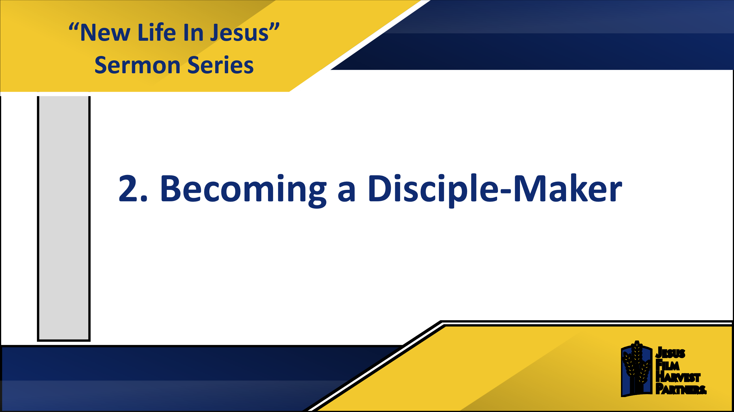

What is true for Peter is true for all of Jesus’ followers. We are all called to die to ourselves. And this means not just asking Jesus to forgive us of our past sins and to take away our lingering guilt. It also means surrendering everything we are now and will be to Jesus. It means being willing to have Jesus transform everything in us contrary to His love, compassion, peace, and joy, and to mold us into His image. When Jesus calls us, He bids us *“come and die,”* so that He can resurrect us!

One of the most obvious ways we display this death to ourselves and our resurrection to Jesus’ living within us is in how we treat others. In a world that teaches us to put ourselves first, Jesus instead calls us to put others first. And one of the ways we put others first is by helping others come closer to Jesus Christ.

Three times Jesus calls upon Peter to care for Jesus’ followers, to be a Disciple- Maker. “Feed my sheep,” “Take care of my lambs,” “Feed my sheep.” Unfortunately, Christians often think you must have a special calling from God or thorough special training in a Seminary to be a Disciple-Maker. Not true, Jesus calls all Christians to be Disciple-Makers. In other words, we are all called to help others become closer to Jesus.

Sometimes this looks like introducing someone to Jesus for the first time. Other times it looks like teaching a Sunday School class.

Sometimes it is living out our Christian faith with grace and compassion in demanding situations at work or school. Other times it is taking part in a Small Groups in which we learn from each other what being a disciple of Jesus Christ looks like in very practical ways.

Sometimes it is giving a grieving person a shoulder to cry upon. Other times it is teaching a theology class to ministers-in-training.

In other words, Jesus calls all Christians, like Peter, to be Disciple-Makers. Using our unique gifts and reflecting our commitment to Christ, we can help train others in what it means and looks like to be reflections of the life and love of Jesus Christ.

Isabella lives in Chili, and from an early age was diagnosed with a mild autism spectrum disorder. However, while this is a challenge to her, it does not prevent her from participating in Bible study meetings, as her parents carry her into the classroom. She is known for her cheerful character and participates in the worship services by helping with the offering collection. Recently she has been motivated to be a disciple, and so one of the young teachers in the church has begun Bible lessons and spiritual exercises with her so that she can serve in this mission. Even at her young age, she wants to be discipled so that she can become a Disciple-Maker, to reach other children who live in the neighborhood.

**Conclusion**

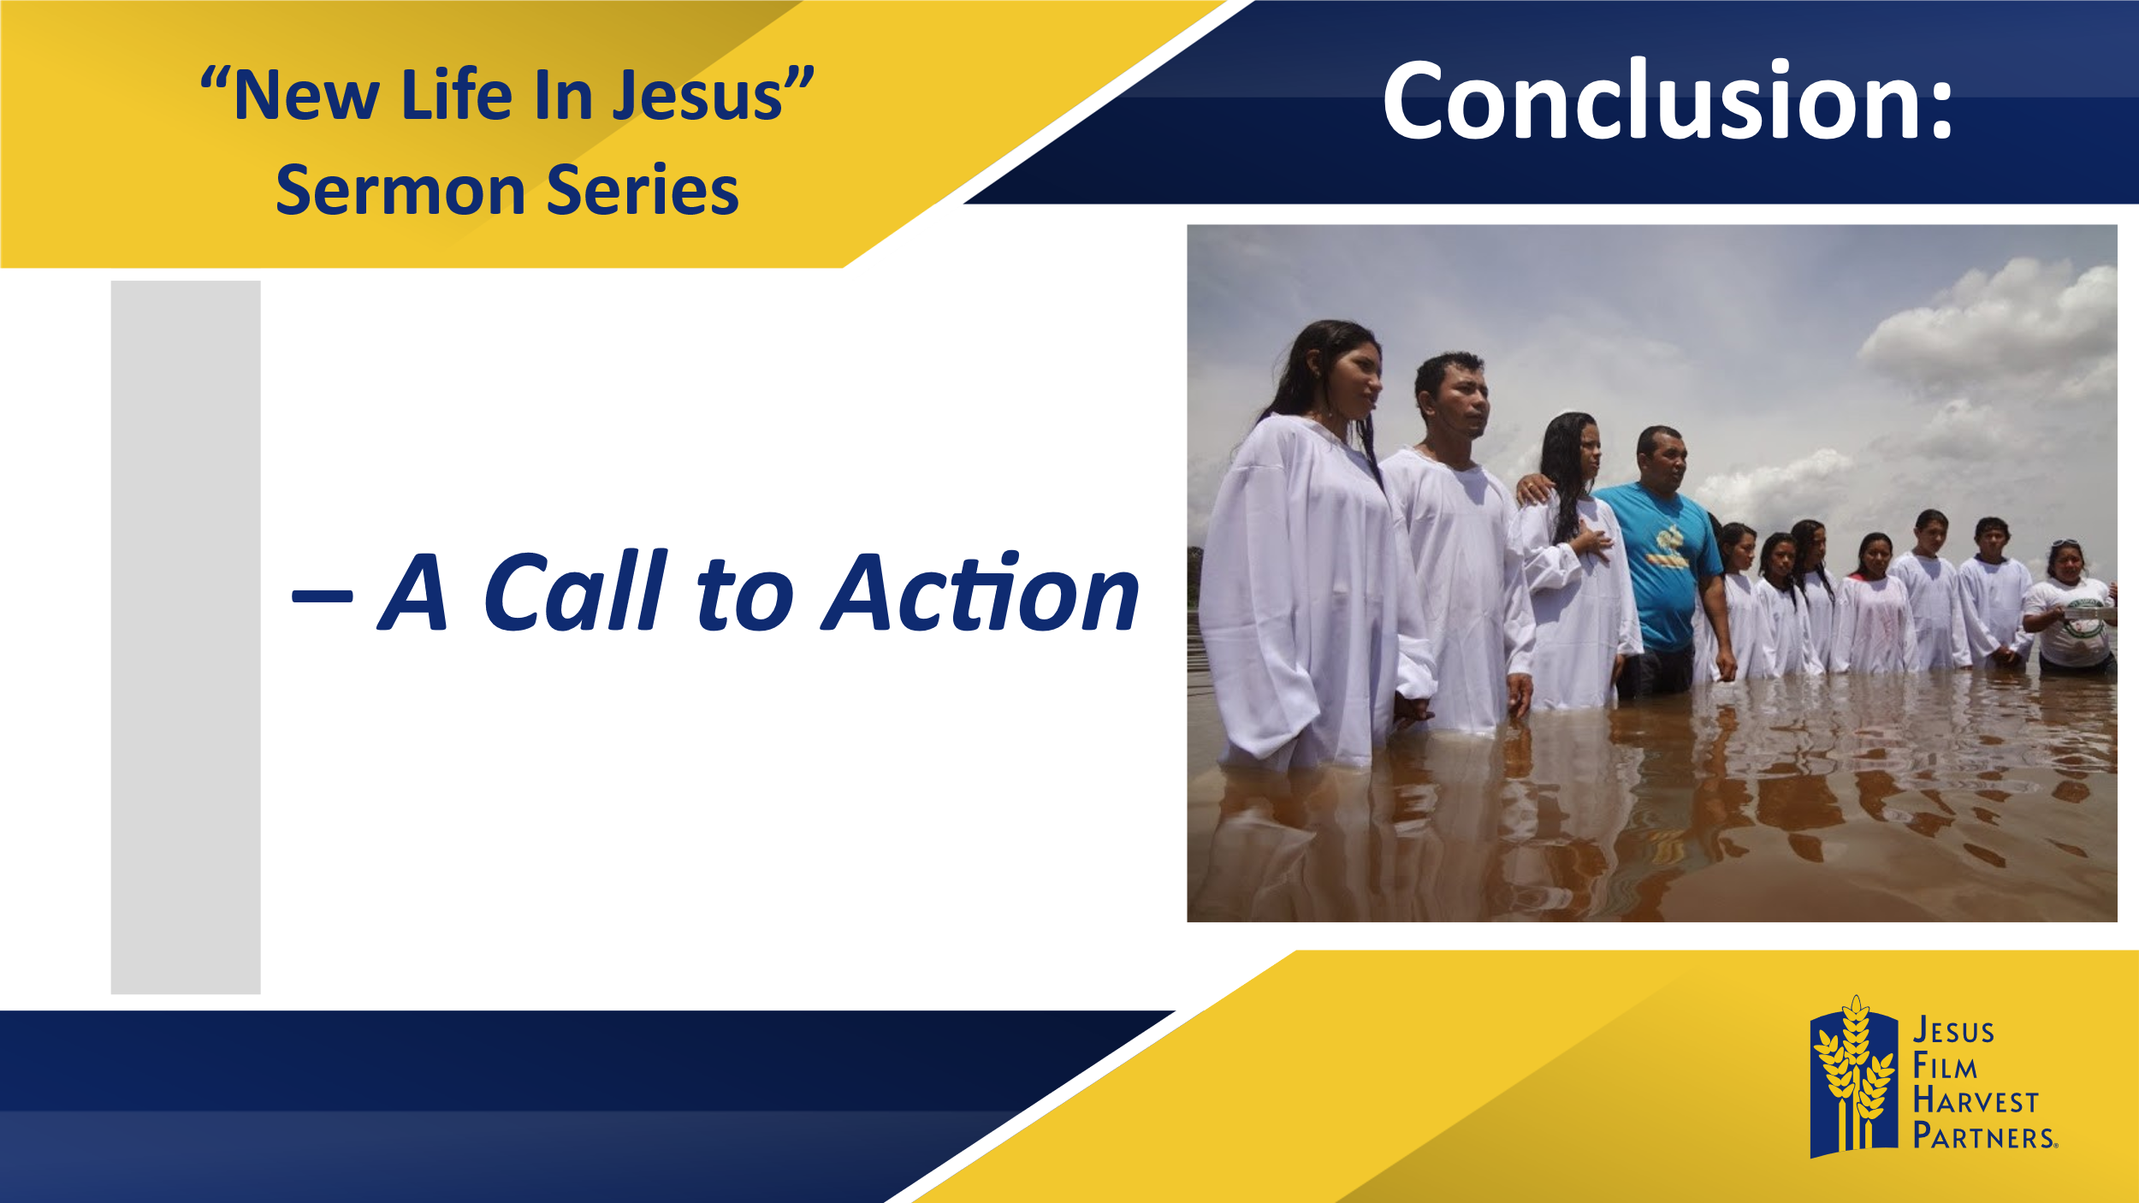

So, I have two questions for each and everyone here today. First, are you growing closer to Jesus? That could look like not just reading your Bible but prayerfully finding ways to apply it to your life. It could look like dedicating more of your time to prayer and acts of compassion. It could look like developing a deeper capacity for compassion and forgiveness this year than you had last year. First, are you growing closer to Jesus?

Second, who are you helping grow closer to Jesus? That could look like being a Sunday School teacher or a Small Group leader.

It could look like sharing a meal with a new Christian once a month and helping them discern God’s work in their lives.

It could also look like finding people at school or work who are lonely or on the margins and befriending them.

It could look like not always having to have the last work in a disagreement, but being willing to put your pride and ego aside so that what could escalate into a break in relationship instead de-escalates into being unwilling to let one issue break a relationship.

Two simple, but especially important questions. Are you growing closer to Jesus? And who are you helping grow closer to Jesus?

**Call to Action: *Make Sure Your Faith Is Being Made Public.*** This can take many forms, like a very public ministry of preaching or teaching a Sunday School class. It can also be a much more “behind the scenes” ministry like offering help to the poor or grieving. In each life, living out the faith will look differently, but Jesus calls all Christians to use their lives to draw people closer to Jesus Christ. Jesus calls all Christians to be Disciple-Makers.