
Week 1: Youth Lesson

Mary: From Lost to Found & Called

John 20:11-18

Author: Rev. Nik Davis

Introduction
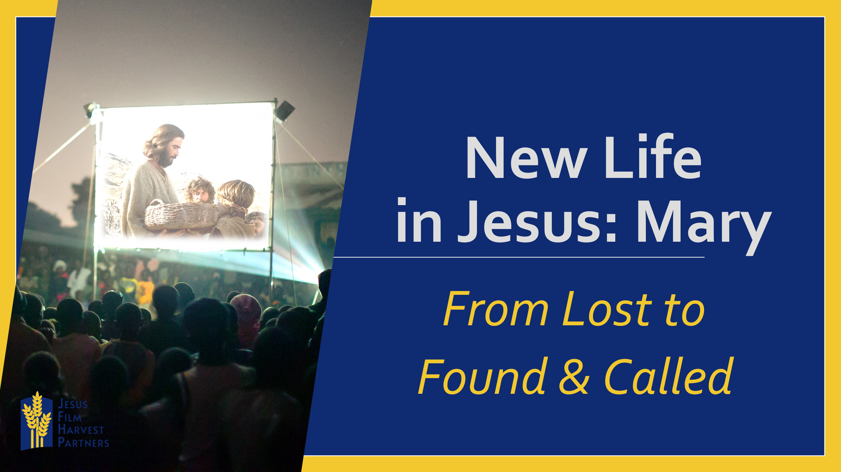
Jesus Christ finds those who need Him, engages with them and calls them by name!
Jonas grew up in Haiti and needed to be found and called. He shares that he had been living an immoral life, serving the devil and making sacrifices to him. Basically, living a life of slavery to the devil. One day a JESUS Film Team came to his town, and Jonah watched the JESUS film and heard Jesus call to him and say, “Come to me.” Jonas accepted Jesus’ call, and now his life is saved and changed as a result.
Jesus Christ finds those who need Him, engages with them and calls them by name!
Jonas received salvation and New Life.
Will you open your Bibles with me to John 20:11-18 where we will read of another person who needed to be found, engaged with and called by name: Mary Magdalene. Mary had already been found and called by name once before, but here in this moment, standing before an empty tomb, she was in a place of needing to be found, engaged with and called by name at a deeper level. Her life had been partially changed before, as she followed her teacher Jesus. But now, risen from the dead, Jesus appears to her not just as a teacher, but as a Savior.

Read John 20:11-18
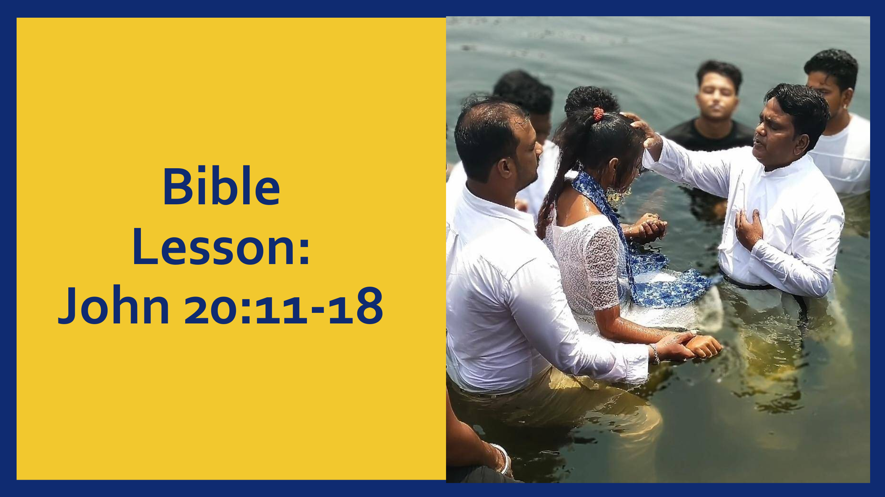

- Jesus finds us where we are… Exactly where we are.
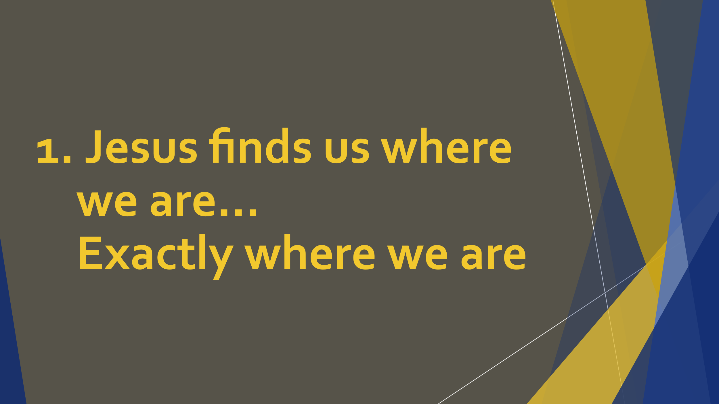
Jesus finds those who need Him, engages with them and calls them by name!
Over the next four weeks we will be looking at four passages in the book of John in which Jesus finds people exactly where they are, not necessarily where they should be. But the Good News is that Jesus did not just leave them there! He engages them where they are amid their sorrow, their fear, doubt or need for restoration, and promises them a New Life in Him.
The promise of Jesus is not just that He can save us from our sins, but the promise that He can take us from the middle of all our brokenness where He finds us and completely transforms us. This transformation comes as Jesus engages with us, calls us by name and then commissions us to share with others the powerful work that has been done in our lives. Much like Mary Magdalene, much like Jonas from Haiti, Jesus finds us where we are and chooses not to leave us there. He restores our joy, heals our relationships, emboldens our faith and commissions us to enter His story and share it with others.

Matyas is another example of Jesus meeting us where we are engaging with us and calling us by name. He was a member of a secret society for 18 years in Haiti. However, even though he was part of this group that promised acceptance and success, he never felt peace in his life until Jesus called him in his sleep and said, “Come to me.” He decided to accept Jesus as his Savior and now feels free and at peace. Jesus finds us where we are even in the middle of sleep!

Jesus finds those who need Him, engages with them and calls them by name!

- Jesus engages with us…

Jesus engages with us…
Jesus doesn’t just find us where we are, He engages with us, reaching out to us amid our circumstances, so that we will not be left there. Jesus speaks to us, calls out to us, remains in our vision. Much like in our passage where Mary saw Jesus as who she assumed was a gardener, Jesus will be present in our lives. He calls out to us and engages with us.

This was the case for another friend we find in Guatemala, James. He chose to go to the JESUS film showing because friends were going just out of curiosity. When he arrived, he did not find his friends but decided to stay anyway and just stay at the back of the crowd. Even in the back without his friends around our friend says that once the film started it was just like it was only him there in the room, that the film was just for him. He shares that,
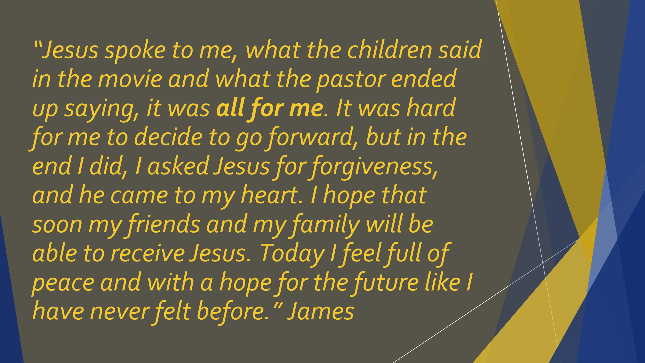

“Jesus spoke to me, what the children said in the movie and what the pastor ended up saying, it was all for me. It was hard for me to decide to go forward, but in the end I did, I asked Jesus for forgiveness, and He came to my heart. I hope that soon my friends and my family will be able to receive Jesus. Today I feel full of peace and with a hope for the future like I have never felt before.”

Just as Jesus engaged with Mary and our friend James, He wants not only to meet us where He finds us, He wants to engage with us.

- Jesus calls us by name…

Jesus calls us by name…
Sometimes, even though Jesus has found us where we are and engages with us, it is not until we hear Him speak our name that we recognize Him for who He truly is. This was the case for Mary, she did not recognize Jesus as anyone other than a gardener until Jesus spoke her name. It was at this moment that her eyes were opened to see.

Conclusion
Amanita, a friend from Haiti, never enjoyed hearing people who talked about Jesus. Until one day she heard a voice calling her name saying, “Amanita, if you don’t surrender your life to me, you will perish.” Amanita asked, “Who is speaking?” Then the voice said, ‘It is I, Jesus.’ She gave her life to Jesus.

Much like Mary Magdalene, Jonas and Amanita from Haiti, and James from Guatemala, God wants to find you where you are, engage with you and call you by name. Over the next three weeks we will continue to look at passages and stories that will show us what our response should be when this happens to us. For Mary it was to go and share with the others what she had seen and heard? What response will the Good News of Jesus elicit in your life today?

Optional Group Games
If time and space allow, play a game like sardines, hide and seek or Marco Polo. These games give a tie in to the theme of being found where you are.

