
Week 2: Youth Lesson

Thomas: From Afraid to Empowered

John 20:19-23

Author: Rev. Nik Davis

Introduction
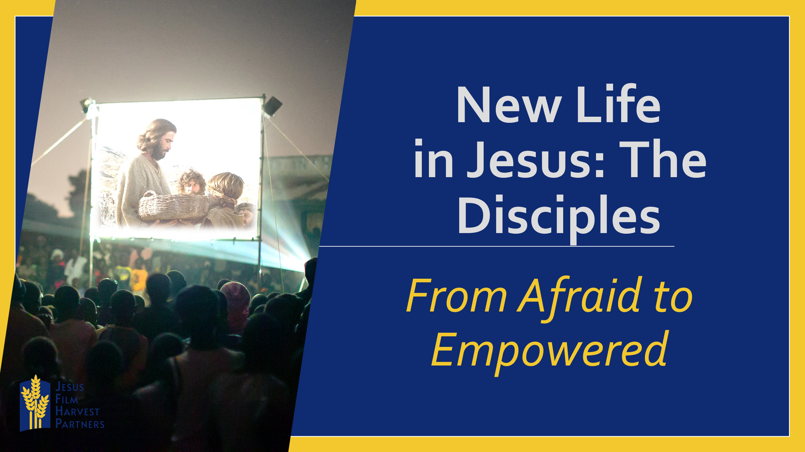
What would cause a family to go from watching a film to being kicked out of the home they live in separated from the things that are familiar?
What would cause someone to go from being afraid to being empowered?
For Mr. G and his family in a village in India it was the presentation of the JESUS film. Prior to seeing the JESUS Film, Mr. G shared that he and his family were from a religious background in which they were taught to worship many gods. He also shared that they had just started believing in Jesus and were opposed by their community. Then a JESUS Film Team shared the JESUS Film with Mr. G and his family and after seeing what Jesus did for them, it transformed them from afraid people who believed in Christ, to empowered believers who took huge steps to make Christ the most important part of their lives.
Mr. G later shared with the JESUS Film team that they found the strength to follow only Christ, and no longer all the other gods their former religion told them they needed to worship. After a few days they started praying at home and removed all the idols of the false gods from their home. As a result, they were thrown out of their family home because they believed in Jesus and faced humiliation from their community leaders. Yet they did not leave their path of Christ and started a New Life in Jesus. They strongly believe God will help them as they have moved to a new home. They regularly attend Sunday church services and today the entire family stands as a testimony of the work of Jesus Christ in their village.
Jesus’ work in our lives can take us from fear to empowerment to share His Good News.
Read John 20:19-23
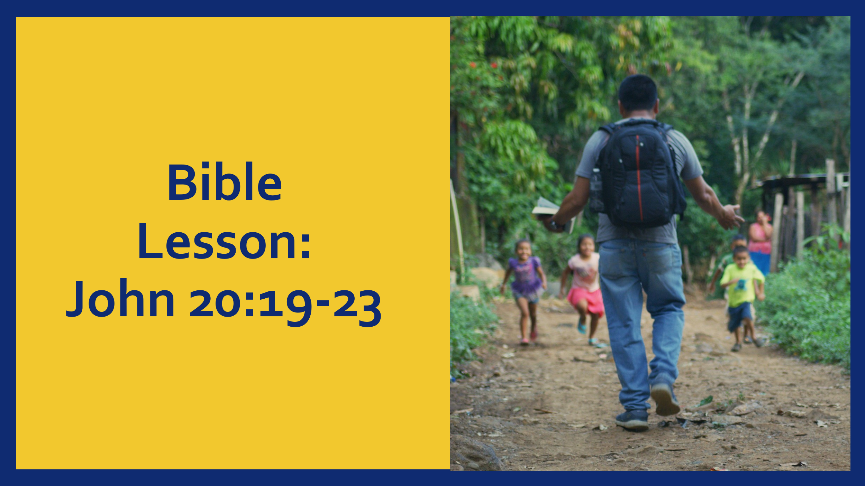

- Jesus Brings Peace Amid Our Fear

It is now evening on what we know as Easter Sunday, and the disciples find themselves together. They are together with the doors locked out of fear of the Jewish leaders, who have threatened to arrest Jesus followers. The disciples thought that they were following the Messiah, and they thought that the Messiah would be a conquering king. They did not yet understand that God’s plan was for the conquering king to first be the lamb led to the slaughter (see Isaiah 53). The shocking news Mary Magdalene brought them that morning made no sense to them…yet.
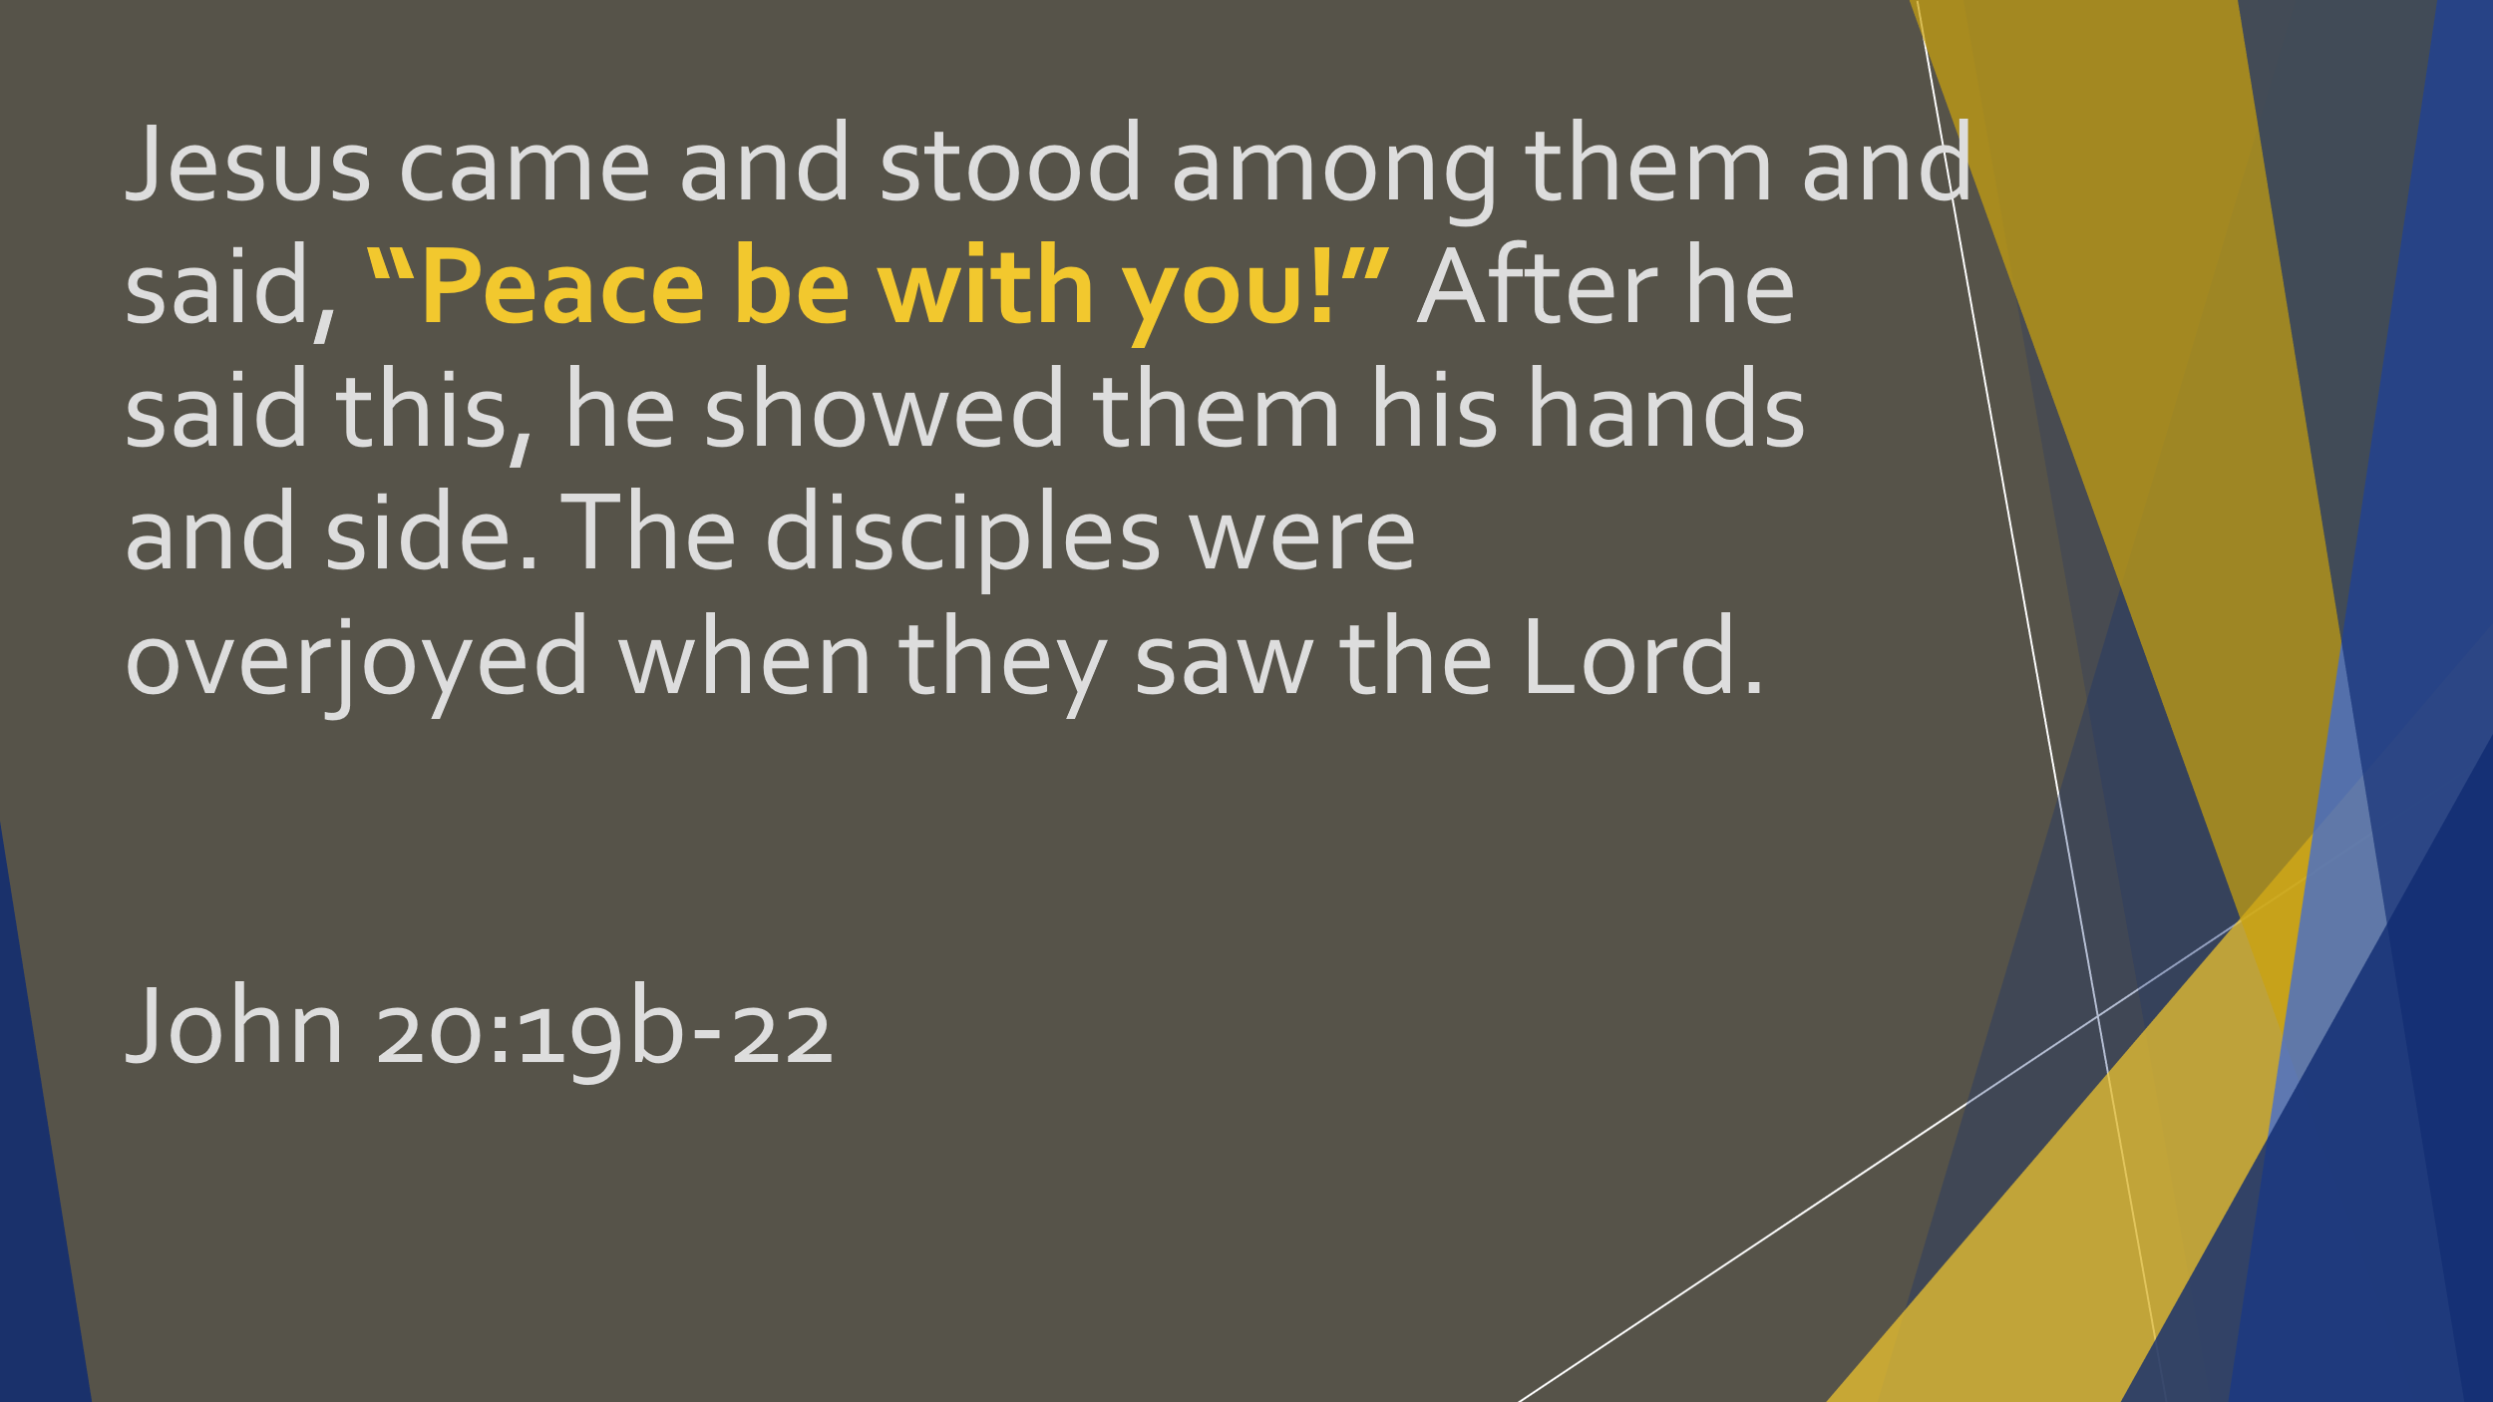
The disciples are together and waiting. Not completely certain of what they were waiting for, but they were waiting and afraid. Amid this waiting and fear Jesus arrives on the scene. Jesus not only arrives on the scene, but He brings with Him peace. Peace in the words that He greets them with, but also peace with His presence, alive and still with the holes in His hands and side.
Joseph from Benin is a 41-year-old woodworker. Like Mr. G we talked about earlier, Joseph was raised to believe not just in many gods, but that there were evil spirits roaming in the forests. This was a big problem for Joseph, because as a woodworker he had to spend a lot of time in the forests cutting down trees for his work. However, after seeing the JESUS film he was so touched by the presentation of Jesus’ life and work, that he gave his life to Christ. He testifies Jesus’ work in his life was so powerful, he now enters the forest without fear because the evil spirits have fled. God surrounds him and he lives under God’s protection.

- Jesus’ Peace Comes with the Call to be Sent as He was Sent
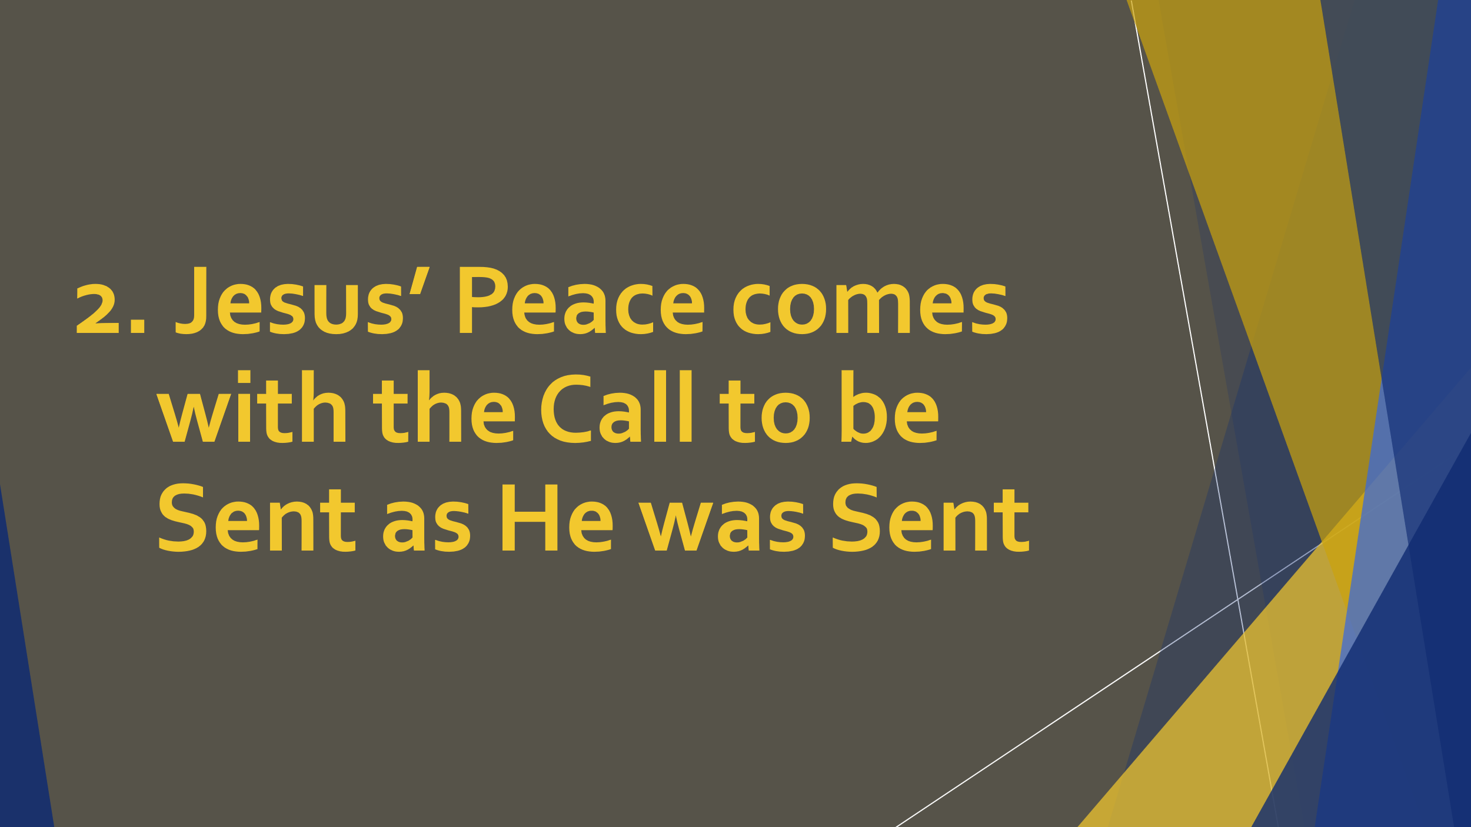
Jesus arrives and gives peace to the disciples, again not simply with His words but with His presence. Jesus challenges them as well. Jesus didn’t simply come to bring peace to the disciples, with His peace comes the call to be sent as the Father as the Father had sent Him. This is a reminder Christ does not give salvation only so we can receive salvation, He gives so we might share His salvation with others who are still lost and afraid.
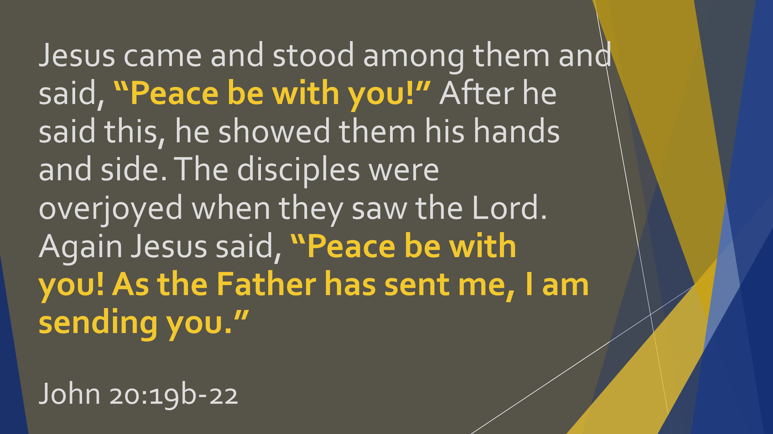
Jesus’ peace comes with the call to be sent as He was sent.

- If Christ Calls You, He Will Equip You

Jesus not only came to the disciples during their fear and brought His peace to them. He not only called the disciples to be sent just as the Father sent Him. He also breathed on them and equipped them with the Holy Spirit. Jesus didn’t leave them to fend for themselves in this brave new world without Him, He gave them what He referred to in John 16:7 as being the best for them.
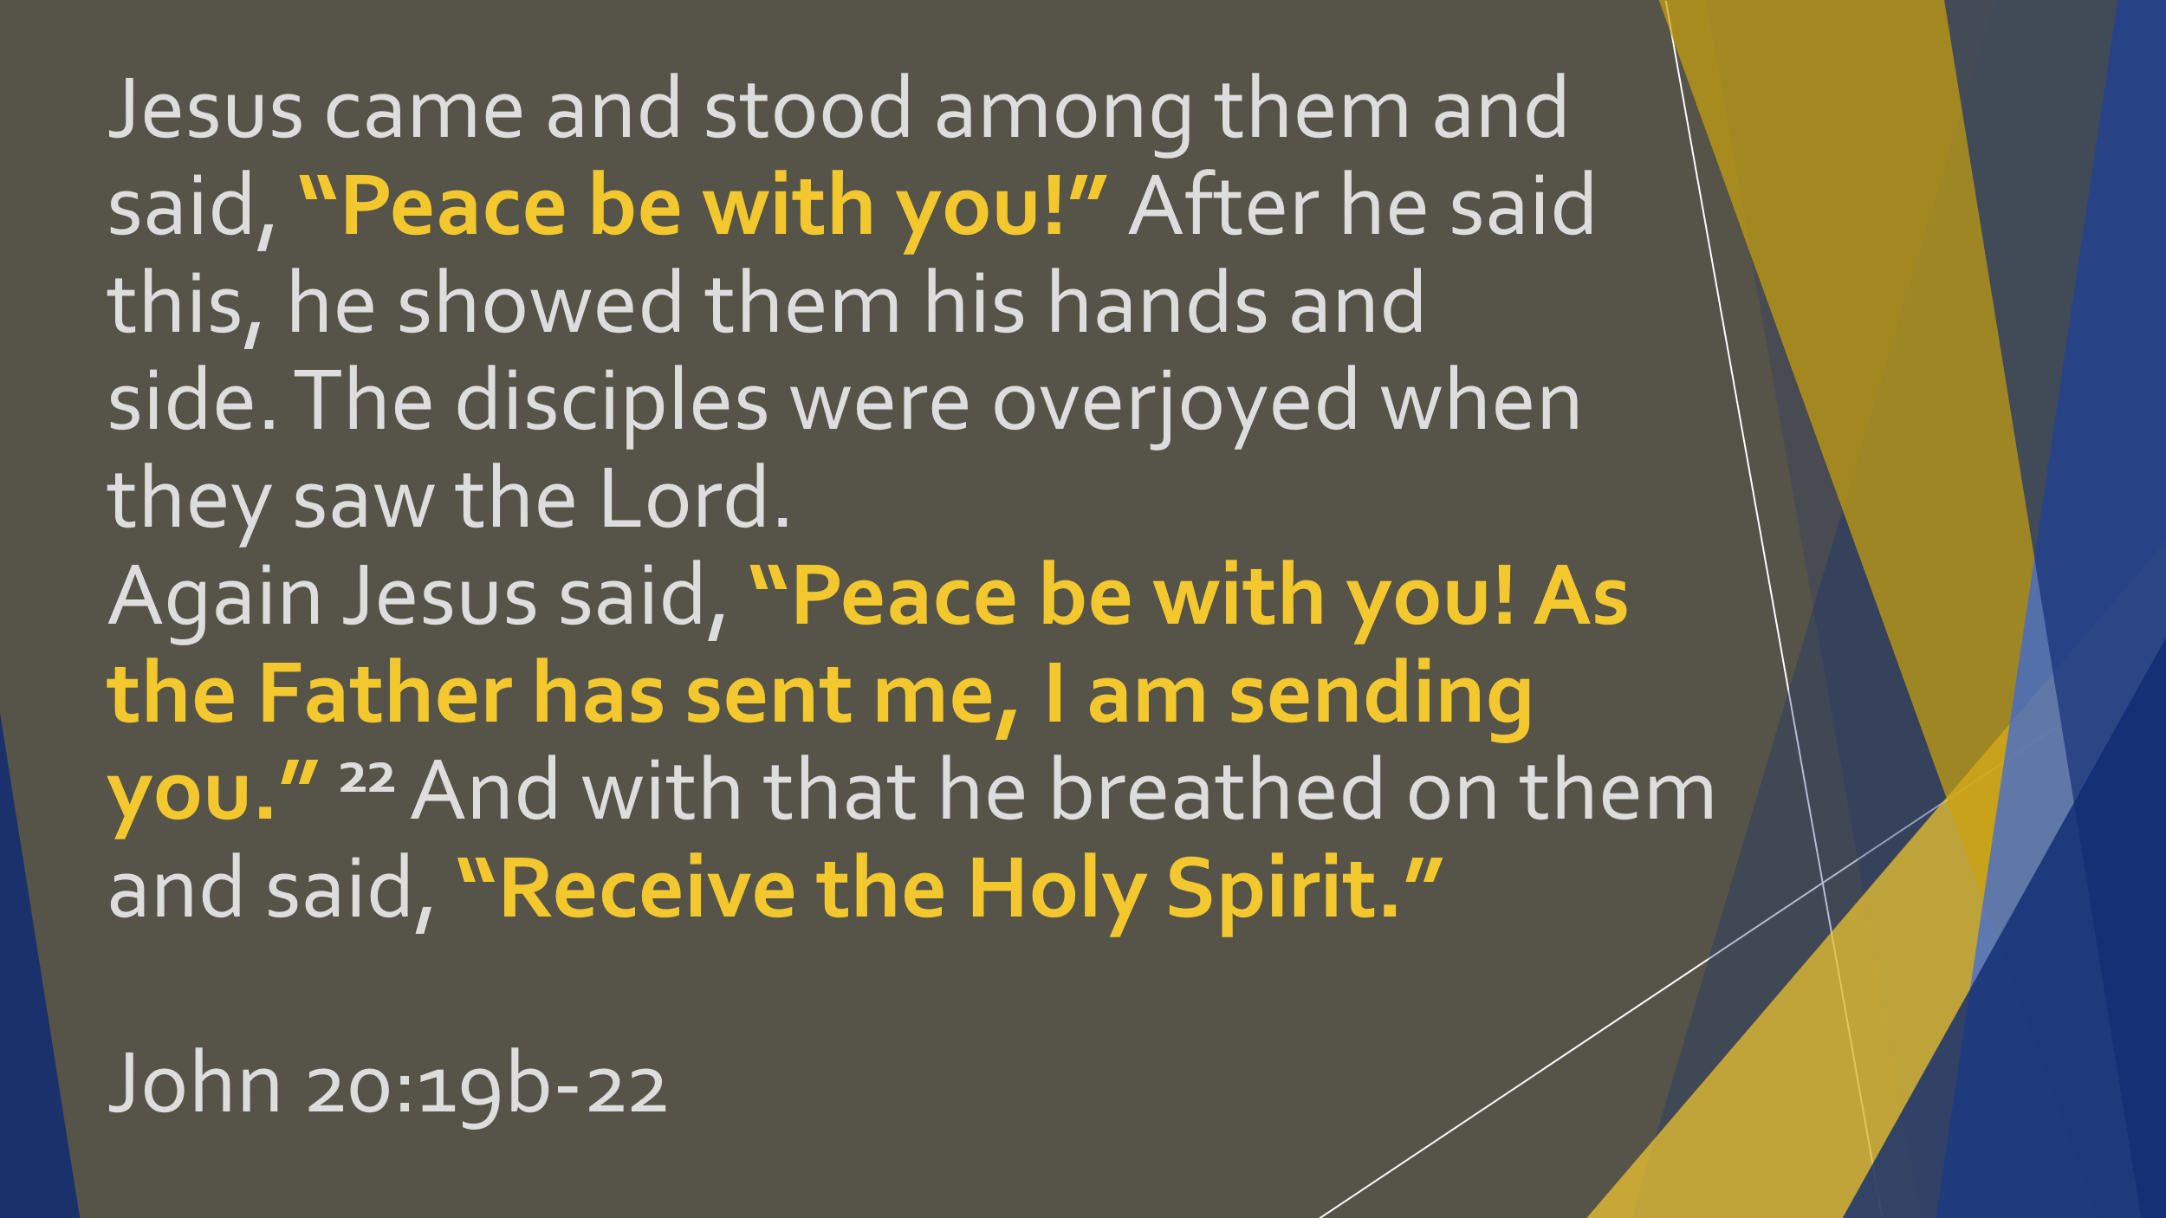
Jesus knows He will soon be returning to the Father in Heaven. He will no longer walk this earth and teach His followers face to face as He has been these past three years. However, as sad as this might sound to the disciples, it is actually good news! For, as Jesus told them back in John 16, when He returns to the Father, He will send the Holy Spirit to them. The Holy Spirit is Jesus’ very presence, living inside the disciples. So, while for the last three years Jesus has been teaching them face to face, training them face to face, correcting them face to face, that is all going to change. Now, through the work of the Holy Spirit, Jesus will live within their hearts. And part of the work of Jesus in their hearts will be to equip them to be Jesus to others!

Conclusion
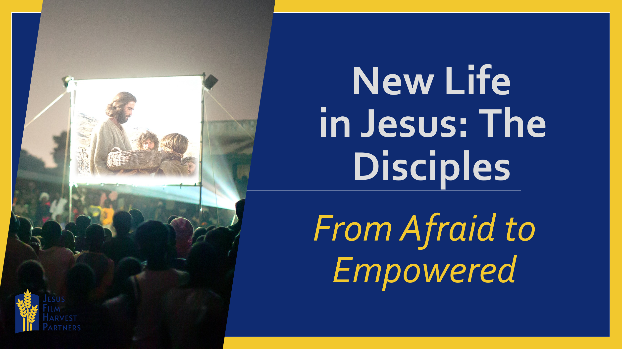
So back to our questions at the beginning,
What would cause a family to go from watching a film to being kicked out of the home they live in separated from the things that are familiar?
What would cause someone to go from being afraid to being empowered?
The answer is, it is the peace, power and infilling of the Holy Spirit. This is what would transform a person from fear to empowered believers.
Christ comes to us in the very midst of our fear, speaks peace over that fear, and calls us to follow in His footsteps.
We opened this lesson with two questions. Let’s end it with two questions I would like you to give serious attention to. Not just now, but throughout this next week.
Think about those things you have struggled to give to God because of fear. Are you willing to allow Him to come into your locked door and speak peace over you?
And secondly, as we heard, Jesus gives us peace so that we can share peace with others. Are you willing to allow Him to call and empower you to step into the place of being sent?

