
Week 3: Youth Lesson

Thomas: From Doubting to Declaring

John 20:24-31

Author: Rev. Nik Davis

Introduction
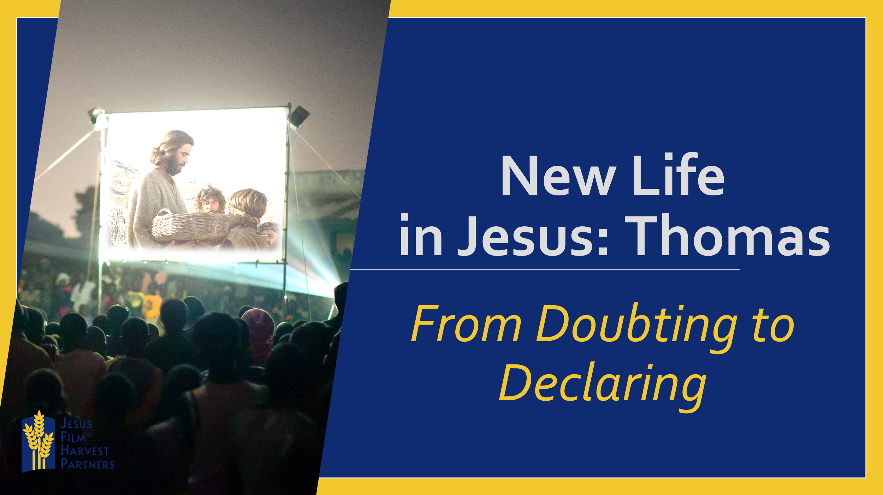
How many of you have struggled with doubt in your life? Doubt your favorite team will win, doubt you studied enough for the test, or maybe even doubt Jesus is real enough, big enough or even willing to save you from your doubt. How many of you have struggled with doubt in your life?
Some of you may be wondering how anyone can even doubt the existence of God. Have your experiences shaped you in a way that there is little that could sway your opinion on the reality of God? For many who grew up in the church it is hard to believe that anyone would doubt Jesus, but this is a reality for many, even for some of you here today.
Maybe you have heard about the hardships, suffering or even tragedy that is going on in a friend’s life and questioned how this could happen if there really is a God. Maybe you yourself have had a life experience of your own that has put doubt in your life as to whether Jesus is really real. You have experienced Him, but there is this thought or fear that makes you question or doubt.
Twenty-six-year-old Angie from Sierra Leone grew up in a Christian household with loving Christian parents. All that changed when at the age of sixteen she lost her parents. After her parents’ deaths she dropped out of college, started hanging out in the streets, and eventually became a drug addict and commercial sex worker. I am pretty sure that the loss of her parents and doubt that God could still be real to her drove her to these self-destructive actions.
As we continue looking at encounters with Jesus after His crucifixion, death, burial and resurrection we come to the night Thomas got his famous (or infamous) nickname.
Read John 20:24-31
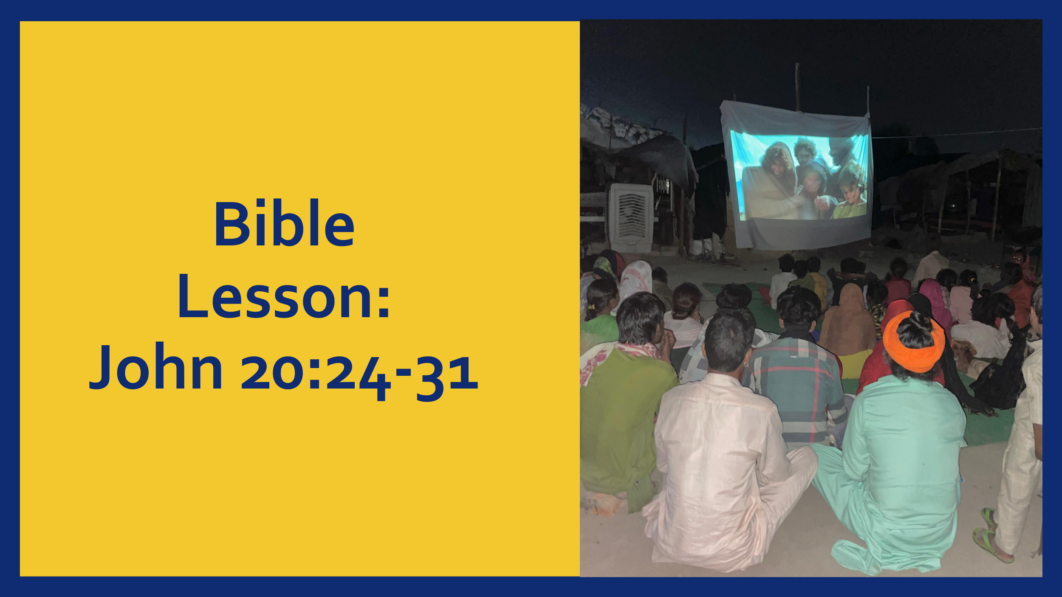

- Jesus Meets Us IN Our Doubt

I don’t think that Thomas ever thought when he started following Jesus that he would end up doubting Him, especially not to the point that he would earn a nickname for that very action. “Doubting Thomas”, how would you like to go down in history for possibly your single worst moment? Unfortunately for Thomas he did, but his worst moment is not without the offer of redemption.
Last week as we looked at Jesus’ first post-resurrection appearance to His disciples. However, as we learn in this week’s scripture, not all of Jesus’ disciples were in the room in that first event. For whatever reason, Thomas was not present. And despite Mary Magdalene’s testimony, and despite the other disciples’ testimony, Thomas just can’t bring himself to believe Jesus had risen from the dead. Thomas doubts. But that is not the end of the story. Instead, just as He did the week prior, Jesus enters the room full of disciples even though the door was locked. There is something about Jesus, even locked doors are not able to hinder Him.
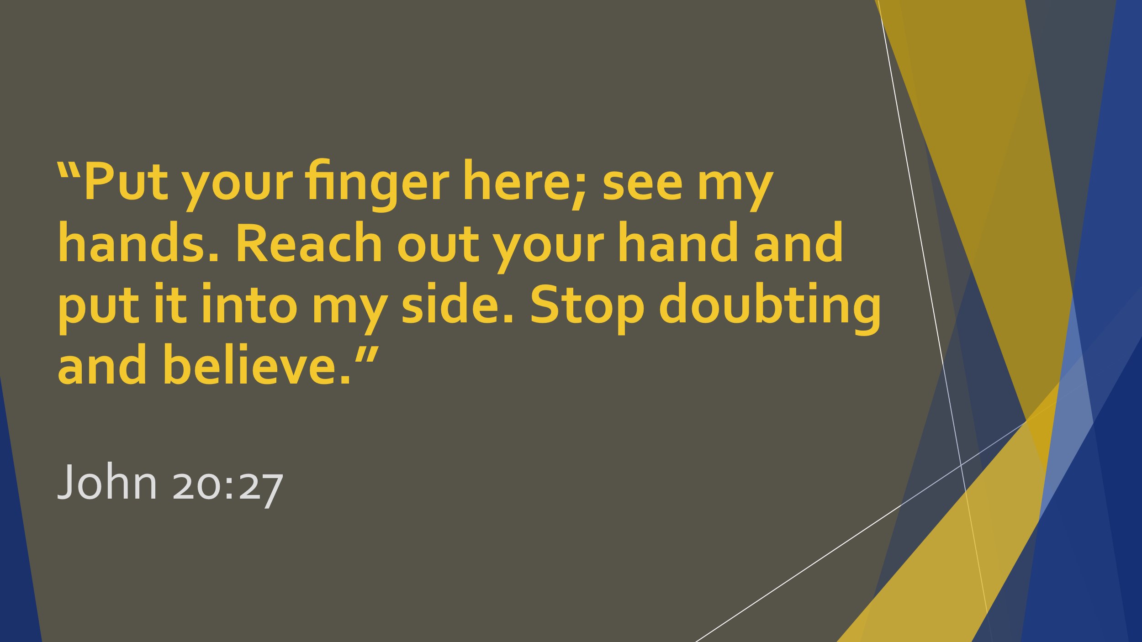
And just like last week, Jesus’ first words are “Peace be with you!” Jesus enters the room where the disciples and Thomas are and looks directly to Thomas offering, “Put your finger here; see my hands. Reach out your hand and put it into my side. Stop doubting and believe.” (v.27)
Back to our friend from Sierra Leone, Angie, Because of the things that she experienced in her life she had quit going to church and yet, Jesus entered her life again. Actually, Jesus had never left Angie, but because of her grief, pain, doubts, and bad decisions she had not been able to recognize Jesus’ presence.
Her eyes were opened, though, through a group showing the JESUS Film. This was the turning point in her life. She couldn’t see past her past. She had gone astray. However, as she watched the JESUS film it became clear to her, as Jesus was calling Matthew to follow Him, that Jesus didn’t come for the self-righteous but for the ones that had gone astray. She realized that even in the middle of her doubt, Jesus had come for her.
- When Our Doubt is Met with Jesus, It is OVERCOME and We DECLARE
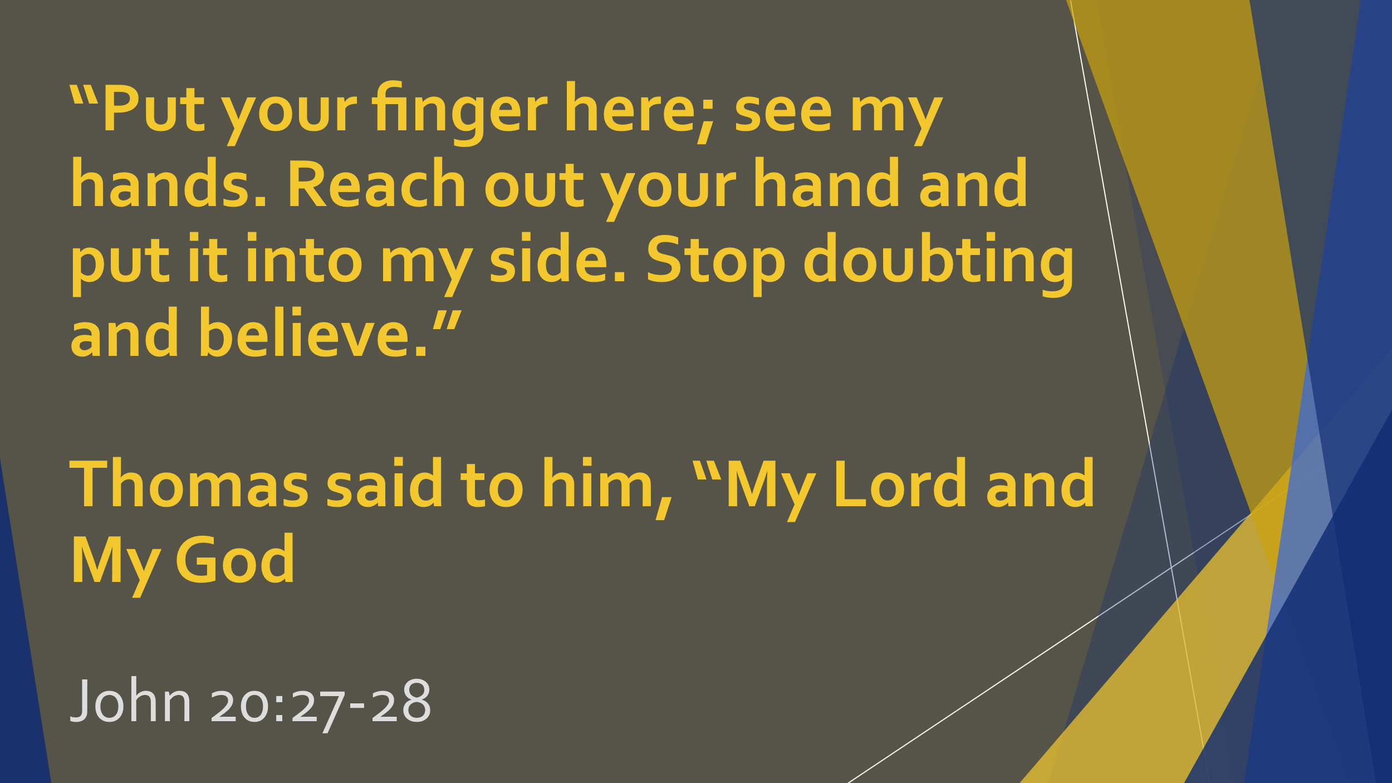
When Jesus told Thomas to reach out, to stop doubting and believe, Thomas’ response was “MY Lord and MY God.” (v. 28) Thomas went from doubting in the resurrection of Jesus that Mary Magdalene and the other disciples had so urgently shared a week earlier, to declaring this truth from his heart and for himself. This is what happens when our doubt is met with the presence of Jesus, we go from doubting to declaring that Jesus is Lord.
Angie, after seeing the JESUS Film and coming to the revelation that Jesus came for the astray not the self-righteous, went home and slept on it that night. The next day was the last day of the JESUS Film showing, and she made up her mind that she would surrender her life to Christ and His glory. She went down and prayed with the pastor at the altar and her life has not been the same since. She is experiencing New Life!
Conclusion
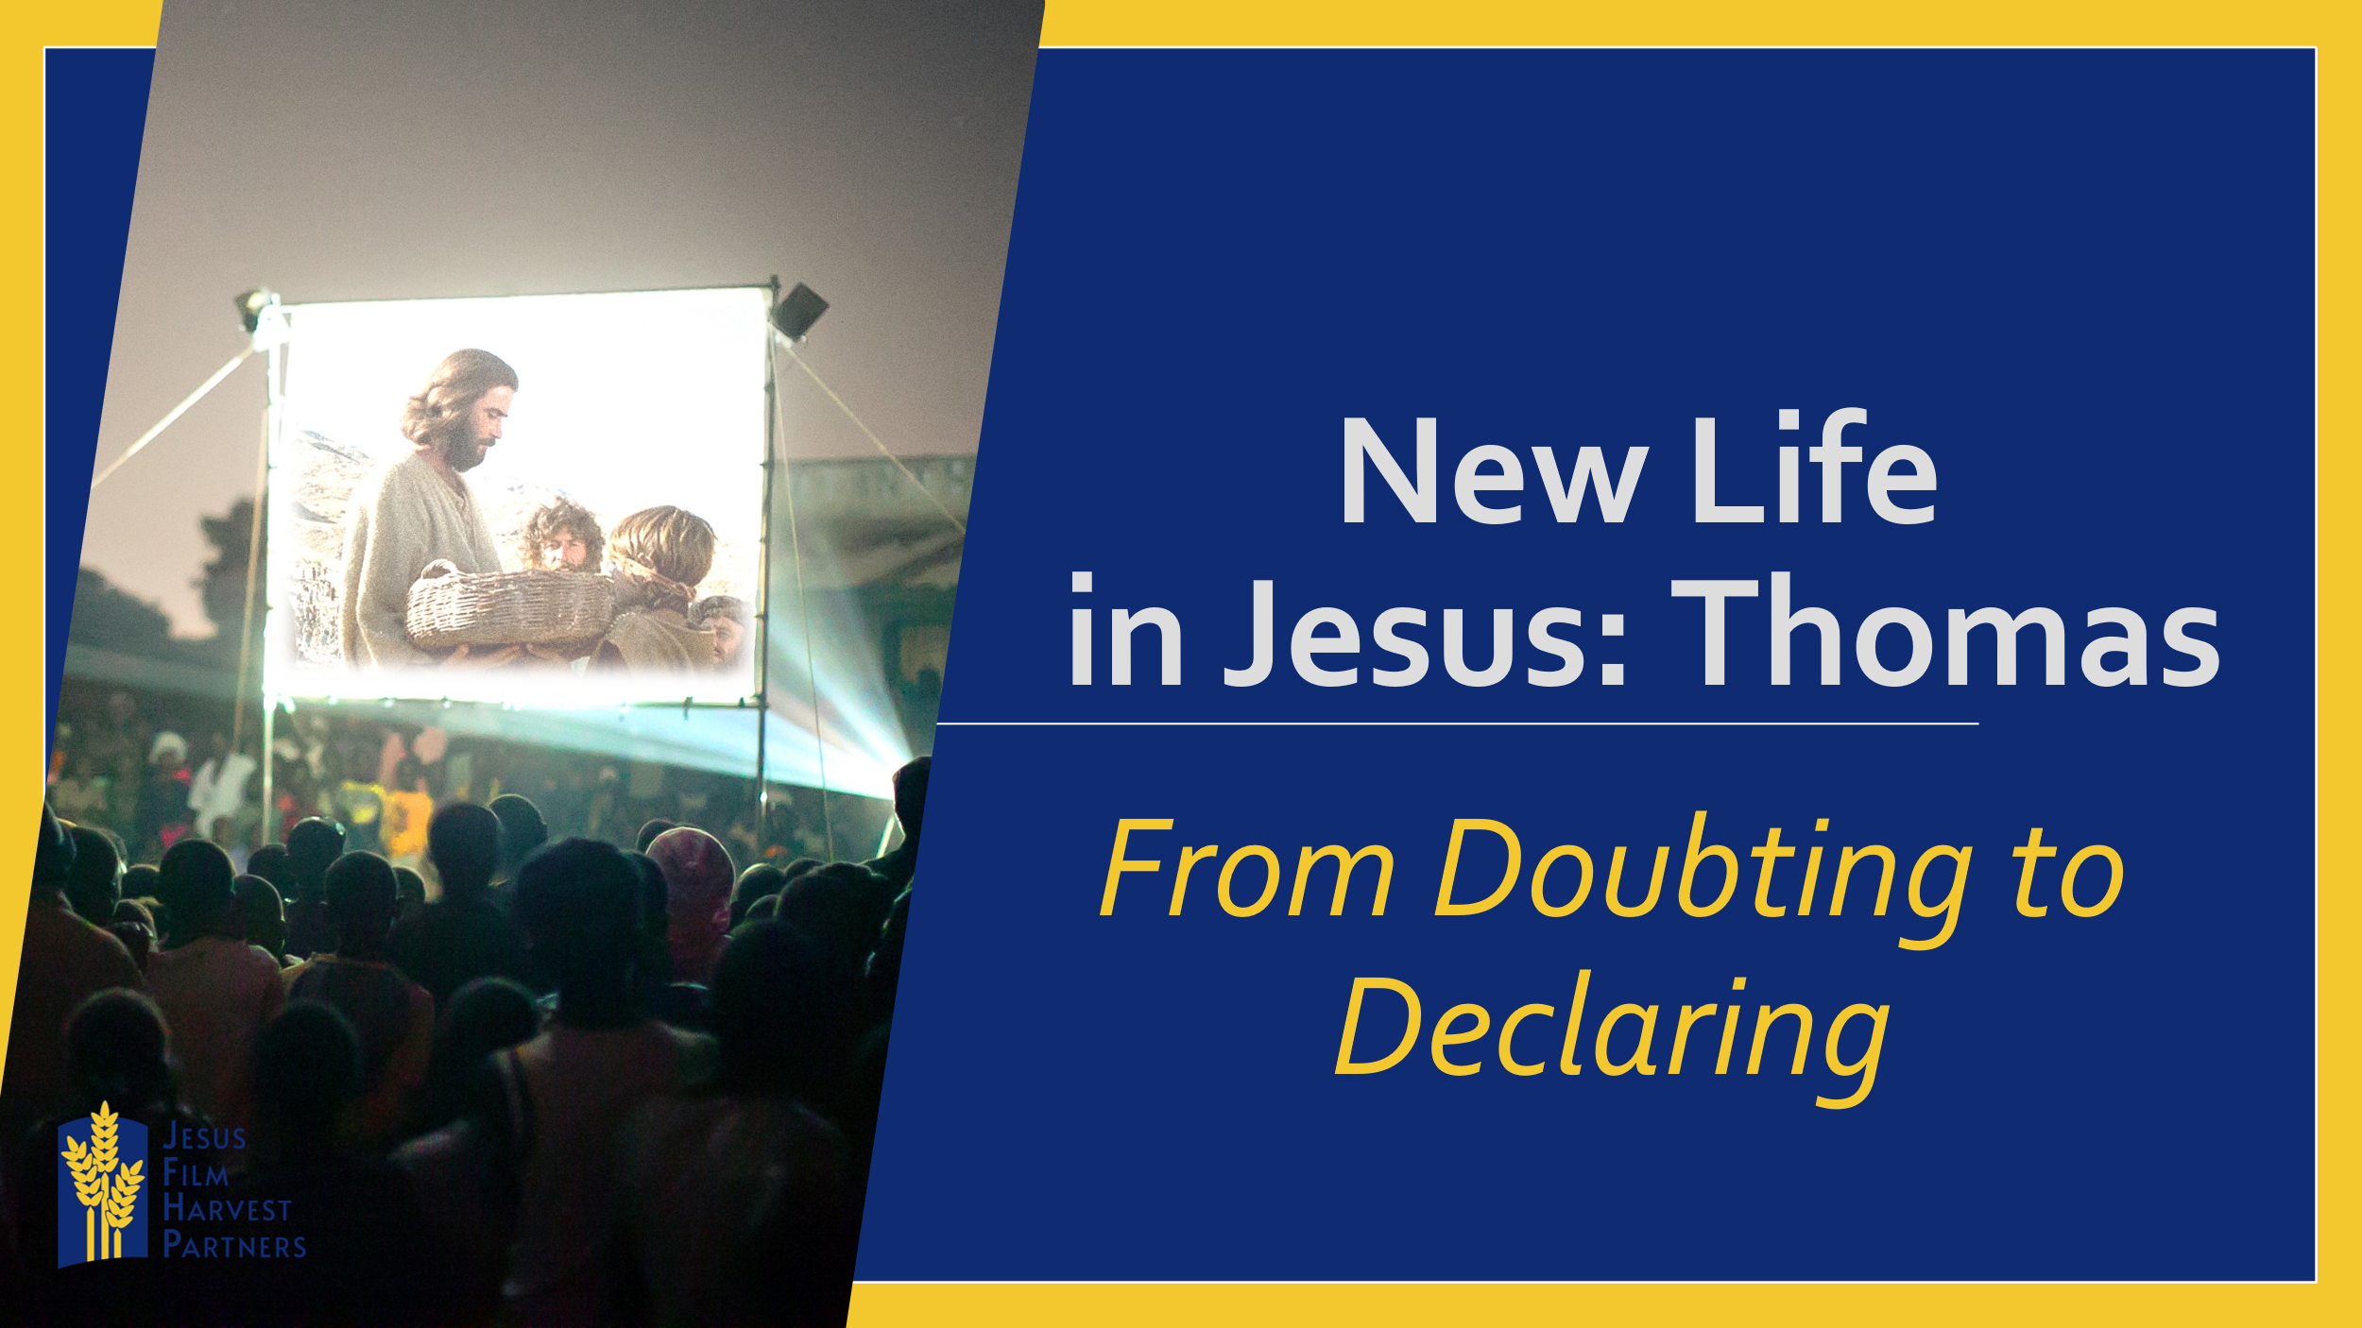
What about you? Have you had one of these moments? If so, I would like to give you time tonight to put it down on paper or share it with a friend.
Have you not had one of these moments and could really use one? What would it take for your doubt to change to declaring that Jesus is your Lord and God? I want you to take time tonight and write down or name that doubt that you are facing and give it to God.
You might never have the kind of experience where you physically see Jesus, but you will have the kind of experience where Jesus can become real to you. How do I know?
“Then Jesus told him, ‘Because you have seen me, you have believed; blessed are those who have not seen and yet have believed.’” (v.29)
Jesus meets us in the middle of our doubt and doesn’t leave us there. He calls to us, declares Himself to us and shifts our doubts to declarations.

