
Week 4: Youth Lesson

Peter: From Fallen to Fanatic-Maker

John 21:15-25

Author: Rev. Nik Davis

Introduction:
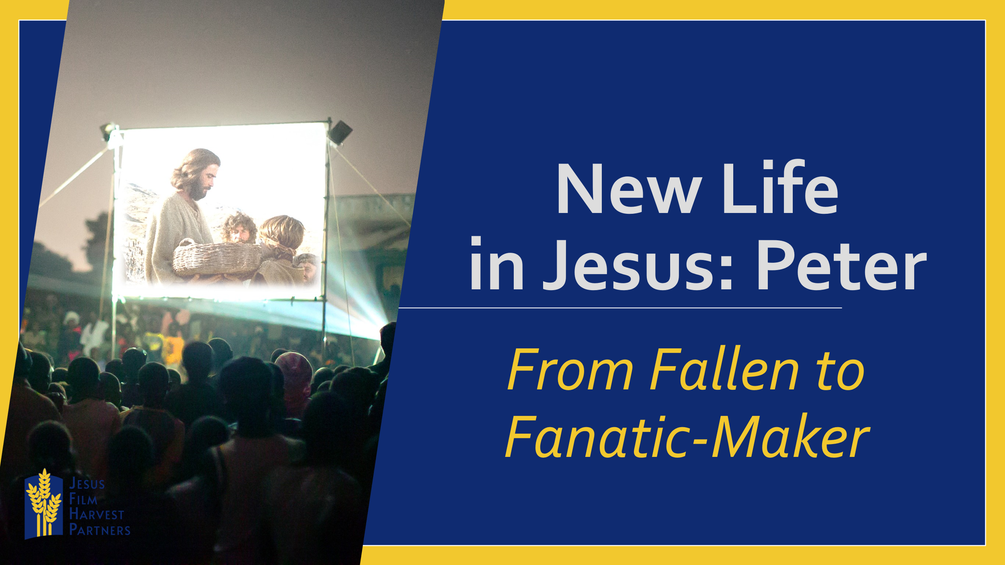
Jesus can take us from our fallen state and put a fanatical heart in us.
Abdul was a young man from Sierra Leone who had family who were followers of a radical religious group and other family who were Christian. He chose not to attend religious services of either religion, and instead ended up spending much of his time with friends who were in a gang. Because of these friendships Abdul ended up choosing to quit school, move out of his family’s house, and move in with these friends.
Abdul found himself walking across a field one evening and the Jesus Film was playing. As he walked through the field he was struck when he heard the voice saying that Jesus will die in Jerusalem for the remission of the sins of the world. He stayed around and listened to it. He shares that for the first time he heard something that made him consider his lifestyle. Abdul was strongly convicted and realized that Jesus died for him to be saved. He suddenly realized that no matter what he had done or been through, he could be pardoned because Jesus Christ has died already for his sins, which means he can be forgiven in Jesus’ name.
Tonight, as we look at our last passage in this post-resurrection series, we find another person who needed Jesus to step into their fallen space and make them once again whole and a fanatic-maker. Peter, the night that Jesus was betrayed, found himself doing something that he never thought that he would do. He found himself betraying even knowing, much less following, Jesus not once or twice but three times. It is in this fallen state that Jesus finds Peter in our scripture passage for today.
Read John 21:15-25
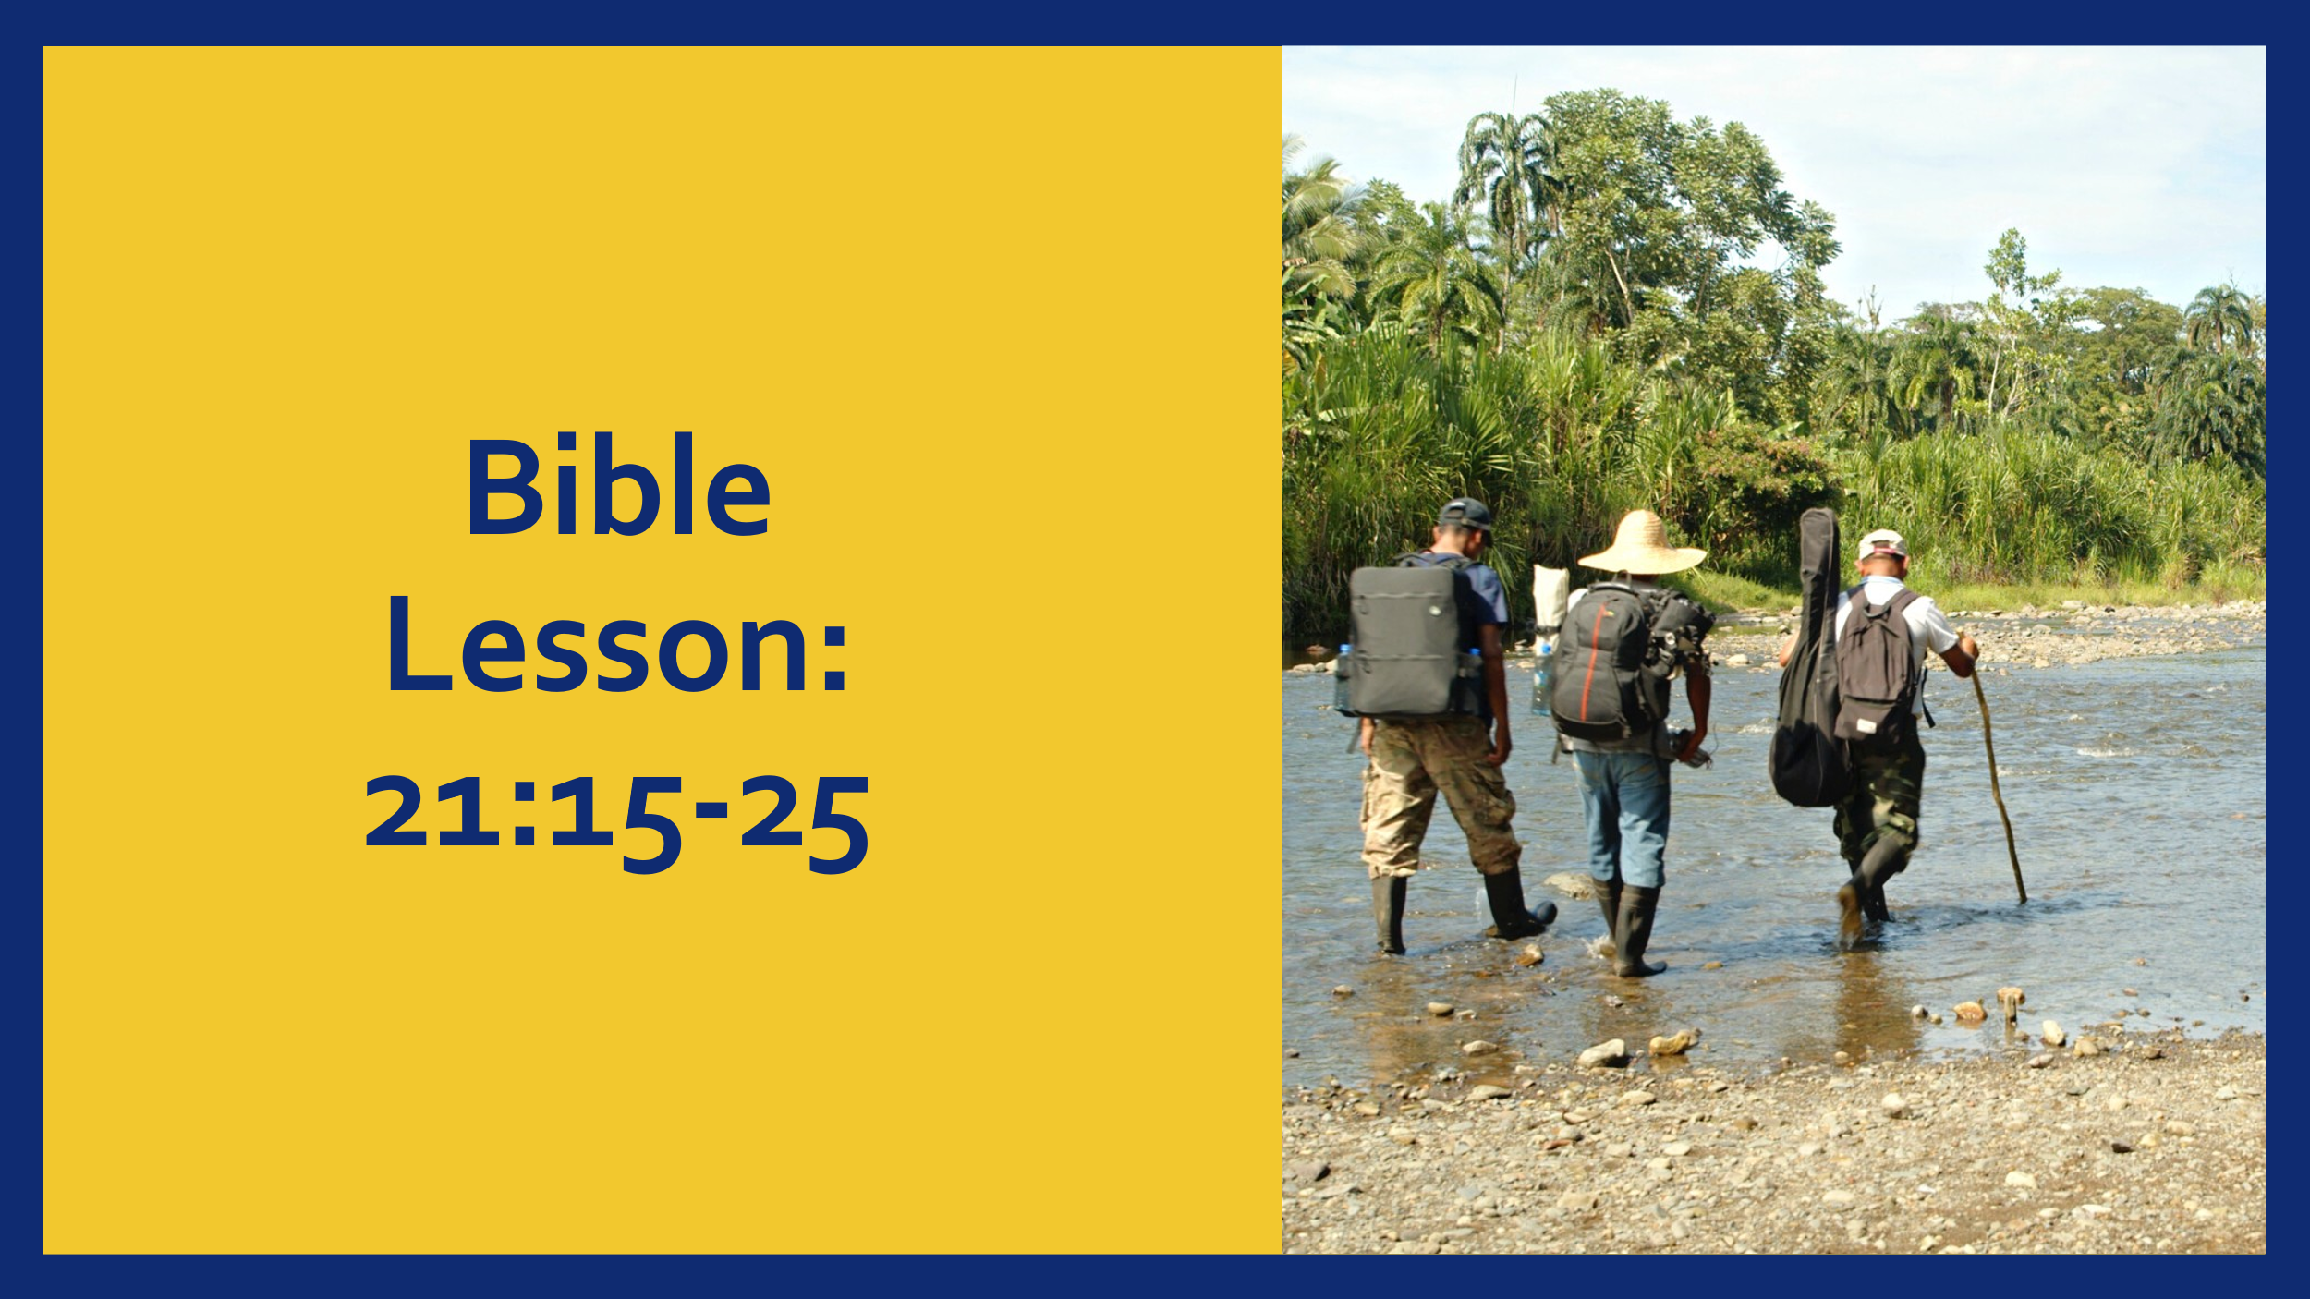

- Jesus Finds Us in Our Fallen State

Whether you are in a place where you are like our friend Abdul, where you have never really known Jesus, or are in a place like Peter found himself, Jesus is willing and able to step into that place with you and engage with you. Peter found himself in a place where he could not believe what he had done and needed Jesus to enter that space to call and remind him that the work on the Cross could cover even this sin. Abdul had never really questioned his lifestyle and yet Jesus entered his life and caused him to question his lifestyle and showed him that he could be forgiven and saved.
Abdul had only ever heard messages of condemnation, but on the night that he saw the Jesus Film, he heard a message of joy. He heard that he could be saved from his sins and live a different life. He took advantage of the invitation at the end of the presentation and gave his heart to Jesus.

- Jesus Calls us to be Fanatic-Makers

In our passage Jesus asks Peter three times if he loves him. Three times Peter’s response is “Jesus, you know that I love you.” If you remember, Peter denied Christ three times. Here Jesus three times gives Peter the opportunity to redeem that denial and proclaim his love for Him. Jesus not only restores Peter, but He calls him.
Jesus never gives us salvation just so that we can be saved, and we never receive salvation just so that we might be saved. We receive so that we might share and give away what we have received. Jesus restores, Peter and at the same time calls him into something greater. He invites Peter to follow Him in a whole new way, and care for those who have given their hearts to Jesus. Jesus essentially says, “you have received now go and give it away and enable others to do the same.”
Jesus called Peter to become a disciple maker. If you look up Disciple in the thesaurus and look for synonyms one is “fanatic.” Our calling is to go and make “fanatics” of Christ.

- This Calling has a Cost

Jesus shares with Peter that there is a cost of the calling that He has placed on his life. For us there is a cost to following Christ and making disciples as well. It is not necessarily spelled out as much for us as it was for Peter, but there is a cost. The one cost that we all pay is daily dying to ourselves and taking up the Cross to follow Jesus.
Yapo, from Cote d’Ivoire, is a math teacher. He was an enemy of Christians until one day the scales fell from his eyes and God, as he states, “caught hold of me.” He is now a Christian and proclaimer and defender of the faith. He shares that he knows being a Christian will cost him, he knows that he will be attacked a lot, but he is with Jesus and his followers.
When you enter the calling that Jesus has placed on you to be His, and to share Him with others it might cost you friends, or popularity, or even sometimes family. But the price is always worth it.

Conclusion
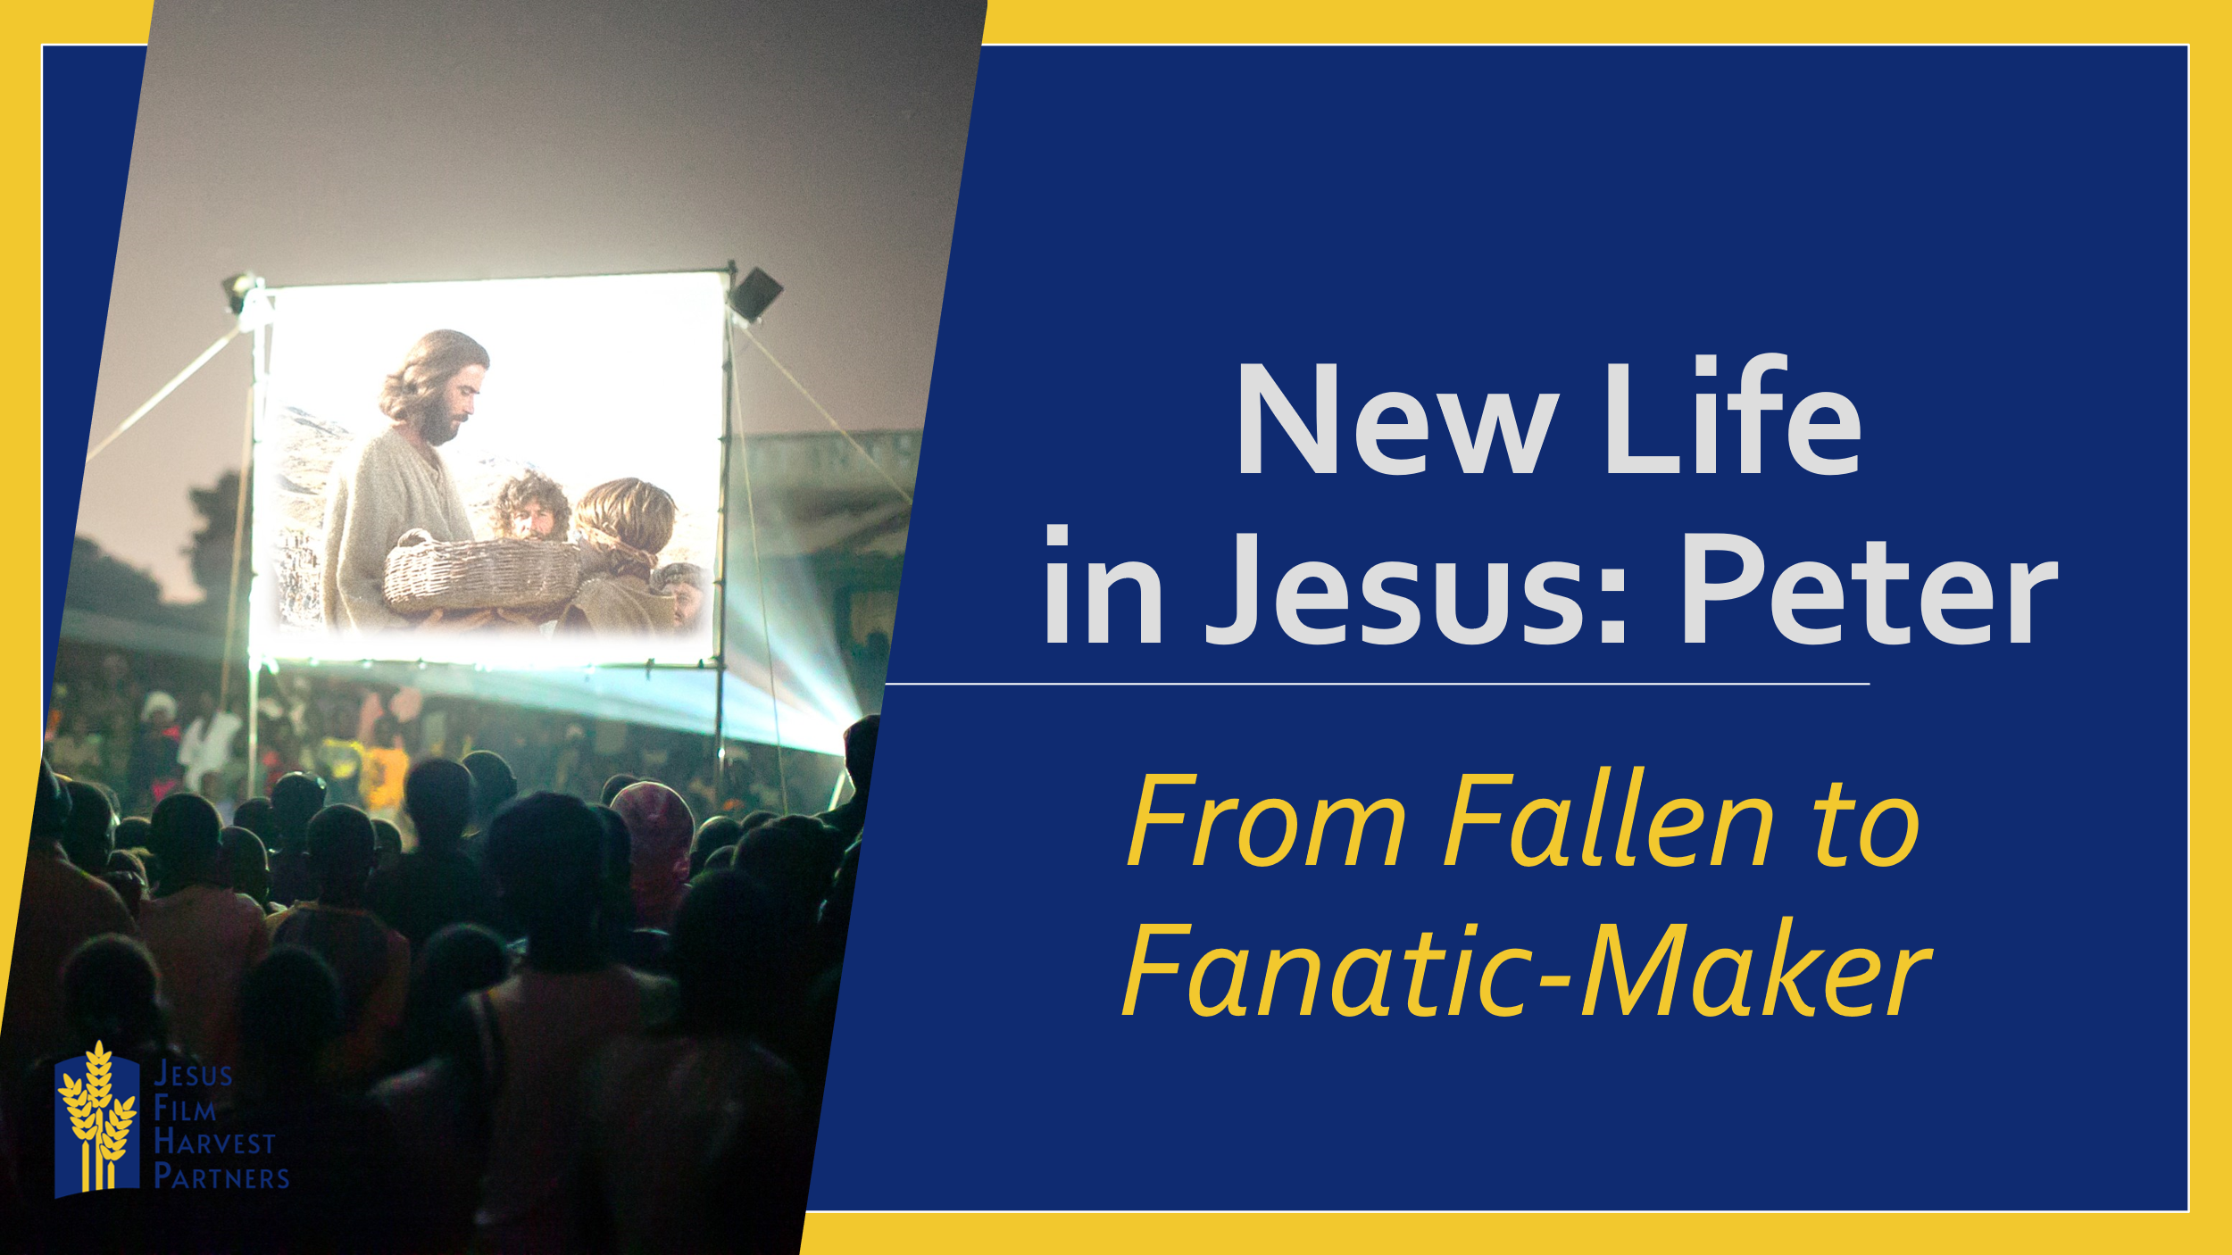
Has God caught hold of you? Or do you find yourself in the place of Abdul or Yapo or Peter where in their fallen state in need of Jesus restoration and calling? Whichever camp you find yourself in I pray that you would today find yourself in a state of being caught hold of a state of being restored and called. “And I am certain that God, who began the good work within you, will continue His work until is finally finished the day when Christ returns.” Philippians 1:6

Optional games to play to help with understanding of counting the cost:
Underground Church- a simple google search will give instructions, if needed.

